

**HIGH LEVEL DESIGN (HLD) SIGN-OFF**

**Authorization Memorandum**

This form is to sign-off completion of the Design Phase for **CAMPUS MANAGEMENT SOFTWARE AT WORLD SKILL CENTER (WSC).**

World Skill Centre (WSC) acknowledges receipt of the deliverables as part of the Design Phase through the submission of this document.

|  |  |
| --- | --- |
| **MODULE NAME** | **Finance & Accounting** |
| **MODULE OWNER** | **Mr. Bibhu Behura / Mr. Subodha Patra** |

**WSC AUTHORITY NAME AND SIGNATURE**

**SOUL AUTHORITY NAME AND SIGNATURE**

 



**Sustainable Outreach And Universal**

**Leadership (SOUL) Limited**

**High Level Design (HLD)**

Of

**Finance & Accounting module**

For Implementation of

**Campus Management Software**

at

**World Skill Center (WSC)**

**Confidentiality**

This document is a strictly confidential communication to and solely for the use of the recipient and may not be reproduced or circulated without SOUL Ltd’s prior written consent. If you are not the intended recipient, you may not disclose or use the information in this documentation in any way

**Document Control History**

|  |  |  |  |  |  |
| --- | --- | --- | --- | --- | --- |
| **Date** | **Version No.** | **Created By** | **Affected Sections** | **Reviewed By** | **Updated By** |
| 07-August-2023 | 1.0 | Subhodeep Dey | All |  |  |
| 07-August-2023 | 1.1 |  | Project control, database design, security,Architectural Risks & Mitigation, UI screenshots | Sharmistha Panda | Sharmistha Panda |

# Project Control

|  |  |
| --- | --- |
| **Package Number:** | PKG 0111 |
| **Project Name:** | Campus Management Software At World Skill Center (WSC) |
| **Location:** | Bhubaneswar |
| **Customer Name:** | World Skill Center (WSC) |
| **Customer Contact Information:** | Mancheswar, Bhubaneswar |
| **Project Manager / Email ID:** | Sharmistha Panda  sharmistha.panda@soulunileaders.com |
| **Module SME / Email ID:** | Mr. Bibhu Behura (bibhu.behura@worldskillcenter.org)  Mr. Subodha Patra (subodha.patra@worldskillcenter.org) |

Table Of Contents

HIGH LEVEL DESIGN (HLD) SIGN-OFF 1

Authorization Memorandum 1

Project Control 3

1 Introduction 11

1.1 Background 11

1.2 Scope and Purpose of the document 11

1.3 Assumptions 12

1.4 Dependencies 12

1.5 Current IT Environment 12

1.6 Document Structure 13

1.7 Required System Architecture 13

1.8 Interoperability Framework 13

1.9 Technical Decision Summary 14

1.10 Architectural Risks & Mitigation 14

1.11 Reference 15

2 Enterprise Architecture Framework (Business Architecture) 15

2.1 Business Drivers 15

2.2 Business Concerns 15

2.3 Business Goals 15

2.4 Business Value Chain 16

2.5 Business Context Diagram 16

2.6 Business Process Flow 16

2.6.1 Accounting 16

2.6.2 System Context Diagram 17

2.7 Conceptual Architecture 17

3 Architecture Views 18

3.1 Company 18

3.1.1 Use Case Diagram 18

3.1.2 Design Workflow 19

3.1.3 Validations 19

3.1.4 Field List: 20

3.1.5 Processes After Form Submission 23

3.1.6 Process Flow: 23

3.1.7 Pre-requisites and Dependency 24

3.2 Account(Chart of Accounts) 24

3.2.1 Use Case Diagram 24

3.2.2 Design of Workflow 25

3.2.3 Validations 25

3.2.4 Field List: 25

3.2.5 Processes After Form Submission 26

3.2.6 Process Flow: 26

3.2.7 Pre-requisites and Dependency 27

3.3 Fiscal Year 27

3.3.1 Use Case Diagram 27

3.3.2 Design of Workflow 28

3.3.3 Validations 28

3.3.4 Field List: 28

3.3.5 Processes After Form Submission 29

3.3.6 Process Flow: 29

3.3.7 Pre-requisites and Dependency 30

3.4 Accounting Period 30

3.4.1 Use Case Diagram 30

3.4.2 Design of Workflow 31

3.4.3 Validations 31

3.4.4 Field List: 32

3.4.5 Processes After Form Submission 32

3.4.6 Process Flow: 33

3.4.7 Pre-requisites and Dependency 33

3.5 Finance Book 33

3.5.1 Use Case Diagram 33

3.5.2 Design of Workflow 34

3.5.3 Validations 34

3.5.4 Field List: 35

3.5.5 Processes After Form Submission 35

3.5.6 Process Flow: 35

3.5.7 Pre-requisites and Dependency 35

3.6 Bank 35

3.6.1 Use Case Diagram 35

3.6.2 Design of Workflow 36

3.6.3 Validations 36

3.6.4 Field List: 36

3.6.5 Processes After Form Submission 37

3.6.6 Process Flow: 37

3.6.7 Pre-requisites and Dependency 38

3.7 Bank Account 38

3.7.1 Use Case Diagram 38

3.7.2 Design of Workflow 39

3.7.3 Validations 39

3.7.4 Field List: 39

3.7.5 Processes After Form Submission 40

3.7.6 Process Flow: 40

3.7.7 Pre-requisites and Dependency 41

3.8 Mode of Payment 41

3.8.1 Use Case Diagram 41

3.8.2 Design of Workflow 42

3.8.3 Validations 42

3.8.4 Field List: 42

3.8.5 Processes After Form Submission 43

3.8.6 Process Flow: 43

3.8.7 Pre-requisites and Dependency 44

3.9 Currency 44

3.9.1 Use Case Diagram 44

3.9.2 Design of Workflow 45

3.9.3 Validations 45

3.9.4 Field List: 45

3.9.5 Processes After Form Submission 46

3.9.6 Process Flow: 46

3.9.7 Pre-requisites and Dependency 46

3.10 Party Type 46

3.10.1 Use Case Diagram 47

3.10.2 Design of Workflow 47

3.10.3 Validations 47

3.10.4 Field List: 47

3.10.5 Processes After Form Submission 48

3.10.6 Process Flow: 48

3.10.7 Pre-requisites and Dependency 48

3.11 Cost Center 48

3.11.1 Use Case Diagram 48

3.11.2 Design of Workflow 49

3.11.3 Validations 49

3.11.4 Field List: 50

3.11.5 Processes After Form Submission 50

3.11.6 Process Flow: 51

3.11.7 Pre-requisites and Dependency 51

3.12 Accounting Dimension 51

3.12.1 Use Case Diagram 51

3.12.2 Design of Workflow 52

3.12.3 Validations 52

3.12.4 Field List: 53

3.12.5 Processes After Form Submission 54

3.12.6 Process Flow: 54

3.12.7 Pre-requisites and Dependency 54

3.13 Journal Entry 55

3.13.1 Use Case Diagram 55

3.13.2 Design of Workflow 55

3.13.3 Validations 55

3.13.4 Field List: 56

3.13.5 Processes After Form Submission 60

3.13.6 Process Flow: 60

3.13.7 Pre-requisites and Dependency 61

3.14 GL Entry 61

3.14.1 Use Case Diagram 61

3.14.2 Design of Workflow 61

3.14.3 Validations 61

3.14.4 Field List: 62

3.14.5 Processes After Form Submission 62

3.14.6 Process Flow: 63

3.14.7 Pre-requisites and Dependency 63

3.15 General Ledger 63

3.15.1 Use Case Diagram 63

3.15.2 Design of Workflow 64

3.15.3 Validations 64

3.15.4 Field List: 65

3.15.5 Processes After Form Submission 66

3.15.6 Process Flow: 66

3.15.7 Pre-requisites and Dependency 67

3.16 Payment Entry 67

3.16.1 Use Case Diagram 67

3.16.2 Design of Workflow 67

3.16.3 Validations 67

3.16.4 Field List: 68

3.16.5 Processes After Form Submission 75

3.16.6 Process Flow: 75

3.16.7 Pre-requisites and Dependency 75

3.17 Bank Reconciliation Tool 75

3.17.1 Use Case Diagram 75

3.17.2 Design of Workflow 76

3.17.3 Validations 76

3.17.4 Field List: 77

Processes After Form Submission 78

3.17.5 Process Flow: 78

3.17.6 Pre-requisites and Dependency 79

3.18 Bank Clearance 79

3.18.1 Use Case Diagram 79

3.18.2 Design of Workflow 79

3.18.3 Validations 79

3.18.4 Field List: 80

3.18.5 Processes After Form Submission 81

3.18.6 Process Flow: 81

3.18.7 Pre-requisites and Dependency 82

3.19 Bank Reconciliation Statement 82

3.19.1 Use Case Diagram 82

3.19.2 Design of Workflow 83

3.19.3 Validations 83

3.19.4 Field List: 83

3.19.5 Processes After Form Submission 84

3.19.6 Process Flow: 84

3.19.7 Pre-requisites and Dependency 84

3.20 Accounts Receivable Report 85

3.20.1 Use Case Diagram 85

3.20.2 Design of Workflow 85

3.20.3 Validations 85

3.20.4 Field List: 86

3.20.5 Processes After Form Submission 87

3.20.6 Process Flow: 88

3.20.7 Pre-requisites and Dependency 88

3.21 Accounts Receivable Summary Report 88

3.21.1 Use Case Diagram 88

3.21.2 Design of Workflow 89

3.21.3 Validations 89

3.21.4 Field List: 89

3.21.5 Processes After Form Submission 91

3.21.6 Process Flow: 91

3.21.7 Pre-requisites and Dependency 91

3.22 Accounts Payable Report 91

3.22.1 Use Case Diagram 91

3.22.2 Design of Workflow 92

3.22.3 Validations 92

3.22.4 Field List: 93

3.22.5 Processes After Form Submission 94

3.22.6 Process Flow: 94

3.22.7 Pre-requisites and Dependency 95

3.23 Accounts Payable Summary Report 95

3.23.1 Use Case Diagram 95

3.23.2 Design of Workflow 95

3.23.3 Validations 96

3.23.4 Field List: 96

3.23.5 Processes After Form Submission 97

3.23.6 Process Flow: 97

3.23.7 Pre-requisites and Dependency 98

3.24 Purchase Register Report 98

3.24.1 Use Case Diagram 98

3.24.2 Design of Workflow 99

3.24.3 Validations 99

3.24.4 Field List: 99

3.24.5 Processes After Form Submission 100

3.24.6 Process Flow: 100

3.24.7 Pre-requisites and Dependency 101

3.25 Item Wise Purchase Register Report 101

3.25.1 Use Case Diagram 101

3.25.2 Design of Workflow 101

3.25.3 Validations 102

3.25.4 Field List: 102

3.25.5 Processes After Form Submission 103

3.25.6 Process Flow: 103

3.25.7 Pre-requisites and Dependency 104

3.26 Trial Balance for Party Report 104

3.26.1 Use Case Diagram 104

3.26.2 Design of Workflow 104

3.26.3 Validations 105

3.26.4 Field List: 105

3.26.5 Processes After Form Submission 106

3.26.6 Process Flow: 106

3.26.7 Pre-requisites and Dependency 107

3.27 Tax Detail Report 107

3.27.1 Use Case Diagram 107

3.27.2 Design of Workflow 107

3.27.3 Validations 107

3.27.4 Field List: 108

3.27.5 Processes After Form Submission 109

3.27.6 Process Flow: 109

3.27.7 Pre-requisites and Dependency 109

3.28 Supplier Ledger Summary Report 109

3.28.1 Use Case Diagram 109

3.28.2 Design of Workflow 110

3.28.3 Validations 110

3.28.4 Field List: 110

3.28.5 Processes After Form Submission 111

3.28.6 Process Flow: 111

3.28.7 Pre-requisites and Dependency 112

3.29 Trail Balance 112

3.29.1 Use Case Diagram 112

3.29.2 Design of Workflow 112

3.29.3 Validations 113

3.29.4 Field List: 113

3.29.5 Processes After Form Submission 115

3.29.6 Process Flow: 115

3.29.7 Pre-requisites and Dependency 115

3.30 Balance Sheet 115

3.30.1 Use Case Diagram 115

3.30.2 Design of Workflow 116

3.30.3 Validations 116

3.30.4 Field List: 117

3.30.5 Processes After Form Submission 118

3.30.6 Process Flow: 118

3.30.7 Pre-requisites and Dependency 118

3.31 Profit and Loss Statement 119

3.31.1 Use Case Diagram 119

3.31.2 Design of Workflow 119

3.31.3 Validations 119

3.31.4 Field List: 120

3.31.5 Processes After Form Submission 121

3.31.6 Process Flow: 121

3.31.7 Pre-requisites and Dependency 121

3.32 Cash Flow 122

3.32.1 Use Case Diagram 122

3.32.2 Design of Workflow 122

3.32.3 Validations 122

3.32.4 Field List: 123

3.32.5 Processes After Form Submission 124

3.32.6 Process Flow: 124

3.32.7 Pre-requisites and Dependency 124

3.33 Consolidated Financial Statement 125

3.33.1 Use Case Diagram 125

3.33.2 Design of Workflow 125

3.33.3 Validations 125

3.33.4 Field List: 126

3.33.5 Processes After Form Submission 127

3.33.6 Process Flow: 127

3.33.7 Pre-requisites and Dependency 128

3.34 Fixed Deposit 128

3.34.1 Use Case Diagram 128

3.34.2 Design of Workflow 128

3.34.3 Validations 129

3.34.4 Field List: 129

3.34.5 Processes After Form Submission 130

3.34.6 Process Flow: 130

3.34.7 Pre-requisites and Dependency 130

4 Tools And Technologies 131

5 Non-Functional Requirements 131

5.1 Performance 131

5.2 Reliability 131

5.3 Usability 131

5.4 Compatibility 131

5.5 Security 131

5.6 Compliance 131

5.7 Documentation 132

5.8 Security: User access and authorization 132

6 Database Design 138

Prototype 139

7 Prototype 140

7.1 Company 140

Figure Company 140

7.2 Account 140

Figure Account 141

7.3 Fiscal Year 141

Figure Fiscal Year 141

7.4 Accounting Period 141

Figure Accounting Period 141

7.5 Finance Book 142

Figure Finance Book 142

7.6 Bank 142

Figure Bank 142

7.7 Bank Account 142

Figure Bank Account 142

7.8 Mode of Payment 143

Figure Mode of Payment 143

7.9 Currency 143

Figure Currency 143

7.10 Party Type 143

Figure Party Type 143

7.11 Cost Center 143

Figure Cost Center 143

7.12 Accounting Dimension 144

Figure Accounting Dimesion 144

7.13 Journal Entry 144

Figure Journal Entry 144

7.14 GL Entry 144

Figure GL Entry 144

7.15 General Ledger 145

Figure General Ledger 145

7.16 Payment Entry 145

Figure Payment Entry 145

7.17 Bank Reconciliation Tool 145

Figure Bank Reconciliation Tool 145

7.18 Bank Clearance 146

Figure Bank Clearance 146

7.19 Bank Reconciliation Statement 146

Figure Bank Reconciliation Statement 146

7.20 Accounts Receivable Report 146

Figure Accounts Receivable 146

7.21 Accounts Receivable Summary Report 146

7.22 Accounts Payable Report 147

7.23 Accounts Payable Summary Report 147

7.24 Purchase Register Report 148

7.25 Item Wise Purchase Register Report 148

7.26 Trail Balance for Party Report 148

7.27 Tax Detail Report 148

7.28 Supplier Ledger Summary Report 149

7.29 Trial Balance 149

7.30 Balance Sheet 150

7.31 Profit and Loss Statement 150

7.32 Cash Flow 150

7.33 Consolidated Financial Statement 151

7.34 Fixed Deposit 151

8 Definitions and Acronyms 152

9 Deployment Description 152

# Introduction

The World Skill Center (WSC) is a premier advanced skill training institute established by the Government of Odisha, Skill Development and Technical Education Department, through the Odisha Skill Development Authority (OSDA). The WSC will impart advanced skill training in eight trades from engineering and service sectors. WSC caters primarily to induct the best talent from ITIs and Polytechnics and training them to become globally employable in emerging areas such as "Industry 4.0". WSC is housed in a state-of-the-art, 18-storey, air-conditioned building with nearly half a million square feet of space in the heart of capital city of Bhubaneswar.

With the implementation of campus management software for WSC the goal is to streamline the operations and functions of the campus by integrating various processes, such as admissions, course registration, academic progress tracking, and financial management, HRMS, Procurement and Inventory management, etc into a unified system. The implementation also aims at providing a user-friendly interface for all stakeholders, making it easier for them to access the necessary information and complete their tasks with ease. The modules to be covered during the implementation of the software include:

|  |  |
| --- | --- |
| Students Management Modules | Infrastructure Management |
| Academic System | Finance and Accounting System |
| Procurement & Inventory Management | Training and Placement |
| Human Resources Management System | Application Integration |

# 

## Background

The Web Based Campus Management Application at World Skill Centre (WSC) application is required by WSC for the smooth operation of all departments / support functions with on-line delivery of services to all stakeholders.

The project aims to create a mechanism to provide the basis for evolution of an IT enabled state of the art workflow automation system in a planned manner.

## Scope and Purpose of the document

The design documents track the necessary information required to effectively define architecture and system design in order to give the development team guidance on the architecture of the system to be developed. Its intended audience is the project manager, project team, and development team. Some portions of this document, such as the user interface (UI), may be shared with the client/user, and other stakeholders whose input/approval into the UI is needed.

This document covers all the design aspects of **Finance and Accounting** module. This module helps in organizing the entire finance setup such as Company, Fiscal Year, Payment Entries etc.

The scope of **Finance and Accounting** module are:

* Receipt and Payment Entries
* Direct Transfer of Caution Money to Student’s Accounts
* Demand Register
* Caution Money Register
* Bank Reconciliation Statement
* Generation of Cash Book (PL)
* Grants-in-aid Register
* Paid Voucher Register
* Advances Register
* Auditing and Tracking Pendency of Audit paras etc.

## Assumptions

The assumptions are listed as follows:

* The required hardware and software requirements will be provided
* Data loading to be handled by WSC

All external entities will provide their interface for application integration

## Dependencies

The ERP system will be dependant on external interfaces for integration services. Following are few external interfaces:

* Payment Gateway
* Communication channels such as – Email, SMS, WhatsApp
* Microsoft 365
* Biometric System
* Website

## Current IT Environment

|  |  |
| --- | --- |
| **Hardware Requirements** | **Software Requirements** |
| Processor: Intel CPU with at least 8 cores | Operating System: Ubuntu 22.04 LTS |
| RAM: 16 GB to 32 GB | Web Server: Nginx |
| Storage: A minimum of 160 GB SSD | Database server: MariaDB |
| Network: 1 Gbps | Python: 3.10 or later |

## Document Structure

The following sections are part of this document :

* Business goals, objectives and requirements
* Understand business context and interactions
* Conceptual design
* Overall system context
* Understand use-case and scenarios
* Define implementation

## Required System Architecture

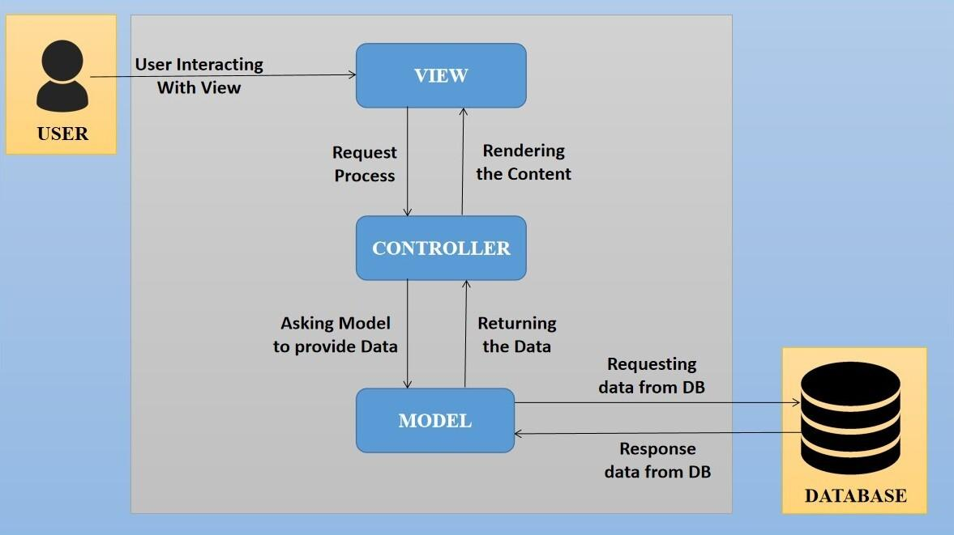

Figure 1 System Architecture

The proposed design is an architectural pattern that separates an application into three main logical

components: The **Model**, the **View** and the **Controller**. Each of these components are built to handle

specific development aspects of the application like:

* The Model component corresponds to all the data-related logic that the user works with. This can represent either the data that is being transferred between the View and Controller components or any other business logic-related data
* The View component is used for all the UI logic of the application. It generates a user interface for the user
* The controller is the component that enables the interconnection between the views and the model so it acts as an intermediary

## Interoperability Framework

Frappe is a full stack, batteries-included, web framework written in Python and JavaScript with MariaDB as the database. It is pretty generic and can be used to build database-driven apps with an elegant and consistent UI.

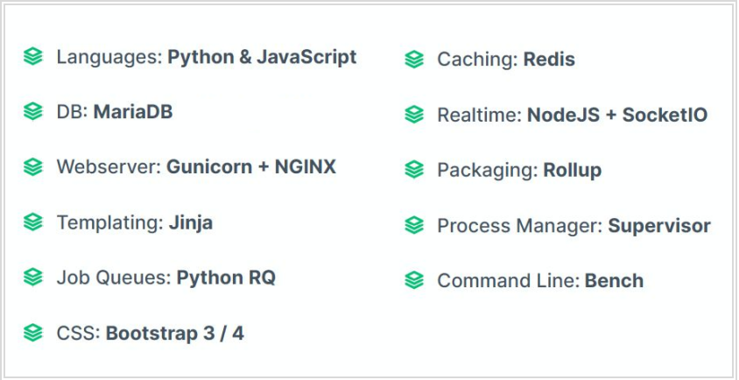

Figure 2 Framework

## Technical Decision Summary

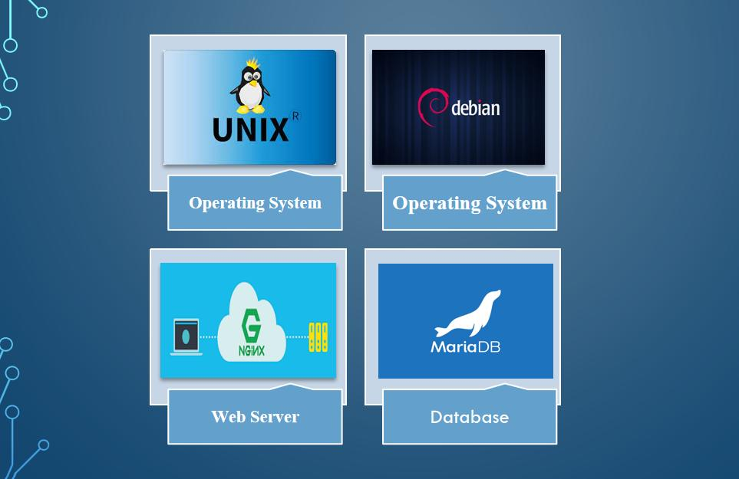

Figure 3 Technical Requirements

## Architectural Risks & Mitigation

|  |  |
| --- | --- |
| **Risks** | **Recommendation** |
| Inability to provide the required hardware resources (Server) for installation of the ERP product | The issue should be brought up during cadence meetings, and the OCAC/WSC IT team should assure timely availability of the required server |
| Unavailability of API for third party integration | The project timeline schedule needs to be shared with third parties to avoid the delay in integration. Also, inclusion of external teams to meet timelines |
| The number of users accessing the application exceeds its limit (as specified in the proposal document), leading to performance issues | WSC leadership team to ensure the scalability of the hardware / software resources |
| End Users of the application unavailable for the training to be provided by SOUL | SOUL to inform WSC Stakeholders on training plan in advance and engage early for training |

## Reference

|  |  |
| --- | --- |
| ***Sl No.*** | ***Document Name*** |
| 1 | SRS for Finance & Accounting v1.1 |
|  |  |

# Enterprise Architecture Framework (Business Architecture)

## Business Drivers

The following points motivate the business efficacy of Campus Management Software at World Skill Center (WSC) system:

* Integrate the various functions such as Admission, Academics, Examination, Training & Placement, HRMS, Procurement, Finance into a single platform which can be customized as per user requirements
* Implement a common framework for the system and sub systems
* Provide a web based application for the users to interact with the system with Role based Access and consistent look and feel

## Business Concerns

Campus Management Software At World Skill Center application is designed to address the following concerns:

Student Management: To help the students / trainers manage the students admission activities, starting from initial communication to course enrollment

Financial Management: Managing finances is a fundamental concern for businesses. This includes budgeting, cash flow management, ledger maintenance, balance sheet,etc

Employee Engagement: Attracting, retaining, and engaging skilled and motivated employees is critical. Human resources concerns also include training, performance management

Procurement management: The source-to-settle process. It encompasses the evaluation, selection, and creation of formal contractual agreements as well as managing the company's ongoing supplier relationships

## Business Goals

The goal is to implement web based Campus Management Application System for efficient internal functioning of World Skill Center (WSC) with on-line delivery of services to each stakeholder of WSC supported by a suitable, robust, secure and reliable system

## Business Value Chain

The ERP system's business value chain typically encompasses the following key components:

Procurement Management: This includes the processes related to sourcing and acquiring raw materials, goods, or services required for the organization's operations. The ERP system streamlines procurement activities, such as supplier management, purchase requisitions, purchase orders, and inventory management, leading to cost savings and better supply chain management.

Production/Operations Management: The ERP system facilitates the planning, scheduling, and execution of production processes. It optimizes resource allocation, tracks work progress, manages bills of materials, and monitors production costs to enhance overall operational efficiency and quality.

Inventory Management: The ERP system enables real-time tracking of inventory levels, stock movements, and stock outs. It helps in maintaining optimal inventory levels, reducing carrying costs, and ensuring timely availability of products.

Financial Management: ERP systems centralize financial data and automate accounting, financial reporting, budgeting, and financial analysis. This streamlines financial processes, enhances accuracy, and provides management with a clear financial overview for better decision-making.

Human Resources Management: ERP systems handle various HR functions, including payroll, employee records, recruitment, performance management, and training. This leads to streamlined HR processes, improved workforce management, and enhanced employee satisfaction.

## Business Context Diagram

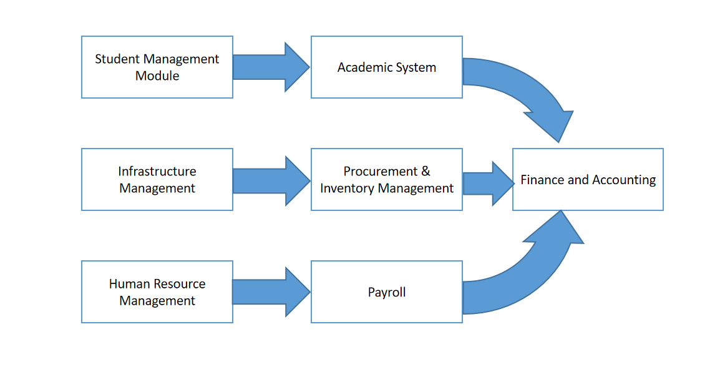

## Business Process Flow

### Accounting

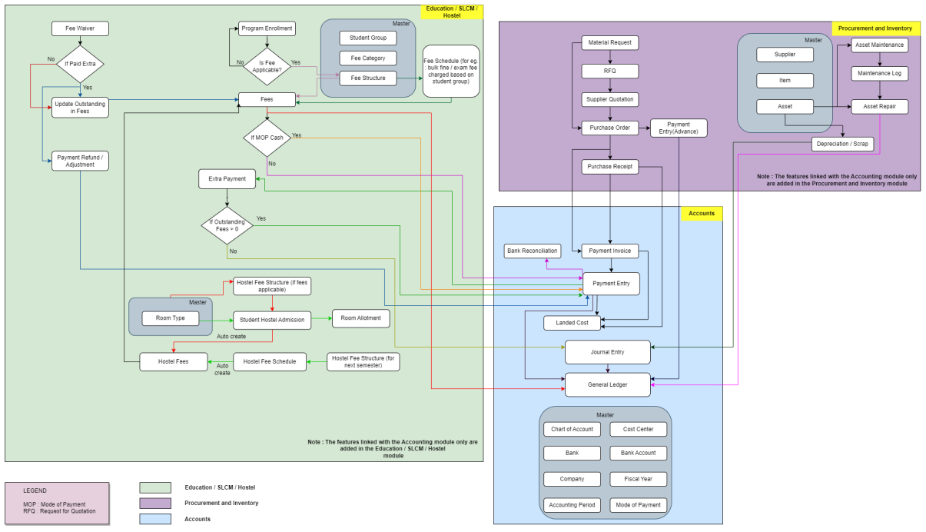

Figure : Accounting Process Flow

### System Context Diagram

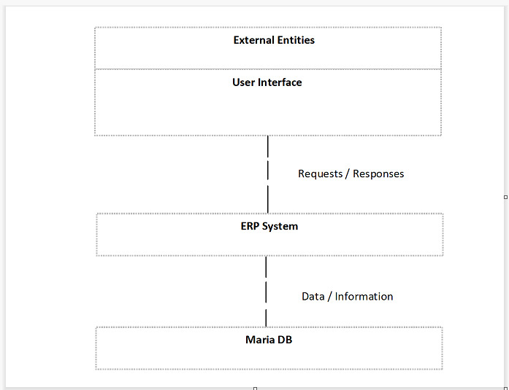

## Conceptual Architecture

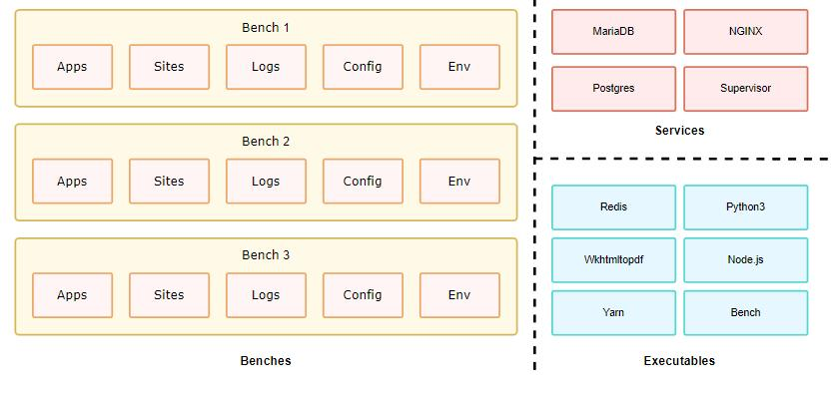

Figure 7 Multi tenant Architecture

A single bench can host multiple combinations of sites and apps. For the most part, having a single bench works for hosting hundreds of sites that depend on the same versions of said app, given you've scaled up the workers. You can host multiple versions of the application on the same server by creating multiple benches parallelly. The following diagram hints to the system dependencies and how they are used.

# Architecture Views

## Company

A company is a legal entity made up of an association of people carrying on a commercial or industrial enterprise.

You can set up multiple companies, the company structure can be parallel, i.e., sister companies, parent-child companies, or a combination of both.

### Use Case Diagram

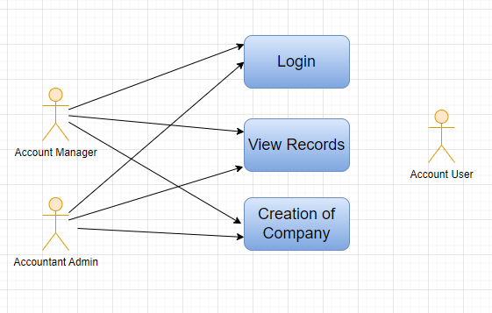

### Design Workflow

* Design workflow is not applicable to this screen as records in it are created by only one role and are not sent to users with other roles for approval or modification.

### Validations

**Client Side Validation :**

Client-side validation refers to the process of validating user input directly on the client's web browser before saving it to the server for further processing.

The following validations are done on client side for Company Screen:

* Mandatory checks for fields : Abbr, Default Currency, Country
* Linked Fields : The Default Currency field is linked with the Currency Screen. The Country field is linked with the Country Screen. The Default Holiday List is linked with the Holiday List Screen. The Default Letter Head field is linked with the Letter Head Screen. The Parent Company field is linked with the Company Screen. The Default Receivable Account field is linked with the Account Screen. The Round Off Account field is linked with the Account Screen. The Round Off Cost Center field is linked with the Account Screen. The Write Off Account field is linked with the Account Screen. The Exchange Gain / Loss Account field is linked with the Account Screen. The Default Payable Account field is linked with the Account Screen. The Default Cost Center field is linked with the Cost Center Screen. The Default Income Account field is linked with the Account Screen. The Default Finance Book field is linked with the Finance Book Screen.

**Server Side Validation :**

Server-side validation refers to the process of validating user input on the server to ensure data integrity, security, and adherence to business rules before accepting or processing the information.

No server side validation is done for Company Screen.

**Notification:**

* Not Applicable

### Field List:

|  |  |  |  |  |  |  |
| --- | --- | --- | --- | --- | --- | --- |
| **ID** | **Field Name** | **Field Type** | **Mandatory** | **Validation/Action** | **Remarks** | **R/N/D** |
|  | Abbr | Data | Yes |  |  |  |
|  | Default Currency | Link Field | Yes | Links to Currency. | Sets default currency w.r.t the company |  |
|  | Country | Link Field | Yes | Links to Country. | Sets default country w.r.t the company |  |
|  | Is Group | Checkbox | No |  |  |  |
|  | Default Holiday List | Link Field | No | Links to Holiday List. | Sets default holiday list w.r.t the company |  |
|  | Default Letter Head | Link Field | No | Links to Letter Head. | Sets default letter head w.r.t the company |  |
|  | Tax ID | Data | No |  |  |  |
|  | Domain | Data | No |  |  |  |
|  | Date of Establishment | Date | No |  |  |  |
|  | Parent Company | Link Field | No | Links to Parent Company. |  |  |
|  | Company Logo | Attach Image | No |  |  |  |
|  | Date of Incorporation | Date | No |  |  |  |
|  | Phone No | Data | No |  |  |  |
|  | Email | Data | No |  |  |  |
|  | Company Description | Text Editor | No |  |  |  |
|  | Date of Commencement | Date |  |  |  |  |
|  | Fax | Data | No |  |  |  |
|  | Website | Data | No |  |  |  |
|  | Existing Company | Link Field | No |  |  |  |
|  | Create Chart Of Accounts Based On | Dropdown | No | Options: Standard Template, Existing Company |  |  |
|  | Chart Of Accounts Template | Select | No |  |  |  |
|  | Default Buying Terms | Link Field | No | Links to buying terms. | Sets default buying terms w.r.t the company |  |
|  | Credit Limit | Currency | No |  |  |  |
|  | Transactions Annual History | Code | No | Links to Transactions Annual History. |  |  |
|  | Default Cash Account | Link Field | No | Links to Account. | Sets default cash account w.r.t the company |  |
|  | Default Receivable Account | Link Field | No | Links to Account. | Sets default Receivable account w.r.t the company |  |
|  | Round Off Account | Link Field | No | Links to Account. |  |  |
|  | Round Off Cost Center | Link Field | No | Links to Account. |  |  |
|  | Write Off Account | Link Field | No | Links to Account. |  |  |
|  | Exchange Gain / Loss Account | Link Field | No | Links to Account. |  |  |
|  | Unrealized Exchange Gain/Loss Account | Link Field | No | Links to Account. |  |  |
|  | Unrealized Profit / Loss Account | Link Field | No | Links to Account. |  |  |
|  | Allow Account Creation Against Child Company | Checkbox | No | Displays depends on if value inserted in Parent Company | If checked account will be created against child company |  |
|  | Default Payable Account | Link Field | No | Links to Account. | Sets default Payable account w.r.t the company |  |
|  | Default Income Account | Link Field | No | Links to Account. | Sets default Income account w.r.t the company |  |
|  | Default Deferred Revenue Account | Link Field | No | Links to Account. | Sets default Deferred Revenue account w.r.t the company |  |
|  | Default Deferred Expense Account | Link Field | No | Links to Account. | Sets default Expense account w.r.t the company |  |
|  | Default Payment Discount Account | Link Field | No | Links to Account. | Sets default Payment Discount account w.r.t the company |  |
|  | Default Payment Terms Template | Link Field | No | Links to Payment Terms Template. | Sets default Payment Terms Template w.r.t the company |  |
|  | Default Cost Center | Link Field | No | Links to Cost Center. | Sets default Cost Center w.r.t the company |  |
|  | Default Finance Book | Link Field | No | Links to Finance Book | Sets default Finance Book w.r.t the company |  |
|  | Enable Perpetual Inventory | Checkbox | No |  |  |  |
|  | Enable Provisional Accounting For Non Stock Items | Checkbox | No |  |  |  |
|  | Default Inventory Account | Link Field | No | Links to Inventory Account. |  |  |
|  | Stock Adjustment Account | Link Field | No | Links to Adjustment Account. |  |  |
|  | Default In-Transit Warehouse | Link Field | No | Links to In-Transit Warehouse. |  |  |
|  | Stock Received But Not Billed | Link Field | No | Links to Stock Received But Not Billed. |  |  |
|  | Default Provisional Account | Link Field | No | Links to Provisional Account. |  |  |
|  | Expenses Included In Valuation | Link Field | No |  |  |  |
|  | Accumulated Depreciation Account | Link Field | No |  |  |  |
|  | Depreciation Expense Account | Link Field | No |  |  |  |
|  | Series for Asset Depreciation Entry (Journal Entry) | Data | No |  |  |  |
|  | Expenses Included In Asset Valuation | Link Field | No |  |  |  |
|  | Gain/Loss Account on Asset Disposal | Link Field | No |  |  |  |
|  | Asset Depreciation Cost Center | Link Field | No |  |  |  |
|  | Capital Work In Progress Account | Link Field | No |  |  |  |
|  | Asset Received But Not Billed | Link Field | No |  |  |  |
|  | Exception Budget Approver Role | Link Field | No |  |  |  |
|  | Registration Details | Code | No |  |  |  |

### Processes After Form Submission

* This section is not applicable since the form is not submittable.

### Process Flow:

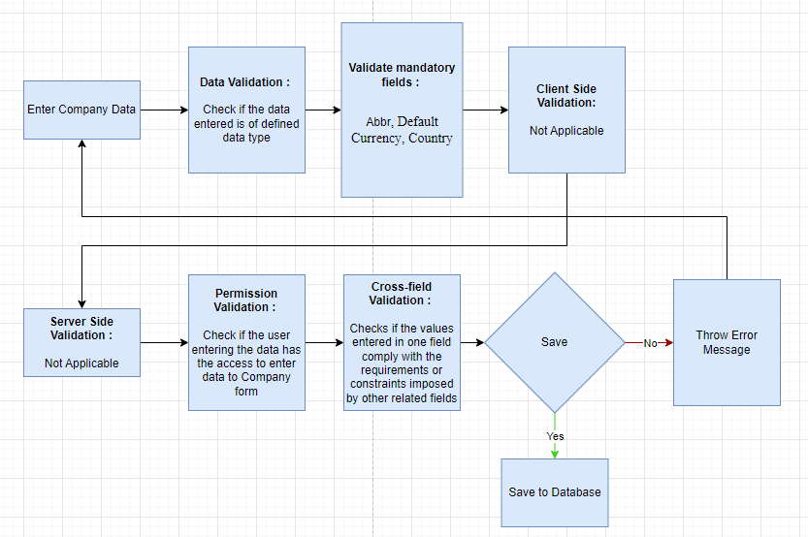

### Pre-requisites and Dependency

* Default Currency
* Country

## Account(Chart of Accounts)

The Chart of Accounts is the blueprint of the accounts in your organization.Chart of Accounts is a tree view of the names of the Accounts (Ledgers and Groups) that a Company requires to manage its books of accounts.Each of the Accounts of chart of Accounts is Link Fielded to General Ledger.

### Use Case Diagram

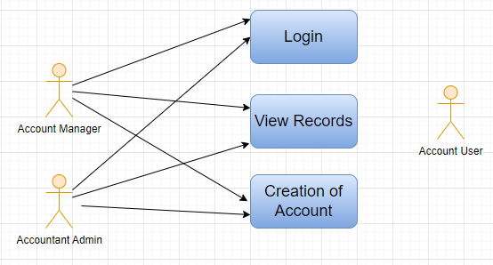

### Design of Workflow

* Design workflow is not applicable to this screen as records in it are created by only one role and are not sent to users with other roles for approval or modification.

### Validations

**Client Side Validation:**

Client-side validation refers to the process of validating user input directly on the client's web browser before saving it to the server for further processing.

The following validations are done on client side for Account Screen:

* Mandatory checks for fields: Account Name, Company, Parent Account.
* Linked Fields: The Company field is linked with the Company Screen. The Currency field is linked with the Currency Screen. The Company field is linked with the Company Screen. The Parent Account field is linked with the Account Screen.

**Server Side Validation:**

Server-side validation refers to the process of validating user input on the server to ensure data integrity, security, and adherence to business rules before accepting or processing the information.

No server side validation is done for Account Screen.

**Notification:**

* Not Applicable

### Field List:

|  |  |  |  |  |  |  |
| --- | --- | --- | --- | --- | --- | --- |
| **ID** | **Field Name** | **Field Type** | **Mandatory** | **Validation/Action** | **Remarks** | **R/N/D** |
|  | Disable | Checkbox | No | If checked account will be disabled along with the ledger |  |  |
|  | Liability | Checkbox | No | If checked account will be treated as liability |  |  |
|  | Is Group | Checkbox | No | If checked account will be treated as a group |  |  |
|  | Account Name | Data | Yes |  |  |  |
|  | Account Number | Data | No |  |  |  |
|  | Company | Link Field | Yes | Links to company | By default company will be fetched |  |
|  | Root Type | Select | No |  |  |  |
|  | Report Type | Select | No |  |  |  |
|  | Currency | Link Field | No |  |  |  |
|  | Inter Company Account | Checkbox | No |  |  |  |
|  | Parent Account | Link Field | Yes | Links to Parent Account. |  |  |
|  | Account Type | Select | No |  |  |  |
|  | Rate | Float | No |  |  |  |
|  | Frozen | Select | No |  |  |  |
|  | Balance must be | Select | No |  |  |  |

### Processes After Form Submission

* This section is not applicable since the form is not submittable.

### Process Flow:

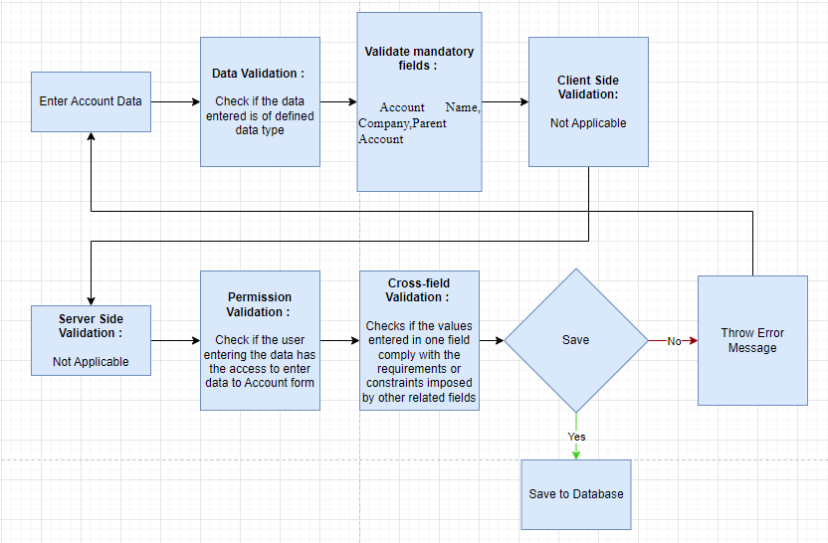

### Pre-requisites and Dependency

* Company
* Parent Account

## Fiscal Year

**A** Fiscal **Year is used to record and report the transactions for the year.**It is also known as a financial year or a budget year. It is used for calculating financial statements in businesses and other organizations. The Fiscal Year may or may not be the same as a calendar year.

### Use Case Diagram

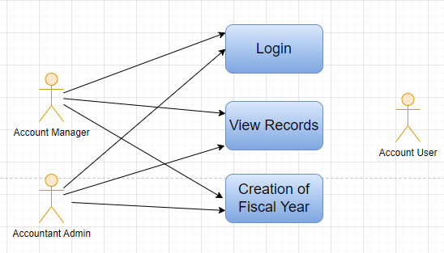

### Design of Workflow

* Design workflow is not applicable to this screen as records in it are created by only one role and are not sent to users with other roles for approval or modification.

### Validations

**Client Side Validation:**

Client-side validation refers to the process of validating user input directly on the client's web browser before saving it to the server for further processing.

The following validations are done on client side for Fiscal Year Screen:

* Mandatory checks for fields : Year Start Date, Year End Date, Companies
* Linked fields : The Company field in the Companies child table is linked with the Company Screen.

**Server Side Validation:**

Server-side validation refers to the process of validating user input on the server to ensure data integrity, security, and adherence to business rules before accepting or processing the information.

No server side validation is done for Fiscal Year Screen.

**Notification:**

* Not Applicable

### Field List:

|  |  |  |  |  |  |  |
| --- | --- | --- | --- | --- | --- | --- |
| **ID** | **Field Name** | **Field Type** | **Mandatory** | **Validation/Action** | **Remarks** | **R/N/D** |
|  | Disabled | Checkbox | No | If checked, fiscal year will be disabled |  |  |
|  | Is Short Year | Checkbox | No |  |  |  |
|  | Year Start Date | Date | Yes | Set the year's start date |  |  |
|  | Year End Date | Date | Yes | Set the year end date |  |  |
|  | Companies | Table | Yes |  | For further details regarding the table Please check below |  |

|  |  |  |  |  |  |  |
| --- | --- | --- | --- | --- | --- | --- |
| **Company** | | | | | | |
| **ID** | **Field Name** | **Field Type** | **Validation/Action** | **Mandatory** | **Remarks** | **R/N/D** |
| 1 | Company | Link Field |  | No | Default company will be fetched while adding rows |  |

### Processes After Form Submission

* This section is not applicable since the form is not submittable.

### Process Flow:

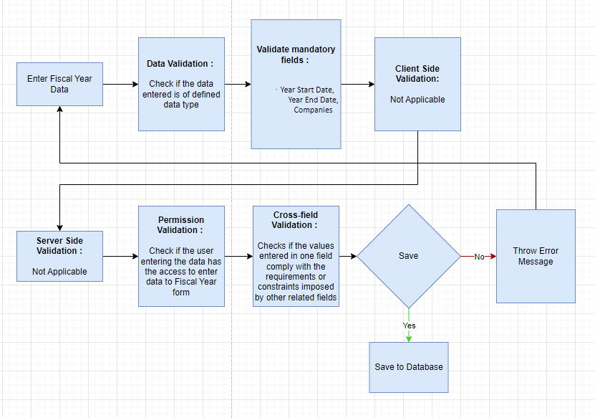

### Pre-requisites and Dependency

* Company

## Accounting Period

**An Accounting period defines a time period in which financial statements are recorded.** Accounting Period is a time frame outside which selected submit-table transactions (like Purchase Invoice, Stock Entry, Payroll Entry, Journal Entry etc) are not allowed to be created. The selected transactions are only allowed to be created within the defined Accounting Period.

### Use Case Diagram

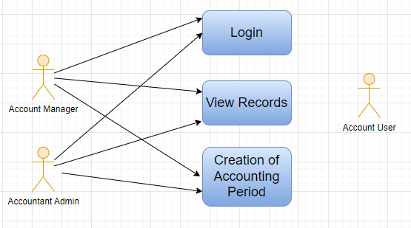

### Design of Workflow

* Design workflow is not applicable to this screen as records in it are created by only one role and are not sent to users with other roles for approval or modification.

### Validations

**Client Side Validation:**

Client-side validation refers to the process of validating user input directly on the client's web browser before saving it to the server for further processing.

The following validations are done on client side for Accounting Period Screen:

* Mandatory checks for fields : Start Date, End Date, Company, Closed Documents
* Linked fields : The Company field is linked with the Company Screen. The Document Type field in the Closed Documents child table is linked with the DocType Screen.

**Server Side Validation:**

Server-side validation refers to the process of validating user input on the server to ensure data integrity, security, and adherence to business rules before accepting or processing the information.

No server side validation is done for Accounting Period Screen.

**Notification:**

* Not Applicable

### Field List:

|  |  |  |  |  |  |  |
| --- | --- | --- | --- | --- | --- | --- |
| **ID** | **Field Name** | **Field Type** | **Mandatory** | **Validation/Action** | **Remarks** | **R/N/D** |
| 1 | Start Date | Date | Yes | Set the period start date |  |  |
| 2 | End Date | Date | Yes | Set the period end date |  |  |
| 3 | Company | Link Field | Yes | Links to Company Screen . |  |  |
| 4 | Closed Documents | Table | Yes | For further details regarding table Please check below |  |  |

|  |  |  |  |  |  |  |
| --- | --- | --- | --- | --- | --- | --- |
| **Closed Documents** | | | | | | |
| **ID** | **Field Name** | **Field Type** | **Validation/Action** | **Mandatory** | **Remarks** | **R/N/D** |
| 1 | Document Type | Link Field | Links to doc type. | Yes |  |  |
| 2 | Closed | Checkbox |  | No | If checked the corresponding documents will be disabled which means none of the users will be able to create new entries. |  |

### Processes After Form Submission

* This section is not applicable since the form is not submittable.

### Process Flow:

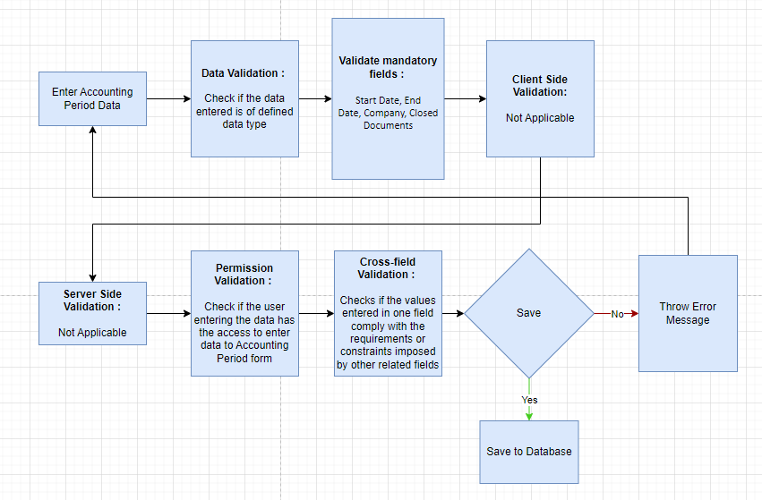

### Pre-requisites and Dependency

* Company
* Closed Documents

## Finance Book

**A Finance Book is a**book**against which all the accounting entries are booked.**

### Use Case Diagram

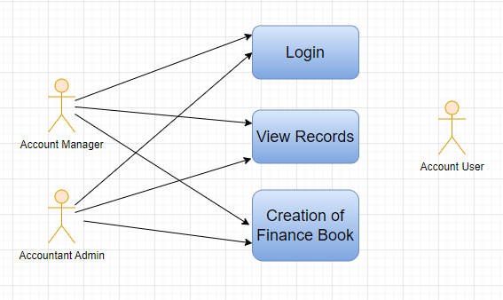

### Design of Workflow

* Design workflow is not applicable to this screen as records in it are created by only one role and are not sent to users with other roles for approval or modification.

### Validations

**Client Side Validation:**

Client-side validation refers to the process of validating user input directly on the client's web browser before saving it to the server for further processing.

The following validations are done on client side for Finance Book Screen:

* Mandatory checks for fields : None
* Linked fields : None

**Server Side Validation:**

Server-side validation refers to the process of validating user input on the server to ensure data integrity, security, and adherence to business rules before accepting or processing the information.

No server side validation is done for Finance Book Screen.

**Notification:**

* Not Applicable

### Field List:

|  |  |  |  |  |  |  |
| --- | --- | --- | --- | --- | --- | --- |
| **ID** | **Field Name** | **Field Type** | **Mandatory** | **Validation/Action** | **Remarks** | **R/N/D** |
| 1 | Name | Data | No |  |  |  |

### Processes After Form Submission

* This section is not applicable since the form is not submittable.

### Process Flow:

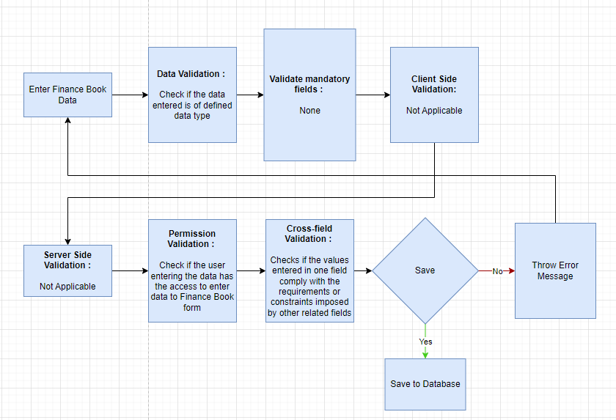

### Pre-requisites and Dependency

No Pre-requisite.

## Bank

A screen where information Bank information is stored , like Bank name,Account name details and address will be there.

### Use Case Diagram

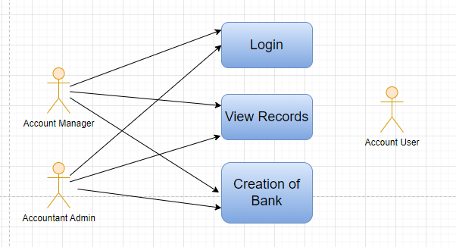

### Design of Workflow

* Design workflow is not applicable to this screen as records in it are created by only one role and are not sent to users with other roles for approval or modification.

### Validations

**Client Side Validation:**

Client-side validation refers to the process of validating user input directly on the client's web browser before saving it to the server for further processing.

The following validations are done on client side for Bank Screen:

* Mandatory checks for fields : Field in Bank Transaction, Column in Bank File
* Linked fields : None

**Server Side Validation:**

Server-side validation refers to the process of validating user input on the server to ensure data integrity, security, and adherence to business rules before accepting or processing the information.

No server side validation is done for Bank Screen.

**Notification:**

* Not Applicable

### Field List:

|  |  |  |  |  |  |  |
| --- | --- | --- | --- | --- | --- | --- |
| **ID** | **Field Name** | **Field Type** | **Mandatory** | **Validation/Action** | **Remarks** | **R/N/D** |
|  | SWIFT number | Data | No |  |  |  |
|  | Website | Data | No |  |  |  |
|  | Address HTML | HTML | No |  |  |  |
|  | Contact HTML | HTML | No |  |  |  |
|  | Bank Transaction Mapping | Table | No | For further details regarding table Please check below |  |  |
|  | Paid Access Token | Data | No |  |  |  |

|  |  |  |  |  |  |  |
| --- | --- | --- | --- | --- | --- | --- |
| **Bank Transaction Mapping** | | | | | | |
| **ID** | **Field Name** | **Field Type** | **Mandatory** | **Validation/Action** | **Remarks** | **R/N/D** |
| 1 | Field in Bank Transaction | Select | Yes |  |  |  |
| 2 | Column in Bank File | Data | Yes |  |  |  |

### Processes After Form Submission

* This section is not applicable since the form is not submittable.

### Process Flow:

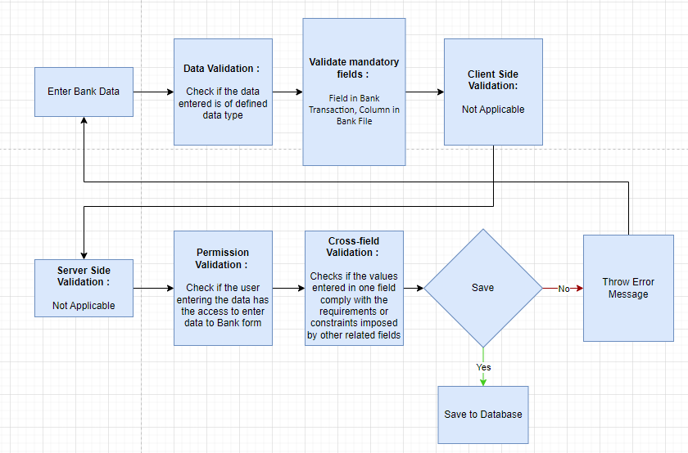

### Pre-requisites and Dependency

* No Pre-requisite.

## Bank Account

It is a screen where Bank Accounts can be created for a Company as well as other parties like Suppliers, Employee etc. Doing this lets you record all the bank transactions correctly for accounting accuracy.

### Use Case Diagram

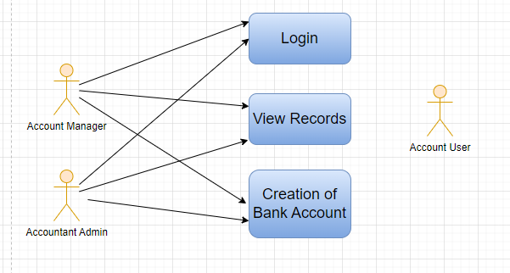

### Design of Workflow

* Design workflow is not applicable to this screen as records in it are created by only one role and are not sent to users with other roles for approval or modification.

### Validations

**Client Side Validation:**

Client-side validation refers to the process of validating user input directly on the client's web browser before saving it to the server for further processing.

The following validations are done on client side for Bank Account Screen:

* Mandatory checks for fields : Account Name, Bank
* Linked fields : The Company Account field is linked with the Company Screen. The Account Type field is linked with the Account Type Screen. The Company field is linked with the Company Screen. The Party Type field is linked with the Party Type Screen. The Party field is linked with the Party Screen.

**Server Side Validation:**

Server-side validation refers to the process of validating user input on the server to ensure data integrity, security, and adherence to business rules before accepting or processing the information.

No server side validation is done for Bank Account Screen.

**Notification:**

* Not Applicable

### Field List:

|  |  |  |  |  |  |  |
| --- | --- | --- | --- | --- | --- | --- |
| **ID** | **Field Name** | **Field Type** | **Mandatory** | **Validation/Action** | **Remarks** | **R/N/D** |
| 1 | Account Name | Data | Yes |  |  |  |
| 2 | Company Account | Link Field | No | Links to Company |  |  |
| 3 | Bank | Link Field | Yes |  |  |  |
| 4 | Account Type | Link Field | No | Links to Account Type Screen |  |  |
| 5 | Account Sub Type | Link Field | No | Links to Account Sub Type. |  |  |
| 6 | Is Default Account | Checkbox | No |  | If checked will set the account as default |  |
| 7 | Is Company Account | Checkbox | No |  |  |  |
| 8 | Company | Link Field | No | Links to Company screen. |  |  |
| 9 | Party Type | Link Field | No | Links to Party Type screen. |  |  |
| 10 | Party | Dynamic Link Field | No | Links to Party screen. |  |  |
| 11 | IBAN | Data | No |  |  |  |
| 12 | Branch Code | Data | No |  |  |  |
| 13 | Bank Account No | Data | No |  |  |  |
| 14 | Address | HTML | No |  |  |  |
| 15 | Contact | HTML | No |  |  |  |
| 16 | Integration ID | Data | No |  |  |  |
| 17 | Last Integration Date | Date | No |  |  |  |
| 18 | Mask | Data | No |  |  |  |

### Processes After Form Submission

* This section is not applicable since the form is not submittable.

### Process Flow:

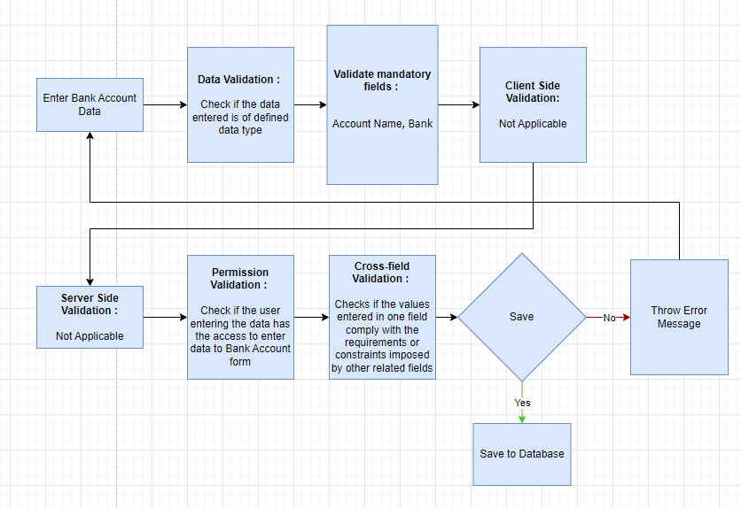

### Pre-requisites and Dependency

* Bank
* Account Name

## Mode of Payment

In purchase transactions, there are various options to settle the payment. We can do it in cash, via bank transfer, via promotion voucher to list a few. In the application, you can create Mode of Payments as per your requirement. In the Payment Entry, you can select the Mode of Payment applicable.

### Use Case Diagram

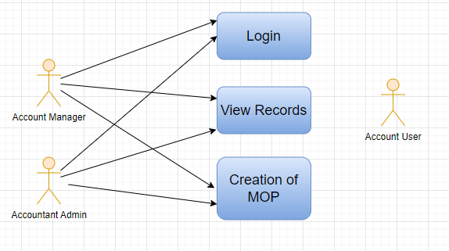

### Design of Workflow

* Design workflow is not applicable to this screen as records in it are created by only one role and are not sent to users with other roles for approval or modification.

### Validations

**Client Side Validation:**

Client-side validation refers to the process of validating user input directly on the client's web browser before saving it to the server for further processing.

The following validations are done on client side for Mode of Payment Screen:

* Mandatory checks for fields : Mode of Payment, Mode of Payment Account
* Linked fields : The Company field in Mode of Payment Account child table is linked with the Company Screen.

**Server Side Validation:**

Server-side validation refers to the process of validating user input on the server to ensure data integrity, security, and adherence to business rules before accepting or processing the information.

No server side validation is done for Mode of Payment Screen.

**Notification:**

* Not Applicable

### Field List:

|  |  |  |  |  |  |  |
| --- | --- | --- | --- | --- | --- | --- |
| **ID** | **Field Name** | **Field Type** | **Mandatory** | **Validation/Action** | **Remarks** | **R/N/D** |
| 1 | Mode of Payment | Data | Yes |  |  |  |
| 2 | Enable | Check | No | If checked then Mode of payment will be enabled. |  |  |
| 3 | is Refundable or Adjustable | Check | No | If checked then Mode of payment will be refundable or adjustable. |  |  |
| 4 | Type | Select | No |  | There are different types of Mode of Payment such as  -Cash  -Bank  -General  -Phone |  |
| 5 | Mode of Payment Account | Table | Yes |  | The description of the table is given below. |  |

|  |  |  |  |  |  |  |
| --- | --- | --- | --- | --- | --- | --- |
| **Mode of payment Account** | | | | | | |
| **ID** | **Field Name** | **Field Type** | **Validation/Action** | **Mandatory** | **Remarks** | **R/N/D** |
| 1 | Company | Link Field |  | No | Default company will be fetched while adding rows |  |
| 2 | Default Account | Link Field |  | No |  |  |

### Processes After Form Submission

* This section is not applicable since the form is not submittable.

### Process Flow:

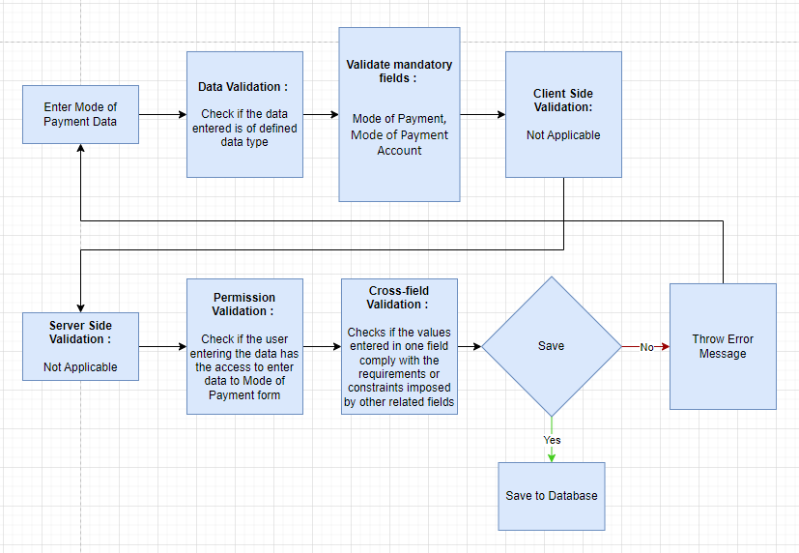

### Pre-requisites and Dependency

* Account

## Currency

The Currency list stores the currency value, it's symbol and fraction unit. Most of the commonly used currencies are already present in the application.

### Use Case Diagram

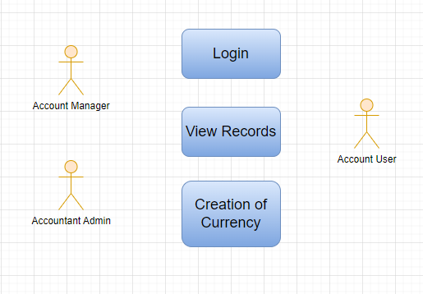

### Design of Workflow

* Design workflow is not applicable to this screen as records in it are created by only one role and are not sent to users with other roles for approval or modification.

### Validations

**Client Side Validation:**

Client-side validation refers to the process of validating user input directly on the client's web browser before saving it to the server for further processing.

The following validations are done on client side for Currency Screen:

* Mandatory checks for fields : Currency Name
* Linked fields : None

**Server Side Validation:**

Server-side validation refers to the process of validating user input on the server to ensure data integrity, security, and adherence to business rules before accepting or processing the information.

No server side validation is done for Currency Screen.

**Notification:**

* Not Applicable

### Field List:

|  |  |  |  |  |  |  |
| --- | --- | --- | --- | --- | --- | --- |
| **ID** | **Field Name** | **Field Type** | **Mandatory** | **Validation/Action** | **Remarks** | **R/N/D** |
| 1 | Currency Name | Data | Yes |  |  |  |
| 2 | Enabled | Check | No |  |  |  |
| 3 | Fraction | Data | No |  |  |  |
| 4 | Fraction Units | Number | No |  |  |  |
| 5 | Smallest Currency Fraction Value | Currency | No |  |  |  |
|  | Symbol | Data | No |  |  |  |
|  | Show Currency Symbol on Right Side | Check | No | Currency Symbol will appear to the left of the amount by default if not checked | This will determine where the currency side will appear beside the amount |  |
|  | Number Format | Select | No |  | How should this currency be formatted? If not set, will use system defaults |  |

### Processes After Form Submission

* This section is not applicable since the form is not submittable.

### Process Flow:

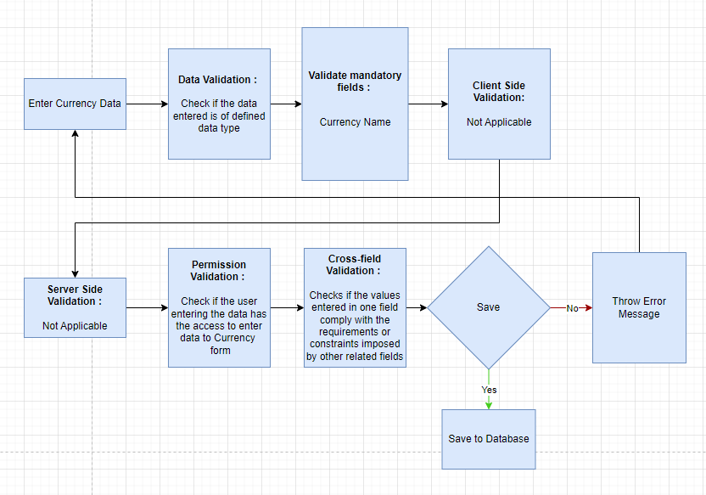

### Pre-requisites and Dependency

* No prerequisite

## Party Type

 This can be Supplier or Student or Employee.

### Use Case Diagram

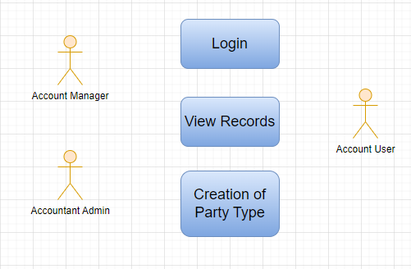

### Design of Workflow

* Design workflow is not applicable to this screen as records in it are created by only one role and are not sent to users with other roles for approval or modification.

### Validations

**Client Side Validation:**

Client-side validation refers to the process of validating user input directly on the client's web browser before saving it to the server for further processing.

The following validations are done on client side for Party Type Screen:

* Mandatory checks for fields : Party Type, Account Type
* Linked fields : The Party Type field is linked with the DocType Screen.

**Server Side Validation:**

Server-side validation refers to the process of validating user input on the server to ensure data integrity, security, and adherence to business rules before accepting or processing the information.

No server side validation is done for Party Type Screen.

**Notification:**

* Not Applicable

### Field List:

|  |  |  |  |  |  |  |
| --- | --- | --- | --- | --- | --- | --- |
| **ID** | **Field Name** | **Field Type** | **Mandatory** | **Validation/Action** | **Remarks** | **R/N/D** |
| 1 | Party Type | Link Field | Yes | This field links to DocType |  |  |
| 2 | Account Type | Select | Yes | This field have options: Payable and Receivable |  |  |

### Processes After Form Submission

* This section is not applicable since the form is not submittable.

### Process Flow:

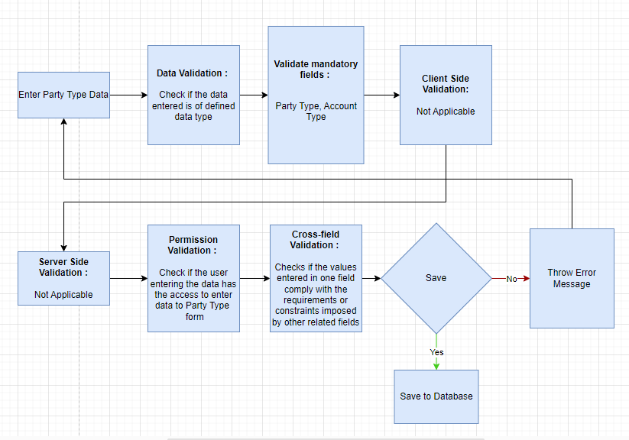

### Pre-requisites and Dependency

* No prerequisite

## Cost Center

A Cost Center is a part of an organization where costs or income can be charged.

### Use Case Diagram

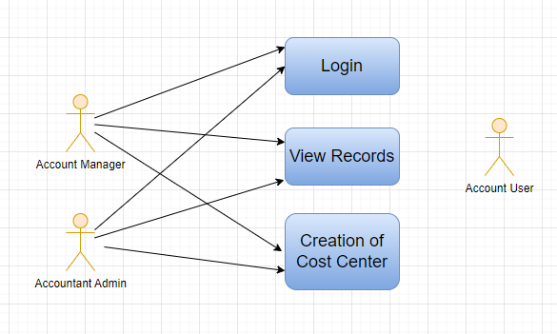

### Design of Workflow

* Design workflow is not applicable to this screen as records in it are created by only one role and are not sent to users with other roles for approval or modification.

### Validations

**Client Side Validation:**

Client-side validation refers to the process of validating user input directly on the client's web browser before saving it to the server for further processing.

The following validations are done on client side for Cost Center Screen:

* Mandatory checks for fields : Cost Center Name, Parent Cost Center, Company
* Fields displayed on condition : Not Applicable
* Linked fields : The Parent Cost Center field is linked with the Cost Center Screen. The Company field is linked with the Company Screen.

Server Side Validation:

Server-side validation refers to the process of validating user input on the server to ensure data integrity, security, and adherence to business rules before accepting or processing the information.

No server side validation is done for Cost Center Screen.

Notification:

* Not Applicable

### Field List:

|  |  |  |  |  |  |  |
| --- | --- | --- | --- | --- | --- | --- |
| **ID** | **Field Name** | **Field Type** | **Mandatory** | **Validation/ Action** | **Remarks** | **R/N/D** |
| 1 | Cost Center Name | Data | Yes |  |  |  |
| 2 | Cost Center Number | Data |  |  |  |  |
| 3 | Parent Cost Center | Link | Yes |  |  |  |
| 4 | Company | Link | Yes | Link Fields to Master Screen Company | Default company name will be fetched |  |
| 5 | Is Group | Checkbox |  | If checked will create a group which can is visible under tree view |  |  |
| 6 | Disabled | Checkbox |  | If checked the cost center will be disabled |  |  |
| 7 | Update Cost Center Name / Number Button | | | On click you can update two fields i.e. Cost Center Name and Cost Center Number | Click this button to update cost center name or number |  |
| 8 | Convert to Group Button | | | Cost Center with existing transactions cannot be converted to group | Click this button to activate is group checkbox and make it a group which will be reflected under Chart of Cost Centers(tree view) |  |
| 9 | Chart of Cost Centers Button | | |  | This will open the tree view of cost centers |  |
| 10 | Budget Button | | |  | This will open the Budget screen of the application |  |

### 

### Processes After Form Submission

* This section is not applicable since the form is not submittable.

### Process Flow:

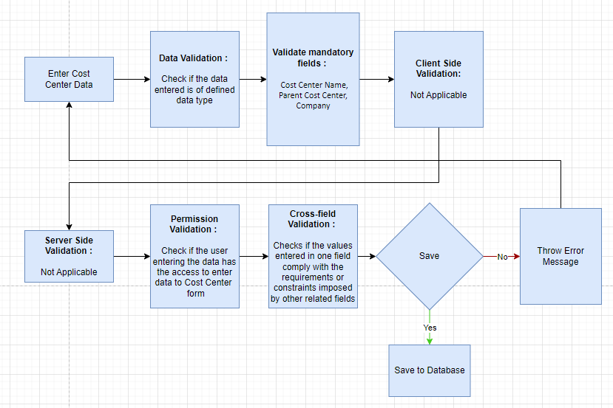

### Pre-requisites and Dependency

* Company

## Accounting Dimension

In the application you can create configurable accounting dimensions and use them in transactions and reports. Dimensional accounting means tagging each transaction with appropriate dimensions like Branch, Business Unit, etc. This allows you to maintain each segment separately, thereby limiting the overall maintenance on GL accounts and your Chart of Accounts remains pure.

### Use Case Diagram

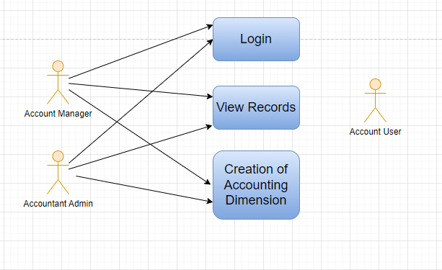

### 

### Design of Workflow

* Design workflow is not applicable to this screen as records in it are created by only one role and are not sent to users with other roles for approval or modification.

### Validations

**Client Side Validation:**

Client-side validation refers to the process of validating user input directly on the client's web browser before saving it to the server for further processing.

The following validations are done on client side for Accounting Dimension Screen:

* Mandatory checks for fields : Reference Document Type
* Fields displayed on condition : Not Applicable
* Linked fields: The Reference Document Type field is linked with the DocType Screen. The Company field in Dimension Default child table is linked with the Company Screen.

**Server Side Validation:**

Server-side validation refers to the process of validating user input on the server to ensure data integrity, security, and adherence to business rules before accepting or processing the information.

No server side validation is done for Accounting Dimension Screen.

**Notification:**

* Not Applicable

### Field List:

|  |  |  |  |  |  |  |
| --- | --- | --- | --- | --- | --- | --- |
| **ID** | **Field Name** | **Field Type** | **Mandatory** | **Validation/ Action** | **Remarks** | **R/N/D** |
| 1 | Reference Document Type | Link | Yes |  | The Doc-type whose values are required as accounting dimension |  |
| 2 | Dimension Name | Data |  | Same as Reference Document Type |  |  |
| 3 | Fieldname | Data |  |  |  |  |
| 4 | Dimension Defaults | Table |  |  | Description of the table is given below |  |
| 5 | Disable | Checkbox |  | Disables the accounting dimension if checked |  |  |
|  | Show ““Reference Document Type”” button | | |  | This will redirect to the “Reference Document Type” |  |
|  | Enable/Disable button | | |  | This will enable/disable the accounting dimension |  |

|  |  |  |  |  |  |  |  |
| --- | --- | --- | --- | --- | --- | --- | --- |
| **Dimension Default (Accounting Dimension Detail)** | | | | | | | |
| **ID** | **Field Name** | **Field Type** | **Mandatory** | **Validation / Action** | | **Remarks** | **R/N/D** |
| 1 | Company | Link Field |  | This will fetch the default company of the application |  | |  |
| 2 | Reference Document | Link Field |  | This field is hidden |  | |  |
| 3 | Default Dimension | Dynamic Link Field |  |  | This is where you can mention company specific default dimensions.This dimension will be automatically fetched in the transaction against that specific company. | |  |
| 4 | Mandatory For Balance Sheet | Checkbox |  |  | Check "Mandatory" checkbox if you want the dimension to be mandatory in the transactions | |  |
| 5 | Mandatory For Profit and Loss Account | Checkbox |  |  | Check "Mandatory" checkbox if you want the dimension to be mandatory in the transactions | |  |

### Processes After Form Submission

* This section is not applicable since the form is not submittable.

### Process Flow:

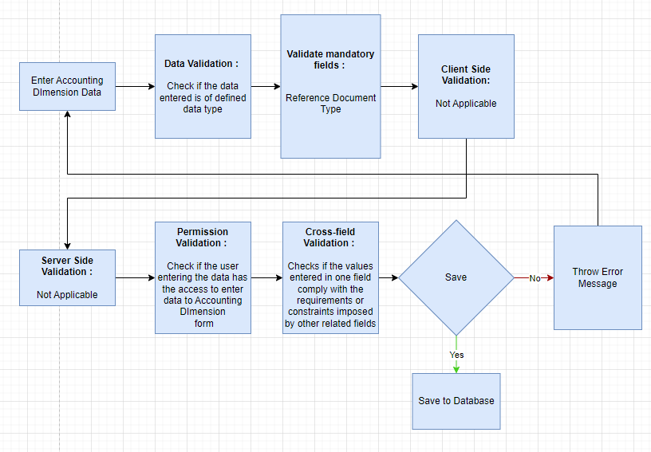

### Pre-requisites and Dependency

* Reference Document Type

## Journal Entry

A Journal Entry is an entry made in the general ledger and it indicates the affected accounts.

### Use Case Diagram

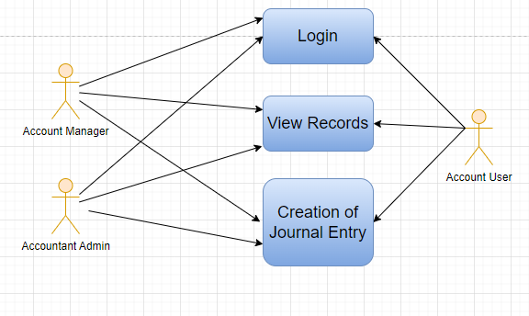

### Design of Workflow

* Design workflow is not applicable to this screen as records in it are created by only one role and are not sent to users with other roles for approval or modification.

### Validations

**Client Side Validation:**

Client-side validation refers to the process of validating user input directly on the client's web browser before saving it to the server for further processing.

The following validations are done on client side for Journal Entry Screen:

* Mandatory checks for fields : Entry Type, Company, Posting Date, Accounting Entries
* Fields displayed on condition : Not Applicable
* Linked fields : The Finance Book field is linked with the Finance Book Screen. The Process Deferred Accounting field is linked with the Process Deferred Accounting Screen. The Reversal Of field is linked with the Journal Entry Screen. The Tax Withholding Category field is linked with the Tax Category Screen. The From Template field is linked with the Journal Entry Template Screen. The Company field is linked with the Company Screen.

**Server Side Validation:**

Server-side validation refers to the process of validating user input on the server to ensure data integrity, security, and adherence to business rules before accepting or processing the information.

The following are the validations in the Journal Entry screen:

* Validate - This contains the validations and logic when the form is saved
* On_submit - This contains the validations and logic when the form is submit
* On_cancel - This contains the validations and logic when the form is canceled

**Notification:**

* Not Applicable

### Field List:

|  |  |  |  |  |  |  |
| --- | --- | --- | --- | --- | --- | --- |
| **ID** | **Field Name** | **Field Type** | **Mandatory** | **Validation/ Action** | **Remarks** | **R/N/D** |
|  | Title | Text |  |  |  |  |
|  | Entry Type | Dropdown | Yes | Options:  Journal Entry  Inter Company Journal Entry  Bank Entry  Cash Entry  Credit Card Entry  Debit Note  Credit Note  Contra Entry  Excise Entry  Write Off Entry  Opening Entry  Depreciation Entry  Exchange Rate Revaluation  Deferred Revenue  Deferred Expense |  |  |
|  | Finance Book | Link Field |  | Link Fields to Finance Book Screen |  |  |
|  | Process Deferred Accounting | Link Field |  | Link Fields to Process Deferred Accounting Screen |  |  |
|  | Reversal Of | Link Field |  | Link Fields to Journal Entry Screen |  |  |
|  | Tax Withholding Category | Link Field |  | Link Fields to Tax Withholding Category Screen |  |  |
|  | From Template | Link Field |  | Link Fields to Journal Entry Template Screen |  |  |
|  | Company | Link Field | Yes | Link Fields to Company Screen |  |  |
|  | Posting Date | Date | Yes |  |  |  |
|  | Apply Tax Withholding Amount | Checkbox |  |  |  |  |
|  | Accounting Entries | Table | Yes | Journal Entry Account |  |  |
|  | Reference Number | Text |  |  |  |  |
|  | Reference Date | Date |  |  |  |  |
|  | User Remark | Small Text |  |  |  |  |
|  | Total Debit | Currency |  |  |  |  |
|  | Total Credit | Currency |  |  |  |  |
|  | Difference (Dr - Cr) | Currency |  |  |  |  |
|  | Make Difference Entry | Button |  |  |  |  |
|  | Multi Currency | Check box |  |  |  |  |
|  | Total Amount Currency | Link Field |  | Link Fields to Currency Screen |  |  |
|  | Total Amount | Currency |  |  |  |  |
|  | Total Amount in Words | Text |  |  |  |  |
|  | Clearance Date | Date |  |  |  |  |
|  | Remark | Small Text |  |  |  |  |
|  | Paid Loan | Text |  |  |  |  |
|  | Bill No | Text |  |  |  |  |
|  | Bill Date | Date |  |  |  |  |
|  | Due Date | Date |  |  |  |  |
|  | Get Outstanding Invoices | Button |  |  |  |  |
|  | Pay To / Recd From | Text |  |  |  |  |
|  | Letter Head | Link Field |  | Link Fields to Letter Head Screen |  |  |
|  | Print Heading | Link Field |  | Link Fields to Print Heading Screen |  |  |
|  | Mode of Payment | Link Field |  | Link Fields to Mode of Payment Screen |  |  |
|  | Payment Order | Link Field |  | Link Fields to Payment Order Screen |  |  |
|  | Is Opening | Dropdown |  | Options  No  Yes |  |  |
|  | Stock Entry | Link Fields |  | Link Fields to Stock Entry Screen |  |  |
|  | Auto Repeat | Link Fields |  | Link Fields to Auto Repeat Screen |  |  |
|  | Quick Entry | | | Action Button | On Click a Popup will open and the user need to enter the Credit account, Debit account, date, etc. |  |
|  | Amount | Text | Yes |  | On Click the Quick Entry Button, this field will visible inside a popup. |  |
|  | Debit Account | Link Field | Yes | Link Field to Account Screen | On Click the Quick Entry Button, this field will visible inside a popup. |  |
|  | Credit Account | Link Field | Yes |  | On Click the Quick Entry Button, this field will visible inside a popup. |  |
|  | Date | Date | Yes |  | On Click the Quick Entry Button, this field will visible inside a popup. |  |
|  | User Remark | Long Text |  |  | On Click the Quick Entry Button, this field will visible inside a popup. |  |
|  | Series | Naming Series | Yes | Create the unique naming series for the records. | On Click the Quick Entry Button, this field will visible inside a popup. |  |
|  | View --> Ledger (Custom Button) | | |  | On click the General Ledger Screen will open in report view. |  |
|  | Action --> Reverse Journal Entry (Custom Button) | | |  | It Creates another new record when user can do reverse journal entry. |  |

### 

### Processes After Form Submission

* This section is not applicable since the form has no workflow based on submission.

### Process Flow:

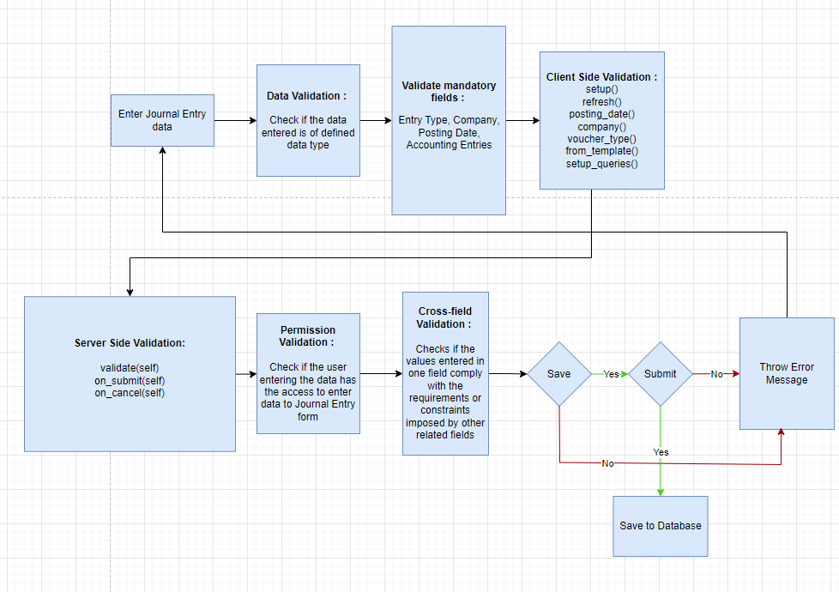

### Pre-requisites and Dependency

* Company
* Finance Book
* Journal Entry Template
* Account
* Party Type
* Party
* Letter Head
* Print Heading
* Mode of Payment

## GL Entry

A general ledger (GL) is a set of numbered accounts a business uses to keep track of its financial transactions and to prepare financial reports.

### Use Case Diagram

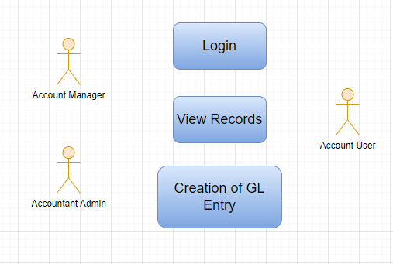

### 

### Design of Workflow

* Design workflow is not applicable to this screen as records in it are created by only one role and are not sent to users with other roles for approval or modification.

### 

### Validations

**Client Side Validation:**

Client-side validation refers to the process of validating user input directly on the client's web browser before saving it to the server for further processing.

The following validations are done on client side for GL Entry Screen:

* Mandatory checks for fields : None
* Fields displayed on condition : Not Applicable
* Linked fields : The Account field is linked to the Account Screen. The Party Type field is linked to the Party Type Screen. The Cost Center field is linked to the Cost Center Screen. The Account Currency field is linked to the Account Currency Screen.

**Server Side Validation:**

Server-side validation refers to the process of validating user input on the server to ensure data integrity, security, and adherence to business rules before accepting or processing the information.

No server side validation is done for GL Entry Screen.

**Notification:**

* Not Applicable

### Field List:

|  |  |  |  |  |  |  |
| --- | --- | --- | --- | --- | --- | --- |
| **ID** | **Field Name** | **Field Type** | **Mandatory** | **Validation/Action** | **Remarks** | **R/N/D** |
| 1 | Posting Date | Date |  |  |  |  |
| 2 | Transaction Date | Date |  |  |  |  |
| 3 | Account | Link Field |  | Link Field to Account Screen |  |  |
| 4 | Party Type | Link Field |  | Link Field to Party Type Screen |  |  |
| 5 | Party | Dynamic Link |  |  |  |  |
| 6 | Cost Center | Link Field |  | Link Field to Party Type Screen |  |  |
| 7 | Debit Amount | Currency |  |  |  |  |
| 8 | Credit Amount | Currency |  |  |  |  |
| 9 | Account Currency | Link Field |  | Link Field to Currency Screen |  |  |

### Processes After Form Submission

* This section is not applicable since the form is not submittable.

### Process Flow:

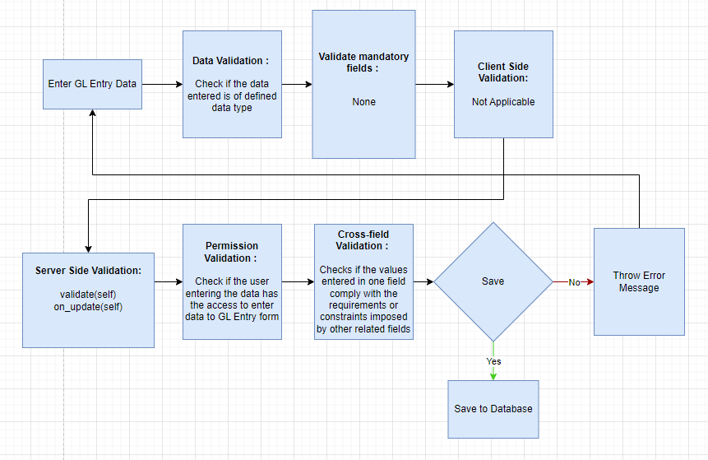

### Pre-requisites and Dependency

* No prerequisite

## General Ledger

The General Ledger is a detailed report for all transactions posted to each account and for every transaction there is a Credit and Debit account so it lists them all up.

### Use Case Diagram

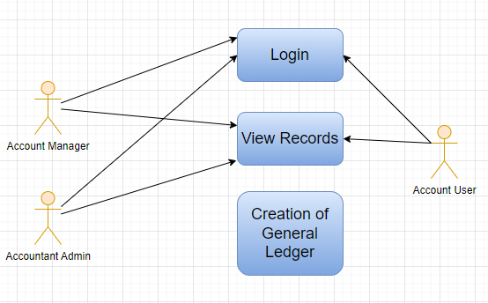

### Design of Workflow

* Design workflow is not applicable to this screen as records in it are created by only one role and are not sent to users with other roles for approval or modification.

### Validations

The data entered on this page will undergo a 2 step validation (I.e. client side and server side validation).

The following validation is done on client side:

1. Fields creation for Filters

The following validation is done on server side before save:

1. Get data
2. Get Column

After successful validation check from both client-side and server-side the result in the reports will be shown to user based on the filter that they have set.

**Client Side Validation**

Client-side validation refers to the process of validating user input directly on the client's web browser before saving it to the server for further processing. Following are some client side validations done for vendor selection report.

* **Field creation for From Date, To date, Company etc :**

Under filters assign fieldname, label, fieldtype, width, reqd and values for each of the filter values you want

**Server Side Validation**

Server-side validation refers to the process of validating user input on the server to ensure data integrity, security, and adherence to business rules before accepting or processing the information. Following are some server side validations done for vendor selection report.

* **Get_data**

1. Get value passed in filter for From date, To date
2. Write a query to get all necessary fields from Asset table
3. Return the data fetched through execution of query

* **Get_columns**

1. Pass values for label, fieldname, fieldtype, options and width of the column to be created
2. Return the columns value to create all columns

**Notification:**

* This section is not applicable since there is no notifications to be triggered

### Field List:

**Filter Fields**

|  |  |  |  |  |  |  |
| --- | --- | --- | --- | --- | --- | --- |
| **ID** | **Input Fields** | **Field Type** | **Mandatory** | **Validation/ Action** | **Remarks** | **R/N/D** |
|  | Company | Link Field |  | Link Fields to Company Screen |  |  |
|  | Finance Book | Link Field |  | Link Fields to Finance Book Screen |  |  |
|  | From Date | Date |  | From date should be before the To date |  |  |
|  | To Date | Date |  | To date should be after from date |  |  |
|  | Account | Link Field |  | Link Fields to Account Screen |  |  |
|  | Voucher No | Text |  |  |  |  |
|  | Party Type | Link Field |  | Link Fields to Customer, Supplier, Student, Employee Screen |  |  |
|  | Party | Link Field |  | Link fields depends upon the party type |  |  |
|  | Group Name | Dropdown |  | Options:   1. Group by Voucher 2. Group by Voucher (Consolidated) 3. Group by Account 4. Group by Party |  |  |
|  | Currency | Dropdown |  | Options:   1. AED 2. AUD 3. CHF 4. CNY 5. EUR 6. GBP 7. INR 8. JPY 9. USD |  |  |
|  | Cost Center | Link Field |  | Link Fields to Cost Center Master Screen |  |  |
|  | Project | Link Field |  | Link Fields to Project Screen |  |  |
|  | Consider Accounting Dimensions | Check box |  | On Check Accounting Dimensions will be considered. |  |  |
|  | Show Opening Entries | Check box |  | On Check It will show the Opening Entries only. |  |  |
|  | Include Default Book Entries | Check box |  | On Check It includes default book entries |  |  |
|  | Show Cancelled Entries | Check box |  | On Check It will show only Cancelled entries. |  |  |
|  | Show Net Values in Party Account | Check box |  | On Check It shows the net values in Party Account |  |  |

|  |  |  |
| --- | --- | --- |
| **ID** | **Column Name** | **Description** |
|  | Posting Date | It is the document posting date |
|  | Account | Name of the Account Type |
|  | Debit | Debited Amount |
|  | Credit | Credited Amount |
|  | Balance | Debit - Credit = Balance |
|  | Voucher Type | Different Types of Vouchers like Purchase Receipt, Stock Entry, etc. |
|  | Voucher No | Voucher no. is based on the voucher type. |
|  | Against Account | Different Types of Vouchers like Purchase Receipt, Stock Entry, etc. |
|  | Party Type | Voucher no. is based on the voucher type. |
|  | Party | A specific Supplier, Customer or Student depending on the option you choose for the Party Type. |
|  | Cost Center | It is a part of an organization where costs or income can be charged. |
|  | Project | Name of the Project |
|  | Against Voucher Type | Payment made against a particular voucher type. |
|  | Against Voucher | Payment made against a particular voucher number. |
|  | Supplier Invoice No | Shows the Supplier Invoice Number. |
|  | Remarks | Remarks given w.r.t. the Party Name |

### Processes After Form Submission

* This section is not applicable since the form is not submittable.

### Process Flow:

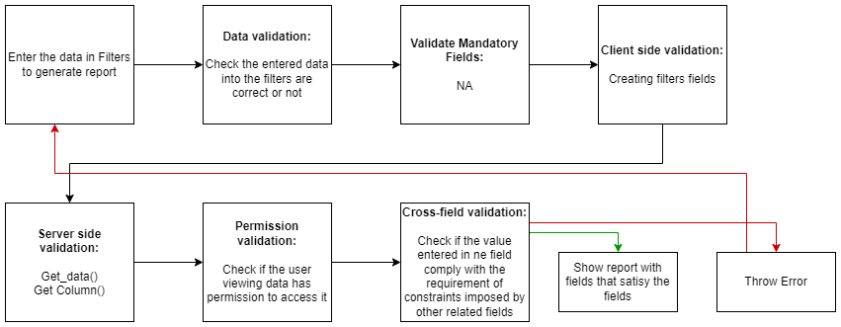

### Pre-requisites and Dependency

* Company
* Finance Book
* Account

## Payment Entry

Payment Entry is a record indicating that payment has been made for an invoice.

### Use Case Diagram

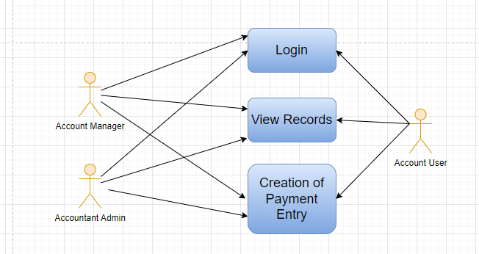

### 

### Design of Workflow

* Design workflow is not applicable to this screen as records in it are created by only one role and are not sent to users with other roles for approval or modification.

### Validations

**Client Side Validation:**

Client-side validation refers to the process of validating user input directly on the client's web browser before saving it to the server for further processing.

The following validations are done on client side for Payment Entry Screen:

* Mandatory checks for fields : Payment Type, Posting Date, Company, Account Paid From, Account Currency (From), Account Paid To, Account Currency (To), Paid Amount, Source Exchange Rate, Paid Amount (Company Currency), Received Amount, Received Amount (Company Currency), Target Exchange Rate
* Linked fields : The Company is linked to the Company Screen. The Mode of Payment field is linked to the Mode of Payment screen. The Party Type field is linked to the to Employee, Customer, Student, Share holder, Supplier Screen. The Company Bank Account field is linked to the Account screen. The Party Bank Account is linked to the Account screen. The Contact is linked to the Contact screen. The Account Paid From is linked to the Account screen. The Account Currency (From) is linked to the Currency screen. The Account Paid To is linked to the Currency screen. The Account Currency (From) is linked to the Currency screen. The Account Currency (To) is linked to the Currency screen.

**Server Side Validation:**

Server-side validation refers to the process of validating user input on the server to ensure data integrity, security, and adherence to business rules before accepting or processing the information.

The following are the validations in the Payment Entry screen:

* Validate - This contains the validations and logic when the form is saved
* On_submit - This contains the validations and logic when the form is submit
* On_cancel - This contains the validations and logic when the form is canceled

**Notification:**

* Email notification will be sent to the student on payment success

### Field List:

|  |  |  |  |  |  |  |
| --- | --- | --- | --- | --- | --- | --- |
| **ID** | **Field Name** | **Field Type** | **Mandatory** | **Validation/ Action** | **Remarks** | **R/N/D** |
|  | Payment Type | Dropdown | Yes | Options:  Receive Pay Internal Transfer |  |  |
|  | Payment Order Status | Dropdown |  | Options:  Initiated  Payment Ordered |  |  |
|  | Posting Date | Date | Yes |  |  |  |
|  | Company | Link Field | Yes | Link Field to Company Screen |  |  |
|  | Mode of Payment | Link Field |  | Link Field to Mode of Payment Screen |  |  |
|  | Party Type | Link Field |  | Link Field to Employee, Customer, Student, Share holder, Supplier Screen |  |  |
|  | Party | Dynamic Link |  | On the basis of Party Type selected by the user, Dynamic Link Field will be visible accordingly. |  |  |
|  | Party Name | Text |  | Auto fetched when Party entered |  |  |
|  | Company Bank Account | Link Field |  | Link Field to Account Screen |  |  |
|  | Party Bank Account | Link Field |  | Link Field to Account Screen |  |  |
|  | Contact | Link Field |  | Link Field to Contact Screen |  |  |
|  | Email | Text |  |  |  |  |
|  | Party Balance | Currency |  |  |  |  |
|  | Account Paid From | Link Field | Yes | Link Field to Account Screen | When user entered payment type equal to Internal transfer then only this field will be visible. |  |
|  | Paid From Account Type | Text |  |  |  |  |
|  | Account Currency (From) | Link Field | Yes | Link Field to Currency Screen | It will be visible When Account Paid From data is entered |  |
|  | Account Balance (From) | Currency |  |  |  |  |
|  | Account Paid To | Link Field | Yes | Link Field to Currency Screen | When user entered payment type equal to Internal transfer then only this field will be visible. |  |
|  | Paid To Account Type | Text |  |  |  |  |
|  | Account Currency (To) | Link Field | Yes | Link Field to Currency Screen | It will be visible When Account Paid To data is entered |  |
|  | Account Balance (To) | Currency |  |  | It will be visible When Account Paid To data is entered |  |
|  | Paid Amount | Currency | Yes |  | It will be visible When Account Paid To data is entered |  |
|  | Paid Amount After Tax | Currency |  |  |  |  |
|  | Source Exchange Rate | Float | Yes |  |  |  |
|  | Paid Amount (Company Currency) | Currency | Yes |  |  |  |
|  | Paid Amount After Tax (Company Currency) | Currency |  |  |  |  |
|  | Received Amount | Currency | Yes |  | It will be visible When Account Paid To data is entered |  |
|  | Received Amount After Tax | Currency |  |  |  |  |
|  | Target Exchange Rate | Float | Yes |  |  |  |
|  | Received Amount (Company Currency) | Currency | Yes |  |  |  |
|  | Received Amount After Tax (Company Currency) | Currency |  |  |  |  |
|  | Get Outstanding Invoice | Button |  |  |  |  |
|  | **Payment References** | Table |  |  |  |  |
|  | Total Allocated Amount | Currency |  |  |  |  |
|  | Total Allocated Amount (Company Currency) | Currency |  |  |  |  |
|  | Set Exchange Gain / Loss | Button |  |  |  |  |
|  | Unallocated Amount | Currency |  |  |  |  |
|  | Difference Amount (Company Currency) | Currency |  |  |  |  |
|  | Write Off Difference Amount | Button |  |  |  |  |
|  | Purchase Taxes and Charges Template | Link Field |  | Link Field to Purchase Taxes and Charges Template Screen |  |  |
|  | Apply Tax Withholding Amount | Checkbox |  |  |  |  |
|  | Tax Withholding Category | Link Field |  | Link Field to Tax Withholding Category Screen |  |  |
|  | **Advance Taxes and Charges** | Table |  |  |  |  |
|  | Total Taxes and Charges (Company Currency) | Currency |  |  |  |  |
|  | Total Taxes and Charges | Currency |  |  |  |  |
|  | **Payment Deductions or Loss** | Table |  |  |  |  |
|  | Cheque/Reference No | Text |  |  | It will visible When Mode of Payment equals to Cheque |  |
|  | Cheque/Reference Date | Date |  |  | It will visible When Mode of Payment equals to Cheque |  |
|  | Clearance Date | Date |  |  |  |  |
|  | Project | Link Field |  | Link Field to Project Screen |  |  |
|  | Cost Center | Link Field |  | Link Field to Cost Center Screen |  |  |
|  | Status | Dropdown |  | Options:  Draft  Submitted  Cancelled |  |  |
|  | Remarks | Small Text |  |  |  |  |
|  | Letter Head | Link Field |  | Link Field to Company Screen |  |  |
|  | Print Heading | Link Field |  | Link Field to Company Screen |  |  |
|  | Bank | Read Only |  |  |  |  |
|  | Bank Account No | Read Only |  |  |  |  |
|  | Payment Order | Link Field |  | Link Field to Payment Order Screen |  |  |
|  | Auto Repeat | Link Field |  | Link Field to Auto Repeat Screen |  |  |
|  | Title | Text |  |  |  |  |

|  |  |  |  |  |  |  |
| --- | --- | --- | --- | --- | --- | --- |
| **Payment References** | | | | | | |
| **ID** | **Field Name** | **Field Type** | **Mandatory** | **Validation/ Action** | **Remarks** | **R/N/D** |
|  | Type | Link Field | Yes | Link Field to Supplier, Customer, Student, Employee Screen |  |  |
|  | Name | Dynamic Link Field | Yes | Dropdown data will come w.r.t. the Type |  |  |
|  | Due Date | Date |  |  |  |  |
|  | Supplier Invoice No | Text |  |  |  |  |
|  | Payment Term | Link Field |  | Link Field to Payment Term Screen |  |  |
|  | Grand Total | Float |  |  |  |  |
|  | Outstanding | Float |  |  |  |  |
|  | Allocated | Float |  |  |  |  |
|  | Exchange Rate | Float |  |  |  |  |
|  | Exchange Gain/Loss | Currency |  |  |  |  |
| **Advance Taxes and Charges** | | | | | | |
| **ID** | **Field Name** | **Field Type** | **Mandatory** | **Validation/ Action** | **Remarks** | **R/N/D** |
|  | Add Or Deduct | Dropdown | Yes | Option:  Add  Deduct |  |  |
|  | Type | Dropdown | Yes | Option:   1. Actual 2. On Paid Amount 3. On Previous Row Amount 4. On Previous Row Total |  |  |
|  | Account Head | Link Field | Yes | Link Filed to Account Screen |  |  |
|  | Description | Long Text | Yes |  |  |  |
|  | Considered In Paid Amount | Check Box |  | Link Field to Payment Term Screen |  |  |
|  | Cost Center | Link Field |  | Link field to Cost Center Screen |  |  |
|  | Rate | Float |  |  |  |  |
|  | Account Currency | Link Field |  | Link field to Currency Screen |  |  |
|  | Amount | Currency |  |  |  |  |
|  | Total | Currency |  |  |  |  |
|  | Allocated Amount | Currency |  |  |  |  |
| **Payment Deductions or Loss** | | | | | | |
| **ID** | **Field Name** | **Field Type** | **Mandatory** | **Validation/ Action** | **Remarks** | **R/N/D** |
|  | Account | Link Field | Yes | Link Field to Account Screen |  |  |
|  | Cost Center | Link Field | Yes | Link Field to Cost Center Screen |  |  |
|  | Amount | Currency | Yes |  |  |  |
|  | Description | Long Text |  |  |  |  |

### Processes After Form Submission

* This section is not applicable since the form has no workflow based on submission.

### Process Flow:

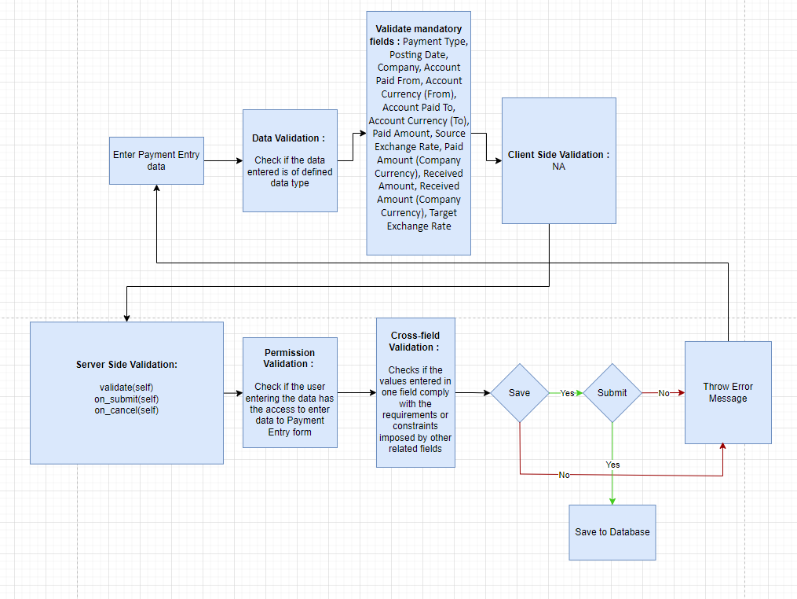

### Pre-requisites and Dependency

* Mode of Payment
* Account
* Party Type
* Party
* Company
* Currency
* Tax Withholding Category
* Cost Center

## Bank Reconciliation Tool

Once all your bank transactions are imported into the application, you can reconcile them with your existing vouchers.

The final goal of Bank Reconciliation is to make the difference amount zero (green) by either matching to an existing voucher or creating a new voucher.

### Use Case Diagram

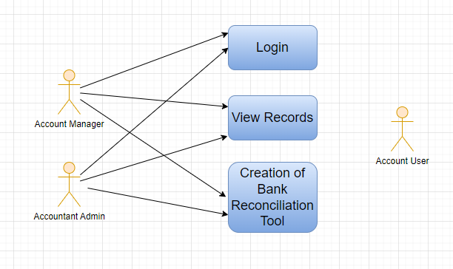

### Design of Workflow

* Design workflow is not applicable to this screen as records in it are created by only one role and are not sent to users with other roles for approval or modification.

### Validations

The data entered on this page will undergo a 2 step validation (I.e. client side and server side validation).

The following validation is done on client side:

1. Fields creation for Filters

The following validation is done on server side before save:

1. Get data
2. Get Column

After successful validation check from both client-side and server-side the result in the reports will be shown to user based on the filter that they have set.

**Client Side Validation**

Client-side validation refers to the process of validating user input directly on the client's web browser before saving it to the server for further processing. Following are some client side validations done for vendor selection report.

* **Field creation for From Date, To date, Company etc :**

Under filters assign fieldname, label, fieldtype, width, reqd and values for each of the filter values you want

**Server Side Validation**

Server-side validation refers to the process of validating user input on the server to ensure data integrity, security, and adherence to business rules before accepting or processing the information. Following are some server side validations done for vendor selection report.

* **Get_data**

1. Get value passed in filter for From date, To date
2. Write a query to get all necessary fields from Asset table
3. Return the data fetched through execution of query

* **Get_columns**

1. Pass values for label, fieldname, fieldtype, options and width of the column to be created
2. Return the columns value to create all columns

**Notification:**

* This section is not applicable since there is no notifications to be triggered

### Field List:

|  |  |  |  |  |  |  |
| --- | --- | --- | --- | --- | --- | --- |
| **ID** | **Field Name** | **Field Type** | **Mandatory** | **Validation/ Action** | **Remarks** | **R/N/D** |
| 1 | Company | Link Field |  | Link Fields to Master Screen Company | Default company name will be fetched |  |
| 2 | Bank Account | Link Field |  | Link Fields to Master Screen Bank Account | Default bank account name will be fetched |  |
| 3 | From Date | Date |  |  |  |  |
| 4 | To Date | Date |  | To Date shall be greater than From date |  |  |
| 5 | From Reference Date | Date |  |  |  |  |
| 6 | To Reference Date | Date |  | To Reference Date shall be greater than From Reference Date |  |  |
| 7 | Filter by Reference Date | Checkbox |  | If checked fields ‘From Reference Date’ and ‘ To Reference Date’ will be displayed instead of ‘From Date’ and ‘To Date’ and vice versa |  |  |
| 8 | Account Opening Balance | Currency |  |  |  |  |
| 10 | Closing Balance | Currency |  |  | Enter the closing balance as per bank statement |  |
| 11 | Reconciliation Tool Cards | HTML |  |  | Displays the ‘Closing Balance as per Bank Statement’ , ‘Closing Balance as per ERP’ and the difference |  |
| 12 | Bank Transactions | HTML |  | For all the bank transactions which are present in the Bank Statement but do not have a clearance date, click on the Actions Button to Match/ Create Vouchers |  |  |
| 13 | Upload Bank Statement Button | | | Make sure you have at least the date, the debit/credit and the currency on every row of your bank statement | Download a bank statement from your bank's website |  |
| 14 | Auto Reconcile Button | | |  | Click on ‘Auto Reconcile’ button to reconcile against matching references |  |

### Processes After Form Submission

* This section is not applicable since the form is not submittable.

### Process Flow:

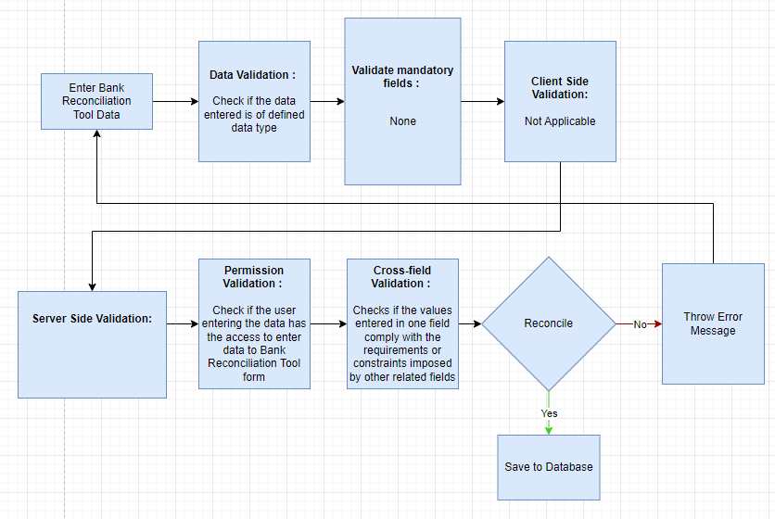

### Pre-requisites and Dependency

* Payment Entries
* Bank Statement

## Bank Clearance

This feature is used to manually update clearance date with respect to payment entries which are not reconciled

### Use Case Diagram

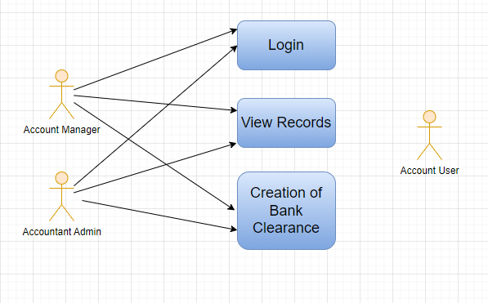

### 

### Design of Workflow

* Design workflow is not applicable to this screen as records in it are created by only one role and are not sent to users with other roles for approval or modification.

### Validations

**Client Side Validation:**

Client-side validation refers to the process of validating user input directly on the client's web browser before saving it to the server for further processing.

The following validations are done on client side for Bank Clearance Screen:

* Mandatory checks for fields :Account, From Date, To Date
* Linked fields : The Account field is linked to the Account Screen. The Account Currency field is linked to the Account Currency Screen. The Bank Account field is linked to the Bank Account Screen.

**Server Side Validation:**

Server-side validation refers to the process of validating user input on the server to ensure data integrity, security, and adherence to business rules before accepting or processing the information.

The following are the validations for Bank Clearance:

* Get_payment_entries - this definition enables getting of payment entry records which are not cleared
* Update_clearance_self - this definition updates the clearance date in the payment entries

**Notification:**

* Not Applicable

### Field List:

|  |  |  |  |  |  |  |
| --- | --- | --- | --- | --- | --- | --- |
| **ID** | **Field Name** | **Field Type** | **Mandatory** | **Validation/ Action** | **Remarks** | **R/N/D** |
| 1 | Account | Link Field | Yes | Link Fields to Master Screen Account | Default account name will be fetched |  |
| 2 | Account Currency | Link Field |  | Link Fields to Master Screen Currency | This field is hidden |  |
| 3 | From Date | Date | Yes |  |  |  |
| 4 | To Date | Date | Yes | To Date shall be greater than From date |  |  |
| 5 | Bank Account | Link Field |  | Link Fields to Master Screen Bank Account |  |  |
| 6 | Include Reconciled Entries | Checkbox |  | If checked reconciled entries will be fetched |  |  |
| 7 | Include POS Transactions | Checkbox |  | If checked POS Transactions will fetch |  |  |
| 8 | Payment Entries | Table |  | Description of the Table is given below | Once clearance date is updated the entries disappear from the table |  |
| 9 | Get Payment Entries Button | | | Payment Entries table is filled with relevant data once clicked |  |  |
| 10 | Update Clearance Date Button | | | Set the clearance date for the relevant payment entries and then click on this button to update clearance date |  |  |

|  |  |  |  |  |  |  |  |
| --- | --- | --- | --- | --- | --- | --- | --- |
| **Payment Entries(Bank Clearance Detail)** | | | | | | | |
| **ID** | **Field Name** | **Field Type** | **Mandatory** | **Validation / Action** | | **Remarks** | **R/N/D** |
| 1 | Payment Document | Link Field |  | Links to Doctype List | Data fetches on click “Get Payment Entries” button | |  |
| 2 | Payment Entry | Dynamic Link Field |  | Links to Doctype selected in Payment Document | Data fetches on click “Get Payment Entries” button | |  |
| 3 | Against Account | Data |  |  | Data fetches on click “Get Payment Entries” button | |  |
| 4 | Amount | Data |  |  | Data fetches on click “Get Payment Entries” button | |  |
| 5 | Posting Date | Date |  |  | Data fetches on click “Get Payment Entries” button | |  |
| 6 | Cheque Number | Data |  |  | Data fetches on click “Get Payment Entries” button | |  |
| 7 | Cheque Date | Date |  |  | Data fetches on click “Get Payment Entries” button | |  |
| 8 | Clearance Date | Date |  |  | Enter clearance date and click on “update clearance date” button | |  |

### Processes After Form Submission

* This section is not applicable since the form is not submittable.

### Process Flow:

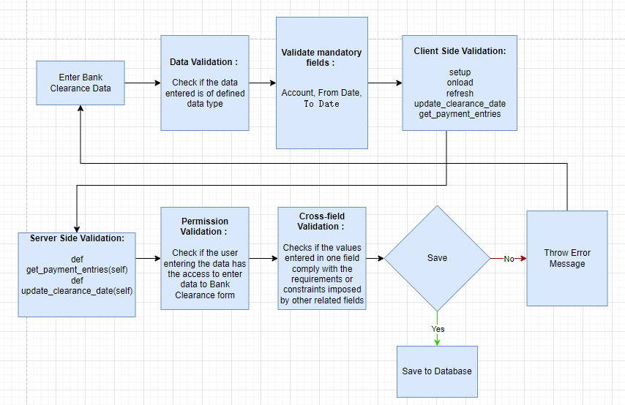

### Pre-requisites and Dependency

* Account
* Account Currency

## Bank Reconciliation Statement

The Bank Reconciliation Report provides the difference between the bank balance shown in an organization's bank statement, as provided by the bank against the amount shown in the companies Chart of Accounts.

### Use Case Diagram

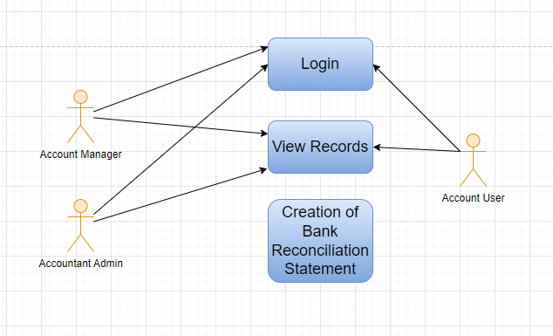

### Design of Workflow

* Design workflow is not applicable to this screen as records in it are created by only one role and are not sent to users with other roles for approval or modification.

### Validations

The data entered on this page will undergo a 2 step validation (I.e. client side and server side validation).

The following validation is done on client side:

1. Fields creation for Filters

The following validation is done on server side before save:

1. Get data
2. Get Column

After successful validation check from both client-side and server-side the result in the reports will be shown to user based on the filter that they have set.

**Client Side Validation**

Client-side validation refers to the process of validating user input directly on the client's web browser before saving it to the server for further processing. Following are some client side validations done for vendor selection report.

* **Field creation for From Company, Bank Acc., Dateetc :**

Under filters assign fieldname, label, fieldtype, width, reqd and values for each of the filter values you want

**Server Side Validation**

Server-side validation refers to the process of validating user input on the server to ensure data integrity, security, and adherence to business rules before accepting or processing the information. Following are some server side validations done for vendor selection report.

* **Get_data**

1. Get value passed in filter for From date, To date
2. Write a query to get all necessary fields from Asset table
3. Return the data fetched through execution of query

* **Get_columns**

1. Pass values for label, fieldname, fieldtype, options and width of the column to be created
2. Return the columns value to create all columns

**Notification:**

* This section is not applicable since there is no notifications to be triggered

### Field List:

**Filter Fields**

|  |  |  |  |  |  |  |
| --- | --- | --- | --- | --- | --- | --- |
| **ID** | **Input Fields** | **Field Type** | **Mandatory** | **Validation/ Action** | **Remarks** | **R/N/D** |
|  | Company | Link Field |  |  | Default Company will be fetched |  |
|  | Bank Account | Link Field |  |  | Default Bank Account will be fetched |  |
|  | Date | Date |  |  | Today’s date will be auto-fetched |  |

**Columns**

|  |  |  |
| --- | --- | --- |
| **ID** | **Column Name** | **Description** |
|  | Posting Date | This displays the posting date of the transaction |
|  | Payment Document Type | This displays the type of voucher associated to the payment |
|  | Payment Document | This shows the primary key of the payment voucher |
|  | Debit | This shows the credit amount |
|  | Credit | This shows the debit amount |
|  | Against Account | This shows the party against which the amount was charged |
|  | Reference | This shows the reference number against transactions, if any |
|  | Ref Date | This shows the reference date against transactions, if any |
|  | Clearance Date | It shows the clearance date of the transactions, if any |
|  | Currency | It shows the currency such as INR, USD, etc. |

### Processes After Form Submission

* This section is not applicable since the form is not submittable.

### Process Flow:



### Pre-requisites and Dependency

* Not Applicable

## Accounts Receivable Report

This reports help you to track the outstanding amount of Students and other parties. It also provides ageing analysis i.e. a break-up of outstanding amount based on the period for which the amount is outstanding.

### Use Case Diagram

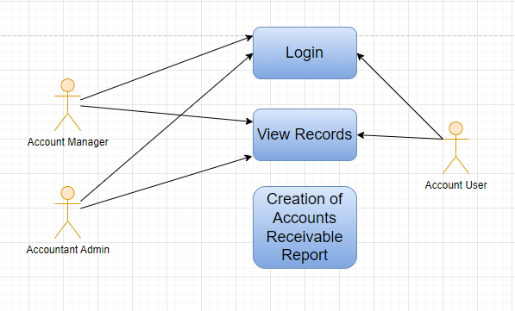

### Design of Workflow

* Design workflow is not applicable to this screen as records in it are created by only one role and are not sent to users with other roles for approval or modification.

### Validations

The data entered on this page will undergo a 2 step validation (I.e. client side and server side validation).

The following validation is done on client side:

1. Fields creation for Filters

The following validation is done on server side before save:

1. Get data
2. Get Column

After successful validation check from both client-side and server-side the result in the reports will be shown to user based on the filter that they have set.

**Client Side Validation**

Client-side validation refers to the process of validating user input directly on the client's web browser before saving it to the server for further processing. Following are some client side validations done for vendor selection report.

* **Field creation for From Company, Posting Date, Finance Book etc :**

Under filters assign fieldname, label, fieldtype, width, reqd and values for each of the filter values you want

**Server Side Validation**

Server-side validation refers to the process of validating user input on the server to ensure data integrity, security, and adherence to business rules before accepting or processing the information. Following are some server side validations done for vendor selection report.

* **Get_data**

1. Get value passed in filter for From date, To date
2. Write a query to get all necessary fields from Asset table
3. Return the data fetched through execution of query

* **Get_columns**

1. Pass values for label, fieldname, fieldtype, options and width of the column to be created
2. Return the columns value to create all columns

**Notification:**

* This section is not applicable since there is no notifications to be triggered

### Field List:

**Filter Fields**

|  |  |  |  |  |  |  |
| --- | --- | --- | --- | --- | --- | --- |
| **ID** | **Input Fields** | **Field Type** | **Mandatory** | **Validation/ Action** | **Remarks** | **R/N/D** |
|  | Company | Link Field |  |  |  |  |
|  | Posting Date | Date |  | From date should be before the To date |  |  |
|  | Finance Book | Link Field |  | Link Fields to Finance Book Screen |  |  |
|  | Cost Center | Link Field |  | Link Fields to Cost Center Screen |  |  |
|  | Customer | Link Field |  | Link Fields to Customer Screen |  |  |
|  | Receivable Account | Link Field |  | Link Fields to Receivable Account Screen |  |  |
|  | Due Date | Date |  |  |  |  |
|  | Ageing Range 1 | Text |  |  |  |  |
|  | Ageing Range 2 | Text |  |  |  |  |
|  | Ageing Range 3 | Text |  |  |  |  |
|  | Ageing Range 4 | Text |  |  |  |  |
|  | Customer Group | Link Field |  | Link Fields to Customer Group Screen |  |  |
|  | Payment Term Template | Link Field |  | Link Fields to Payment Term Template Screen |  |  |
|  | Sales Partner | Link Field |  | Link Fields to Sales Partner Screen |  |  |
|  | Sales Person | Link Field |  | Link Fields to Sales Person Screen |  |  |
|  | Territory | Link Field |  | Link Fields to Territory Screen |  |  |
|  | Group by Customer | Check box |  | Link Fields to Group by Customer Screen |  |  |
|  | Based on Payment Term | Check box |  |  | On check, data will be visible Based on Payment Term |  |
|  | Show Future Payments | Check box |  |  | On check, it will also show the future payments |  |
|  | Show Linked Delivery Notes | Check box |  |  | On check, It will show the linked delivery notes |  |
|  | Show Sales Person | Check box |  |  | On check, It will show the sales person details |  |
|  | Show Remarks | Check box |  |  | On check, It will show the remarks. |  |

**Columns**

|  |  |  |
| --- | --- | --- |
| **ID** | **Column Name** | **Description** |
|  | Posting Date | It is the document posting date |
|  | Customer | It will show the customer names |
|  | Receivable Account | It shows the receivable account name |
|  | Customer Contact | It shows the customer contact details |
|  | Cost Center | It is a part of an organization where costs or income can be charged. |
|  | Voucher Type | Different Types of Vouchers like Purchase Receipt, Stock Entry, etc. |
|  | Voucher No | Voucher no. is based on the voucher type. |
|  | Due Date | It shows the due date for a particular transaction |
|  | Invoice Amount | It will shows the Invoice amount with respect to the individual customers |
|  | Paid Amount | It will shows the paid amount with respect to the individual customers |
|  | Credit Note | It is a document send by a buyer to the supplier notifying that a credit has been recorded. |
|  | Outstanding Amount | It will shows the outstanding amount with respect to the individual customers |

### Processes After Form Submission

* This section is not applicable since the form is not submittable.

### Process Flow:



### Pre-requisites and Dependency

* Not Applicable

## Accounts Receivable Summary Report

This reports help you to track the outstanding amount of Student and other parties. It also provides ageing analysis i.e. a break-up of outstanding amount based on the period for which the amount is outstanding.

### Use Case Diagram

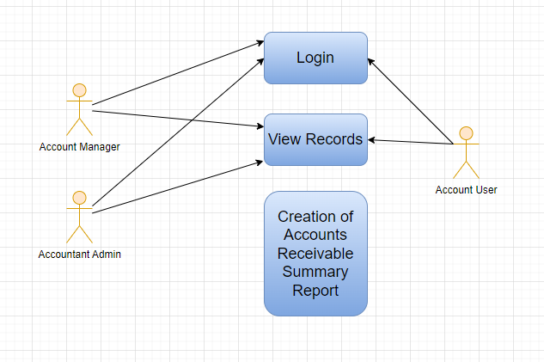

### Design of Workflow

* Design workflow is not applicable to this screen as records in it are created by only one role and are not sent to users with other roles for approval or modification.

### Validations

The data entered on this page will undergo a 2 step validation (I.e. client side and server side validation).

The following validation is done on client side:

1. Fields creation for Filters

The following validation is done on server side before save:

1. Get data
2. Get Column

After successful validation check from both client-side and server-side the result in the reports will be shown to user based on the filter that they have set.

**Client Side Validation**

Client-side validation refers to the process of validating user input directly on the client's web browser before saving it to the server for further processing. Following are some client side validations done for vendor selection report.

* **Field creation for From Company, Posting Date, Finance Book etc :**

Under filters assign fieldname, label, fieldtype, width, reqd and values for each of the filter values you want

**Server Side Validation**

Server-side validation refers to the process of validating user input on the server to ensure data integrity, security, and adherence to business rules before accepting or processing the information. Following are some server side validations done for vendor selection report.

* **Get_data**

1. Get value passed in filter for From date, To date
2. Write a query to get all necessary fields from Asset table
3. Return the data fetched through execution of query

* **Get_columns**

1. Pass values for label, fieldname, fieldtype, options and width of the column to be created
2. Return the columns value to create all columns

**Notification:**

* This section is not applicable since there is no notifications to be triggered

### Field List:

**Filter Fields**

|  |  |  |  |  |  |  |
| --- | --- | --- | --- | --- | --- | --- |
| **ID** | **Input Fields** | **Field Type** | **Mandatory** | **Validation/ Action** | **Remarks** | **R/N/D** |
|  | Company | Link Field |  |  |  |  |
|  | Posting Date | Date |  | From date should be before the To date |  |  |
|  | Ageing Based on | Dropdown |  | Options:  Due Date  Posting Date |  |  |
|  | Finance Book | Link Field |  | Link Fields to Finance Book Screen |  |  |
|  | Cost Center | Link Field |  | Link Fields to Cost Center Screen |  |  |
|  | Customer | Link Field |  | Link Fields to Customer Screen |  |  |
|  | Due Date | Date |  |  |  |  |
|  | Ageing Range 1 | Text |  |  |  |  |
|  | Ageing Range 2 | Text |  |  |  |  |
|  | Ageing Range 3 | Text |  |  |  |  |
|  | Ageing Range 4 | Text |  |  |  |  |
|  | Customer Group | Link Field |  | Link Fields to Customer Group Screen |  |  |
|  | Payment Term Template | Link Field |  | Link Fields to Payment Term Template Screen |  |  |
|  | Sales Partner | Link Field |  | Link Fields to Sales Partner Screen |  |  |
|  | Sales Person | Link Field |  | Link Fields to Sales Person Screen |  |  |
|  | Territory | Link Field |  | Link Fields to Territory Screen |  |  |
|  | Based on Payment Term | Check box |  |  | On check, data will be visible Based on Payment Term |  |
|  | Show Future Payments | Check box |  |  | On check, it will also show the future payments |  |
|  | Show GL Balance | Check box |  |  | On check, It will show the linked delivery notes |  |

**Columns**

|  |  |  |
| --- | --- | --- |
| **ID** | **Column Name** | **Description** |
|  | Customer | It will show the customer names |
|  | Advance Amount | It shows the Advance amount with respect to the individual customers |
|  | Invoice Amount | It will shows the Invoice amount with respect to the individual customers |
|  | Paid Amount | It will shows the paid amount with respect to the individual customers |
|  | Credit Note | It is a document send by a buyer to the supplier notifying that a credit has been recorded. |
|  | Outstanding Amount | It will shows the outstanding amount with respect to the individual customers |
|  | Currency | It shows the currency such as INR, USD, etc. |

### Processes After Form Submission

* This section is not applicable since the form is not submittable.

### Process Flow:



### Pre-requisites and Dependency

* Not Applicable

## Accounts Payable Report

This report helps you to track the outstanding amount of Suppliers.  It also provides ageing analysis i.e. a break-up of outstanding amount based on the period for which the amount is outstanding.

### Use Case Diagram

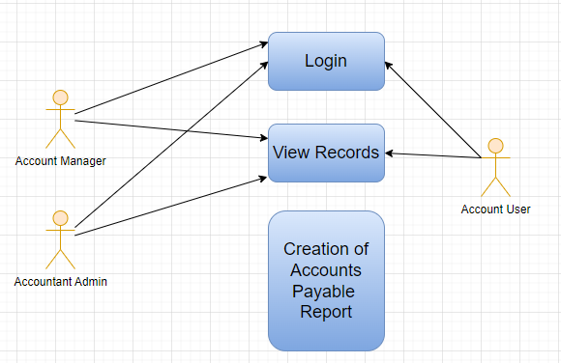

### Design of Workflow

* Design workflow is not applicable to this screen as records in it are created by only one role and are not sent to users with other roles for approval or modification.

### Validations

The data entered on this page will undergo a 2 step validation (I.e. client side and server side validation).

The following validation is done on client side:

1. Fields creation for Filters

The following validation is done on server side before save:

1. Get data
2. Get Column

After successful validation check from both client-side and server-side the result in the reports will be shown to user based on the filter that they have set.

**Client Side Validation**

Client-side validation refers to the process of validating user input directly on the client's web browser before saving it to the server for further processing. Following are some client side validations done for vendor selection report.

* **Field creation for From Company, Posting Date, Finance Book etc :**

Under filters assign fieldname, label, fieldtype, width, reqd and values for each of the filter values you want

**Server Side Validation**

Server-side validation refers to the process of validating user input on the server to ensure data integrity, security, and adherence to business rules before accepting or processing the information. Following are some server side validations done for vendor selection report.

* **Get_data**

1. Get value passed in filter for From date, To date
2. Write a query to get all necessary fields from Asset table
3. Return the data fetched through execution of query

* **Get_columns**

1. Pass values for label, fieldname, fieldtype, options and width of the column to be created
2. Return the columns value to create all columns

**Notification:**

* This section is not applicable since there is no notifications to be triggered

### Field List:

**Filter Fields**

|  |  |  |  |  |  |  |
| --- | --- | --- | --- | --- | --- | --- |
| **ID** | **Input Fields** | **Field Type** | **Mandatory** | **Validation/ Action** | **Remarks** | **R/N/D** |
| 1 | Company | Link Field |  |  | Default Company will be fetched |  |
| 2 | Posting Date | Date |  |  | Today’s date will be auto-fetched |  |
| 3 | Finance Book | Link Field |  |  |  |  |
| 4 | Cost Center | Link Field |  |  |  |  |
| 5 | Supplier | Link Field |  |  |  |  |
| 6 | Payable Account | Link Field |  |  |  |  |
| 7 | Ageing Based On | Dropdown |  |  | Options: Posting Date, Due Date, Supplier Invoice Date |  |
| 8 | Ageing Range 1 | Number |  |  |  |  |
| 9 | Ageing Range 2 | Number |  |  |  |  |
| 10 | Ageing Range 3 | Number |  |  |  |  |
| 11 | Ageing Range 4 | Number |  |  |  |  |
| 12 | Payment Terms Template | Link Field |  |  |  |  |
| 13 | Supplier Group | Link Field |  |  |  |  |
| 14 | Group By Supplier | Checkbox |  | If checked, the report will be show by grouping the suppliers |  |  |
| 15 | Based On Payment Terms | Checkbox |  | If checked, a column payment terms will appear |  |  |
| 16 | Show Remarks | Checkbox |  | If checked, a column with remarks of the transactions will be shown |  |  |
| 17 | Show Future Payments | Checkbox |  | If checked, future payments will be shown |  |  |

**Columns**

|  |  |  |
| --- | --- | --- |
| **ID** | **Column Name** | **Description** |
| 1 | Posting Date | This displays the posting date of the transaction |
| 2 | Payable Account | This displays the payable account |
| 3 | Cost Center | This displays the cost centers linked to the transactions |
| 4 | Voucher Type | This shows the voucher type |
| 5 | Voucher No | This shows the voucher number |
| 6 | Due Date | This shows the due date for the transaction |
| 7 | Bill No | This displays the bill no associated with the transaction |
| 8 | Bill Date | This shows the bill date |
| 9 | Invoiced Amount | Invoiced Amount of the transaction is shown in this column |
| 10 | Paid Amount | Paid Amount of the transaction is shown in this column |
| 11 | Debit Note | Debit Note if any is shown here |
| 12 | Outstanding Amount | Amount which is outstanding is shown in this column |
| 13 | Age (Days) | Age of the transaction is shown here |
| 14 | 0-30 | The 0-30 days interval represents the outstanding payable balances that are due within the next 30 days. |
| 15 | 31-60 | The 31-60 days interval represents the outstanding payable balances that are due within the next 40 days. |
| 16 | 61-90 | The 61-90 days interval represents the outstanding payable balances that are due within the next 90 days. |
| 17 | 91-120 | The 91-120 days interval represents the outstanding payable balances that are due within the next 120 days. |
| 18 | Currency | Currency in which the transaction has occurred is show here |
| 19 | Supplier Group | Supplier Group of the transaction is shown here |

### Processes After Form Submission

* This section is not applicable since the form is not submittable.

### Process Flow:



### Pre-requisites and Dependency

* Not Applicable

## Accounts Payable Summary Report

The accounts payable summary is a report that provides an overview of the money owed by the organization to its vendors or suppliers.

### Use Case Diagram

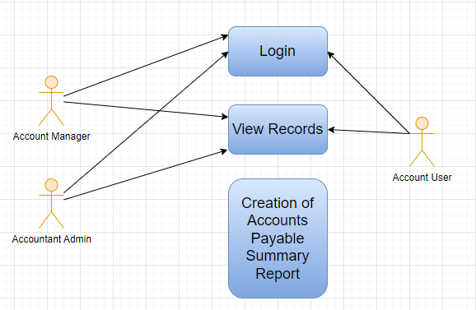

### Design of Workflow

* Design workflow is not applicable to this screen as records in it are created by only one role and are not sent to users with other roles for approval or modification.

### Validations

The data entered on this page will undergo a 2 step validation (I.e. client side and server side validation).

The following validation is done on client side:

1. Fields creation for Filters

The following validation is done on server side before save:

1. Get data
2. Get Column

After successful validation check from both client-side and server-side the result in the reports will be shown to user based on the filter that they have set.

**Client Side Validation**

Client-side validation refers to the process of validating user input directly on the client's web browser before saving it to the server for further processing. Following are some client side validations done for vendor selection report.

* **Field creation for From Company, Posting Date, Finance Book etc :**

Under filters assign fieldname, label, fieldtype, width, reqd and values for each of the filter values you want

**Server Side Validation**

Server-side validation refers to the process of validating user input on the server to ensure data integrity, security, and adherence to business rules before accepting or processing the information. Following are some server side validations done for vendor selection report.

* **Get_data**

1. Get value passed in filter for From date, To date
2. Write a query to get all necessary fields from Asset table
3. Return the data fetched through execution of query

* **Get_columns**

1. Pass values for label, fieldname, fieldtype, options and width of the column to be created
2. Return the columns value to create all columns

**Notification:**

* This section is not applicable since there is no notifications to be triggered

### Field List:

**Filter Fields**

|  |  |  |  |  |  |  |
| --- | --- | --- | --- | --- | --- | --- |
| **ID** | **Input Fields** | **Field Type** | **Mandatory** | **Validation/ Action** | **Remarks** | **R/N/D** |
| 1 | Company | Link Field |  |  | Default Company will be fetched |  |
| 2 | Posting Date | Date |  |  | Today’s date will be auto-fetched |  |
| 3 | Ageing Based On | Dropdown |  |  | Options: Posting Date, Due Date, Supplier Invoice Date |  |
| 4 | Ageing Range 1 | Number |  | User Input |  |  |
| 5 | Ageing Range 2 | Number |  | User Input |  |  |
| 6 | Ageing Range 3 | Number |  | User Input |  |  |
| 7 | Ageing Range 4 | Number |  | User Input |  |  |
| 8 | Finance Book | Link Field |  |  |  |  |
| 9 | Cost Center | Link Field |  |  |  |  |
| 10 | Supplier | Link Field |  |  |  |  |
| 11 | Payment Terms Template | Link Field |  |  |  |  |
| 12 | Supplier Group | Link Field |  |  |  |  |
| 13 | Based On Payment Terms | Checkbox |  | If checked, a column payment terms will appear |  |  |

|  |  |  |
| --- | --- | --- |
| **ID** | **Column Name** | **Description** |
|  | Supplier | This displays the supplier name |
|  | Advance Amount | This displays the advance amount |
|  | Invoice Amount | This displays the invoice amount for the supplier |
|  | Paid Amount | This shows the paid amount |
|  | Debit Note | This shows the debit note if any |
|  | Outstanding Amount | This shows the outstanding amount for the transaction |
|  | 0-30 | The 0-30 days interval represents the outstanding payable balances that are due within the next 30 days. |
|  | 31-60 | The 31-41 days interval represents the outstanding payable balances that are due within the next 40 days. |
|  | 61-90 | The 61-90 days interval represents the outstanding payable balances that are due within the next 90 days. |
|  | 91-120 | The 91-120 days interval represents the outstanding payable balances that are due within the next 120 days. |
|  | 121-Above | This interval represents the outstanding payable balances that are due within the next 120 and above days. |
|  | Total Amount | This represents the amount summation link to each supplier |
|  | Supplier Group | Supplier Group of the transaction is shown here |
|  | Currency | Currency in which the transaction has occurred is show here |

### Processes After Form Submission

* This section is not applicable since the form is not submittable.

### Process Flow:



### Pre-requisites and Dependency

* Not Applicable

## Purchase Register Report

This reports help you to track the outstanding amount of Suppliers with respect to the unique invoice id.

### Use Case Diagram

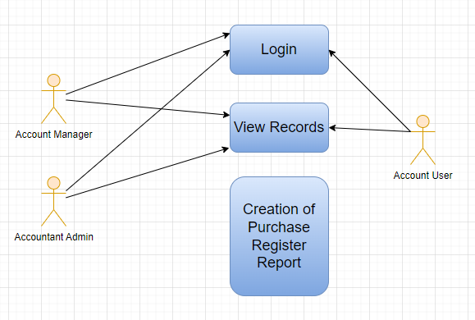

### Design of Workflow

* Design workflow is not applicable to this screen as records in it are created by only one role and are not sent to users with other roles for approval or modification.

### Validations

The data entered on this page will undergo a 2 step validation (I.e. client side and server side validation).

The following validation is done on client side:

1. Fields creation for Filters

The following validation is done on server side before save:

1. Get data
2. Get Column

After successful validation check from both client-side and server-side the result in the reports will be shown to user based on the filter that they have set.

**Client Side Validation**

Client-side validation refers to the process of validating user input directly on the client's web browser before saving it to the server for further processing. Following are some client side validations done for vendor selection report.

* **Field creation for From Company, From Date, To Date etc :**

Under filters assign fieldname, label, fieldtype, width, reqd and values for each of the filter values you want

**Server Side Validation**

Server-side validation refers to the process of validating user input on the server to ensure data integrity, security, and adherence to business rules before accepting or processing the information. Following are some server side validations done for vendor selection report.

* **Get_data**

1. Get value passed in filter for From date, To date
2. Write a query to get all necessary fields from Asset table
3. Return the data fetched through execution of query

* **Get_columns**

1. Pass values for label, fieldname, fieldtype, options and width of the column to be created
2. Return the columns value to create all columns

**Notification:**

* This section is not applicable since there is no notifications to be triggered

### Field List:

**Filter Fields**

|  |  |  |  |  |  |  |
| --- | --- | --- | --- | --- | --- | --- |
| **ID** | **Input Fields** | **Field Type** | **Mandatory** | **Validation/ Action** | **Remarks** | **R/N/D** |
|  | Company | Link Field |  |  |  |  |
|  | From Date | Date |  | From date should be before the To date |  |  |
|  | To Date | Date |  | To date should be after the from date |  |  |
|  | Mode of Payment | Link Field |  | Link Fields to Mode of Payment Screen |  |  |
|  | Cost Center | Link Field |  | Link Fields to Cost Center Screen |  |  |
|  | Supplier | Link Field |  | Link Fields to Supplier Screen |  |  |
|  | Warehouse | Link Field |  | Link Fields to Warehouse Screen |  |  |
|  | Item Group | Link Field |  | Link Fields to Item Group Screen |  |  |

**Columns**

|  |  |  |
| --- | --- | --- |
| **ID** | **Column Name** | **Description** |
|  | Invoice | It will show the purchase invoice Id |
|  | Posting Date | It is the document posting date |
|  | Supplier Id | It is the Unique Id with respect to individual Suppliers |
|  | Supplier Name | It shows the supplier name with respect to the Supplier Id. |
|  | Supplier Group | It shows the Supplier group which divides different supplier based upon their individual details. It also contains the multiple company & accounts name. |
|  | Tax Id | It is the Unique Id for different type of Taxes. |
|  | Payable Account | It shows the Payable Accounts Name only. |
|  | Mode of Payment | Mode of Payment can be Cash, Online Payment, Cheque, etc. |
|  | Project | It will show the project name with respect to the supplier. |
|  | Bill No | Bill No generate with respect to the different item supplied by individual suppliers. |
|  | Bill Date | Date of Bill generate with respect to the different item supplied by individual suppliers. |
|  | Remarks | Remarks with respect to different invoice number will be shown. |
|  | Purchase Order | It show the purchase order id with respect to the head wise different supplier. |
|  | Purchase Receipt | It show the purchase receipt id with respect to the head wise different supplier. |
|  | Currency | It shows the currency such as INR, USD, etc. |
|  | Net Total | It shows the net total of different Items with respect to the received stock |
|  | Total Tax | It shows the total tax for different Items with respect to the received stock |
|  | Grand Total | It shows the Grand total amount created with respect to the different supplier |
|  | Outstanding Amount | It shows the Grand Outstanding amount created with respect to the different supplier. |

### Processes After Form Submission

* This section is not applicable since the form is not submittable.

### Process Flow:



### Pre-requisites and Dependency

* Not Applicable

## Item Wise Purchase Register Report

This reports help you to track the outstanding amount of Suppliers with respect to the individual Items.

### Use Case Diagram

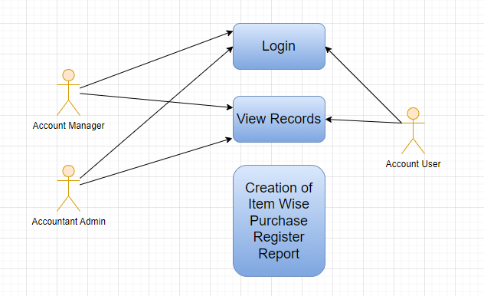

### Design of Workflow

* Design workflow is not applicable to this screen as records in it are created by only one role and are not sent to users with other roles for approval or modification.

### Validations

The data entered on this page will undergo a 2 step validation (I.e. client side and server side validation).

The following validation is done on client side:

1. Fields creation for Filters

The following validation is done on server side before save:

1. Get data
2. Get Column

After successful validation check from both client-side and server-side the result in the reports will be shown to user based on the filter that they have set.

**Client Side Validation**

Client-side validation refers to the process of validating user input directly on the client's web browser before saving it to the server for further processing. Following are some client side validations done for vendor selection report.

* **Field creation for From Company, From Date, To Date etc :**

Under filters assign fieldname, label, fieldtype, width, reqd and values for each of the filter values you want

**Server Side Validation**

Server-side validation refers to the process of validating user input on the server to ensure data integrity, security, and adherence to business rules before accepting or processing the information. Following are some server side validations done for vendor selection report.

* **Get_data**

1. Get value passed in filter for From date, To date
2. Write a query to get all necessary fields from Asset table
3. Return the data fetched through execution of query

* **Get_columns**

1. Pass values for label, fieldname, fieldtype, options and width of the column to be created
2. Return the columns value to create all columns

**Notification:**

* This section is not applicable since there is no notifications to be triggered

### Field List:

**Filter Fields**

|  |  |  |  |  |  |  |
| --- | --- | --- | --- | --- | --- | --- |
| **ID** | **Input Fields** | **Field Type** | **Mandatory** | **Validation/ Action** | **Remarks** | **R/N/D** |
|  | Company | Link Field |  | Link Field to Company Screen |  |  |
|  | From Date | Date |  | From date should be before the To date |  |  |
|  | To Date | Date |  | To date should be after the from date |  |  |
|  | Mode of Payment | Link Field |  | Link Fields to Mode of Payment Screen |  |  |
|  | Cost Center | Link Field |  | Link Fields to Cost Center Screen |  |  |
|  | Supplier | Link Field |  | Link Fields to Supplier Screen |  |  |
|  | Group By | Dropdown |  | Options :   1. Supplier 2. Item Group 3. Item 4. Invoice |  |  |
|  | Item | Link Field |  | Link Fields to Item Screen |  |  |

**Columns**

|  |  |  |
| --- | --- | --- |
| **ID** | **Column Name** | **Description** |
|  | Invoice | It will show the purchase invoice Id |
|  | Posting Date | It is the document posting date |
|  | Supplier Id | It is the Unique Id with respect to individual Suppliers |
|  | Supplier Name | It shows the supplier name with respect to the Supplier Id. |
|  | Payable Account | It shows the Payable Accounts Name only. |
|  | Mode of Payment | Mode of Payment can be Cash, Online Payment, Cheque, etc. |
|  | Project | It will show the project name with respect to the supplier. |
|  | Stock Qty | It shows the Supplier wise stock quantity |
|  | Stock UOM | It shows the Stock UOM such as in numbers, in Grams, in KG, in Faraday, etc. |
|  | Purchase Order | It show the purchase order id with respect to the head wise different supplier. |
|  | Purchase Receipt | It show the purchase receipt id with respect to the head wise different supplier. |
|  | Currency | It shows the currency such as INR, USD, etc. |
|  | Total Other Charger | It shows the total other charges of different Items with respect to the individual Supplier. |
|  | Total Tax | It shows the total tax for different Items with respect to the individual Supplier. |
|  | Rate | It shows the rate of an item |
|  | Amount | It shows the amount of an item |
|  | % of Grand Total | It shows the percentage of grand total amount of an item with respect to a particular Supplier |
|  | Company | It shows the Company name from where the supplier and the items belongs to. |

### Processes After Form Submission

* This section is not applicable since the form is not submittable.

### Process Flow:



### Pre-requisites and Dependency

* Not Applicable

## Trial Balance for Party Report

It is common to review the trial balance for employees, students, and suppliers. This information can be easily accessed for all individuals or for specific individuals.

### Use Case Diagram

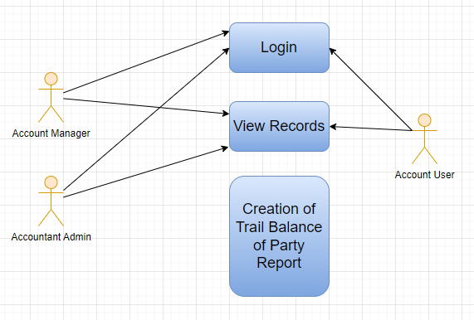

### Design of Workflow

* Design workflow is not applicable to this screen as records in it are created by only one role and are not sent to users with other roles for approval or modification.

### Validations

The data entered on this page will undergo a 2 step validation (I.e. client side and server side validation).

The following validation is done on client side:

1. Fields creation for Filters

The following validation is done on server side before save:

1. Get data
2. Get Column

After successful validation check from both client-side and server-side the result in the reports will be shown to user based on the filter that they have set.

**Client Side Validation**

Client-side validation refers to the process of validating user input directly on the client's web browser before saving it to the server for further processing. Following are some client side validations done for vendor selection report.

* **Field creation for From Company, From Date, To Date etc :**

Under filters assign fieldname, label, fieldtype, width, reqd and values for each of the filter values you want

**Server Side Validation**

Server-side validation refers to the process of validating user input on the server to ensure data integrity, security, and adherence to business rules before accepting or processing the information. Following are some server side validations done for vendor selection report.

* **Get_data**

1. Get value passed in filter for From date, To date
2. Write a query to get all necessary fields from Asset table
3. Return the data fetched through execution of query

* **Get_columns**

1. Pass values for label, fieldname, fieldtype, options and width of the column to be created
2. Return the columns value to create all columns

**Notification:**

* This section is not applicable since there is no notifications to be triggered

### Field List:

**Filter Fields**

|  |  |  |  |  |  |  |
| --- | --- | --- | --- | --- | --- | --- |
| **ID** | **Field Label** | **Field Type** | **Validation/Action** | **Mandatory** | **Remarks** | **R/N/D** |
|  | Company | Link Field | Fetched from Company master screen |  |  |  |
|  | Fiscal Year | Link Field | Fetched from Fiscal Year master screen |  |  |  |
|  | From Date | Date | From Date should be less than To Date |  |  |  |
|  | To Date | Date | To Date should be greater than From Date |  |  |  |
|  | Party Type | Link Field | Fetched from Party Type master screen |  |  |  |
|  | Party | Link Field | Fetched from selected Party Type |  |  |  |
|  | Account | Link Field | Fetched from Account master screen |  |  |  |
|  | Show Zero Values | Check box |  |  | It display parties that have a zero balance in the report. |  |

**Columns**

|  |  |  |
| --- | --- | --- |
| **ID** | **Column Fields** | **Description** |
|  | Party Type | Categorization of parties involved in transactions, such as Student, suppliers etc. |
|  | Opening (Dr) | Opening (Dr) represent the opening debit balances |
|  | Opening (Cr) | Opening (Cr) represent the opening credit balances |
|  | Debit | Debit represent the total debit transactions during the period |
|  | Credit | Credit represent the total credit transactions during the period |
|  | Closing (Dr) | Closing (Dr) represents the closing debit balance |
|  | Closing (Cr) | Closing (Cr) represents the closing credit balance |

### Processes After Form Submission

* This section is not applicable since the form is not submittable.

### Process Flow:



### Pre-requisites and Dependency

* Not Applicable

## Tax Detail Report

Tax Details report provides an overview of all the taxes applied to transactions.This report shows the Item Tax Template, Taxes and Charges Template and Tax Category linked to various voucher types in the application.

### Use Case Diagram

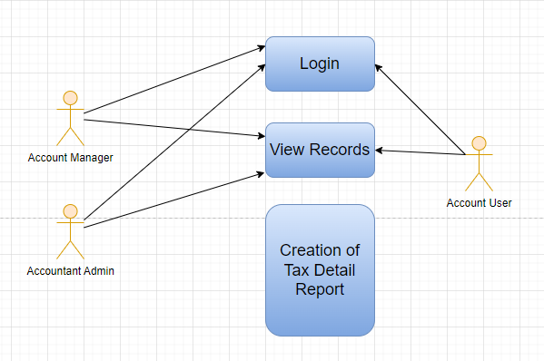

### Design of Workflow

* Design workflow is not applicable to this screen as records in it are created by only one role and are not sent to users with other roles for approval or modification.

### Validations

The data entered on this page will undergo a 2 step validation (I.e. client side and server side validation).

The following validation is done on client side:

1. Fields creation for Filters

The following validation is done on server side before save:

1. Get data
2. Get Column

After successful validation check from both client-side and server-side the result in the reports will be shown to user based on the filter that they have set.

**Client Side Validation**

Client-side validation refers to the process of validating user input directly on the client's web browser before saving it to the server for further processing. Following are some client side validations done for vendor selection report.

* **Field creation for From Company, From Date, To Date etc :**

Under filters assign fieldname, label, fieldtype, width, reqd and values for each of the filter values you want

**Server Side Validation**

Server-side validation refers to the process of validating user input on the server to ensure data integrity, security, and adherence to business rules before accepting or processing the information. Following are some server side validations done for vendor selection report.

* **Get_data**

1. Get value passed in filter for From date, To date
2. Write a query to get all necessary fields from Asset table
3. Return the data fetched through execution of query

* **Get_columns**

1. Pass values for label, fieldname, fieldtype, options and width of the column to be created
2. Return the columns value to create all columns

**Notification:**

* This section is not applicable since there is no notifications to be triggered

### Field List:

**Filter Fields**

|  |  |  |  |  |  |  |
| --- | --- | --- | --- | --- | --- | --- |
| **ID** | **Field Label** | **Field Type** | **Validation/Action** | **Mandatory** | **Remarks** | **R/N/D** |
|  | Company | Link Field | Fetched from Company master screen |  |  |  |
|  | From Date | Date | From Date should be less than To Date |  |  |  |
|  | To Date | Date | To Date should be greater than From Date |  |  |  |

**Columns**

|  |  |  |
| --- | --- | --- |
| **ID** | **Column Fields** | **Description** |
|  | Posting Date | Date of the transaction |
|  | Root Type | Account Root types are mainly classified as income, expense, asset, or liability. |
|  | Account Type | Account type of that account. |
|  | Account | Name of the Account. |
|  | Voucher Type | Different Types of Vouchers like Purchase Receipt, Stock Entry, etc. |
|  | Voucher No | Voucher no. is based on the voucher type. |
|  | Amount | Voucher amount. |
|  | Item Tax Template | Item Tax Template is a predefined tax template applied to items. |
|  | Item Group | Item Group is a grouping of similar items. |
|  | Item Name | Item Name is the name of the item. |
|  | Taxes and Charges Template | Taxes and Charges Template is a predefined tax template applied to transactions. |
|  | Tax Category | Tax Category is a predefined tax category assigned to taxes. |

### Processes After Form Submission

* This section is not applicable since the form is not submittable.

### Process Flow:



### Pre-requisites and Dependency

* Not Applicable

## Supplier Ledger Summary Report

This Shows the Ledger by Individual Supplier Wise

### Use Case Diagram

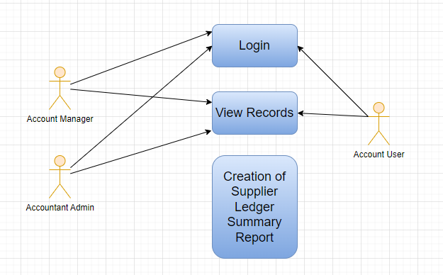

### Design of Workflow

* Design workflow is not applicable to this screen as records in it are created by only one role and are not sent to users with other roles for approval or modification.

### Validations

The data entered on this page will undergo a 2 step validation (I.e. client side and server side validation).

The following validation is done on client side:

1. Fields creation for Filters

The following validation is done on server side before save:

1. Get data
2. Get Column

After successful validation check from both client-side and server-side the result in the reports will be shown to user based on the filter that they have set.

**Client Side Validation**

Client-side validation refers to the process of validating user input directly on the client's web browser before saving it to the server for further processing. Following are some client side validations done for vendor selection report.

* **Field creation for From Company, From Date, To Date etc :**

Under filters assign fieldname, label, fieldtype, width, reqd and values for each of the filter values you want

**Server Side Validation**

Server-side validation refers to the process of validating user input on the server to ensure data integrity, security, and adherence to business rules before accepting or processing the information. Following are some server side validations done for vendor selection report.

* **Get_data**

1. Get value passed in filter for From date, To date
2. Write a query to get all necessary fields from Asset table
3. Return the data fetched through execution of query

* **Get_columns**

1. Pass values for label, fieldname, fieldtype, options and width of the column to be created
2. Return the columns value to create all columns

**Notification:**

* This section is not applicable since there is no notifications to be triggered

### Field List:

**Filter Fields**

|  |  |  |  |  |  |  |
| --- | --- | --- | --- | --- | --- | --- |
| **ID** | **Input Fields** | **Field Type** | **Mandatory** | **Validation/ Action** | **Remarks** | **R/N/D** |
|  | Company | Link Field |  | Link Field to the Company Screen |  |  |
|  | From Date | Date |  | From date should be before the To date |  |  |
|  | To Date | Date |  | To date should be after from date |  |  |
|  | Finance Book | Link Field |  | Link Fields to Finance Book Screen |  |  |
|  | Supplier | Link Field |  | Link Fields to Supplier Screen |  |  |
|  | Supplier Group | Link Field |  | Link Fields to Supplier Group Screen |  |  |
|  | Payment Terms Template | Link Field |  | Link Fields to Payment Terms Template Screen |  |  |

**Columns**

|  |  |  |
| --- | --- | --- |
| **ID** | **Column Name** | **Description** |
|  | Supplier | Suppliers are companies or individuals who provide you with products or services. |
|  | Opening Balance | Opening Balance of the Supplier. |
|  | Invoiced Amount | It shows the Invoiced amount of the supplier |
|  | Paid Amount | It shows the amount paid by the supplier. |
|  | Debit Note | It is a document send by a buyer to the supplier notifying that a debit has been recorded. |
|  | Closing Balance | It shows the closing balance of the supplier |
|  | Currency | It shows the currency such as INR, USD, etc. |

### Processes After Form Submission

* This section is not applicable since the form is not submittable.

### Process Flow:



### Pre-requisites and Dependency

* Not Applicable

## Trail Balance

A Trial Balance is an accounting report which lists account balances for all Accounts for any given reporting period. A company prepares a trial balance periodically, usually at the end of every reporting period. The general purpose of producing a trial balance is to ensure the entries in a company's bookkeeping system are mathematically correct. The totals of Debit and Credit columns must be same for any given period, to ensure the entries are correct.

### Use Case Diagram

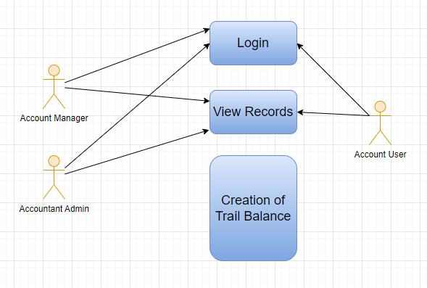

### Design of Workflow

* Design workflow is not applicable to this screen as records in it are created by only one role and are not sent to users with other roles for approval or modification.

### Validations

The data entered on this page will undergo a 2 step validation (I.e. client side and server side validation).

The following validation is done on client side:

1. Fields creation for Filters

The following validation is done on server side before save:

1. Get data
2. Get Column

After successful validation check from both client-side and server-side the result in the reports will be shown to user based on the filter that they have set.

**Client Side Validation**

Client-side validation refers to the process of validating user input directly on the client's web browser before saving it to the server for further processing. Following are some client side validations done for vendor selection report.

* **Field creation for From Company, From Date, To Date etc :**

Under filters assign fieldname, label, fieldtype, width, reqd and values for each of the filter values you want

**Server Side Validation**

Server-side validation refers to the process of validating user input on the server to ensure data integrity, security, and adherence to business rules before accepting or processing the information. Following are some server side validations done for vendor selection report.

* **Get_data**

1. Get value passed in filter for From date, To date
2. Write a query to get all necessary fields from Asset table
3. Return the data fetched through execution of query

* **Get_columns**

1. Pass values for label, fieldname, fieldtype, options and width of the column to be created
2. Return the columns value to create all columns

**Notification:**

* This section is not applicable since there is no notifications to be triggered

### Field List:

**Filter Fields**

|  |  |  |  |  |  |  |
| --- | --- | --- | --- | --- | --- | --- |
| **ID** | **Field Label** | **Field Type** | **Validation/Action** | **Mandatory** | **Remarks** | **R/N/D** |
|  | Company | Link Field | Fetched from Company master screen |  |  |  |
|  | Fiscal Year | Link Field | Fetched from Fiscal Year master screen |  |  |  |
|  | From Date | Date | From Date should be less than To Date |  |  |  |
|  | To Date | Date | To Date should be greater than From Date |  |  |  |
|  | Cost Center | Link Field | Fetched from Cost Center master screen |  |  |  |
|  | Project | Link Field | Fetched from Project master screen |  |  |  |
|  | Finance Book | Link Field | Fetched from Finance Book master screen |  |  |  |
|  | Currency | Link Field | Fetched from Currency master screen |  |  |  |
|  | Period Closing Entry | Checkbox |  |  | It shows the closing balances as per the period closing entries |  |
|  | Show Zero Values | Checkbox |  |  | It display parties that have a zero balance in the report. |  |
|  | Show unclosed fiscal year's P&L balances | Checkbox |  |  | It displays the profit and loss balances of unclosed fiscal years. |  |
|  | Include Default Book Entries | Checkbox |  |  | It includes predefined transactions used for opening balances of ledger accounts, such as banks, cash, and accounts payable/receivable. |  |

**Columns**

|  |  |  |
| --- | --- | --- |
| **ID** | **Column Fields** | **Description** |
|  | Account | Account refers to the ledger accounts |
|  | Opening (Dr) | Opening (Dr) represent the opening debit balances |
|  | Opening (Cr) | Opening (Cr) represents the opening credit balances |
|  | Debit | Debit represents the total debit transactions during the period |
|  | Credit | Credit represents the total credit transactions during the period |
|  | Closing (Dr) | Closing (Dr) represents the closing debit balance |
|  | Closing (Cr) | Closing (Cr) represents the closing credit balance |

### Processes After Form Submission

* This section is not applicable since the form is not submittable.

### Process Flow:



### Pre-requisites and Dependency

* Not Applicable

## Balance Sheet

A Balance Sheet is the financial statement of a company which states assets, liabilities and equity at a particular point in time.

The Balance Sheet gives more flexibility to analyse your financial position. You can run the report across multiple year to compare values. You can check values for a specific Finance Book or Cost Center. You can also choose any other currency to display the balances.

### Use Case Diagram

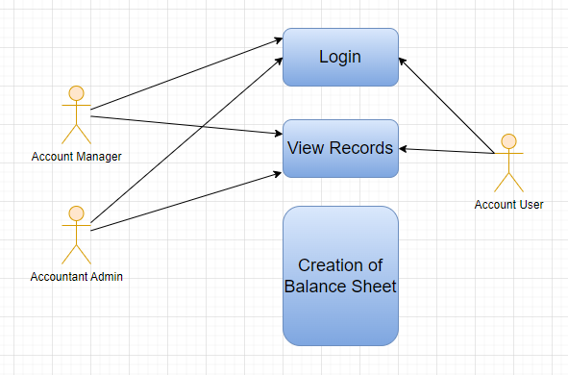

### Design of Workflow

* Design workflow is not applicable to this screen as records in it are created by only one role and are not sent to users with other roles for approval or modification.

### Validations

The data entered on this page will undergo a 2 step validation (I.e. client side and server side validation).

The following validation is done on client side:

1. Fields creation for Filters

The following validation is done on server side before save:

1. Get data
2. Get Column

After successful validation check from both client-side and server-side the result in the reports will be shown to user based on the filter that they have set.

**Client Side Validation**

Client-side validation refers to the process of validating user input directly on the client's web browser before saving it to the server for further processing. Following are some client side validations done for vendor selection report.

* **Field creation for From Company, Start Date, End Date etc :**

Under filters assign fieldname, label, fieldtype, width, reqd and values for each of the filter values you want

**Server Side Validation**

Server-side validation refers to the process of validating user input on the server to ensure data integrity, security, and adherence to business rules before accepting or processing the information. Following are some server side validations done for vendor selection report.

* **Get_data**

1. Get value passed in filter for From date, To date
2. Write a query to get all necessary fields from Asset table
3. Return the data fetched through execution of query

* **Get_columns**

1. Pass values for label, fieldname, fieldtype, options and width of the column to be created
2. Return the columns value to create all columns

**Notification:**

* This section is not applicable since there is no notifications to be triggered

### Field List:

**Filter Fields**

|  |  |  |  |  |  |  |
| --- | --- | --- | --- | --- | --- | --- |
| **ID** | **Field Label** | **Field Type** | **Validation/Action** | **Mandatory** | **Remarks** | **R/N/D** |
|  | Company | Link Field | Fetched from Company master screen |  |  |  |
|  | Finance Book | Link Field | Fetched from Finance Book master screen |  |  |  |
|  | Filter Based On | Drop Down | Fiscal Year/Date Range |  |  |  |
|  | Start Year | Link Field | Fetched from Fiscal Year master screen |  | Display depends on If Filter based on Fiscal Year |  |
|  | End Year | Link Field | Fetched from Fiscal Year master screen |  | Display depends on If Filter based on Fiscal Year |  |
|  | Start Date | Date | Start Date should be less than End Date |  | Display depends on If Filter based on Date Range |  |
|  | End Date | Date | End Date should be greater than Start Date |  | Display depends on If Filter based on Date Range |  |
|  | Periodicity | Dropdown | Monthly/Quarterly/Half-Yearly/Yearly |  |  |  |
|  | Currency | Link Field | Fetched from Currency master screen |  |  |  |
|  | Cost Center | Link Field | Fetched from Cost Center master screen |  |  |  |
|  | Accumulated Values in Group Company | Checkbox |  |  |  |  |
|  | Include Default Book Entries | Checkbox |  |  | It includes predefined transactions used for opening balances of ledger accounts, such as banks, cash, and accounts payable/receivable. |  |

**Columns**

|  |  |  |
| --- | --- | --- |
| **ID** | **Column Fields** | **Description** |
|  | Account | Name of the Account |
|  | Amount | Amount based on the Amount |

### Processes After Form Submission

* This section is not applicable since the form is not submittable.

### Process Flow:



### Pre-requisites and Dependency

* Not Applicable

## Profit and Loss Statement

A Profit and Loss Statement is a financial statement which summarizes all the revenues and expenses in a given period. The report is also known as P&L Statement.

### Use Case Diagram

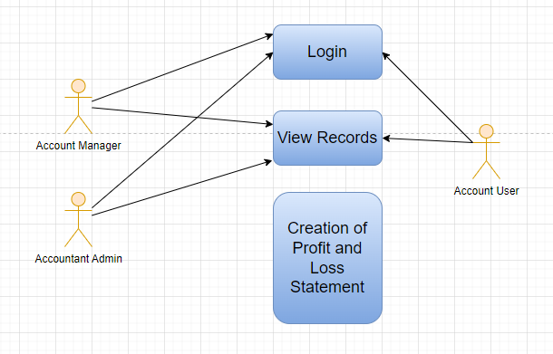

### Design of Workflow

* Design workflow is not applicable to this screen as records in it are created by only one role and are not sent to users with other roles for approval or modification.

### Validations

The data entered on this page will undergo a 2 step validation (I.e. client side and server side validation).

The following validation is done on client side:

1. Fields creation for Filters

The following validation is done on server side before save:

1. Get data
2. Get Column

After successful validation check from both client-side and server-side the result in the reports will be shown to user based on the filter that they have set.

**Client Side Validation**

Client-side validation refers to the process of validating user input directly on the client's web browser before saving it to the server for further processing. Following are some client side validations done for vendor selection report.

* **Field creation for From Company, Start Date, End Date etc :**

Under filters assign fieldname, label, fieldtype, width, reqd and values for each of the filter values you want

**Server Side Validation**

Server-side validation refers to the process of validating user input on the server to ensure data integrity, security, and adherence to business rules before accepting or processing the information. Following are some server side validations done for vendor selection report.

* **Get_data**

1. Get value passed in filter for From date, To date
2. Write a query to get all necessary fields from Asset table
3. Return the data fetched through execution of query

* **Get_columns**

1. Pass values for label, fieldname, fieldtype, options and width of the column to be created
2. Return the columns value to create all columns

**Notification:**

* This section is not applicable since there is no notifications to be triggered

### Field List:

**Filter Fields**

|  |  |  |  |  |  |  |
| --- | --- | --- | --- | --- | --- | --- |
| **ID** | **Field Label** | **Field Type** | **Validation/Action** | **Mandatory** | **Remarks** | **R/N/D** |
|  | Company | Link Field | Fetched from Company master screen |  |  |  |
|  | Finance Book | Link Field | Fetched from Finance Book master screen |  |  |  |
|  | Filter Based On | Drop Down | Fiscal Year/Date Range |  |  |  |
|  | Start Year | Link Field | Fetched from Fiscal Year master screen |  | Display depends on If Filter based on Fiscal Year |  |
|  | End Year | Link Field | Fetched from Fiscal Year master screen |  | Display depends on If Filter based on Fiscal Year |  |
|  | Start Date | Date | Start Date should be less than End Date |  | Display depends on If Filter based on Date Range |  |
|  | End Date | Date | End Date should be greater than Start Date |  | Display depends on If Filter based on Date Range |  |
|  | Periodicity | Dropdown | Monthly/Quarterly/Half-Yearly/Yearly |  |  |  |
|  | Currency | Link Field | Fetched from Currency master screen |  |  |  |
|  | Cost Center | Link Field | Fetched from Cost Center master screen |  |  |  |
|  | Project | Link Field | Fetched from Project master screen |  |  |  |
|  | Include Default Book Entries |  |  |  | It includes predefined transactions used for opening balances of ledger accounts, such as banks, cash, and accounts payable/receivable. |  |

**Columns**

|  |  |  |
| --- | --- | --- |
| **ID** | **Column Fields** | **Description** |
|  | Account | Name of the Account |
|  | Amount | Amount based on the Amount |

### Processes After Form Submission

* This section is not applicable since the form is not submittable.

### Process Flow:



### Pre-requisites and Dependency

* Not Applicable

## Cash Flow

A Cash Flow is a financial statement which shows the incoming and outgoing of cash or cash-equivalents for a company. It is used to analyse the liquidity position of the company.

### Use Case Diagram

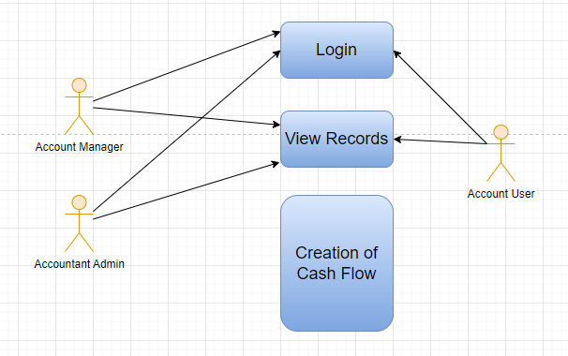

### Design of Workflow

* Design workflow is not applicable to this screen as records in it are created by only one role and are not sent to users with other roles for approval or modification.

### Validations

The data entered on this page will undergo a 2 step validation (I.e. client side and server side validation).

The following validation is done on client side:

1. Fields creation for Filters

The following validation is done on server side before save:

1. Get data
2. Get Column

After successful validation check from both client-side and server-side the result in the reports will be shown to user based on the filter that they have set.

**Client Side Validation**

Client-side validation refers to the process of validating user input directly on the client's web browser before saving it to the server for further processing. Following are some client side validations done for vendor selection report.

* **Field creation for From Company, Start Date, End Date etc :**

Under filters assign fieldname, label, fieldtype, width, reqd and values for each of the filter values you want

**Server Side Validation**

Server-side validation refers to the process of validating user input on the server to ensure data integrity, security, and adherence to business rules before accepting or processing the information. Following are some server side validations done for vendor selection report.

* **Get_data**

1. Get value passed in filter for From date, To date
2. Write a query to get all necessary fields from Asset table
3. Return the data fetched through execution of query

* **Get_columns**

1. Pass values for label, fieldname, fieldtype, options and width of the column to be created
2. Return the columns value to create all columns

**Notification:**

* This section is not applicable since there is no notifications to be triggered

### Field List:

**Filter Fields**

|  |  |  |  |  |  |  |
| --- | --- | --- | --- | --- | --- | --- |
| **ID** | **Field Label** | **Field Type** | **Validation/Action** | **Mandatory** | **Remarks** | **R/N/D** |
|  | Company | Link Field | Fetched from Company master screen |  |  |  |
|  | Finance Book | Link Field | Fetched from Finance Book master screen |  |  |  |
|  | Filter Based On | Drop Down | Fiscal Year/Date Range |  |  |  |
|  | Start Year | Link Field | Fetched from Fiscal Year master screen |  | Display depends on If Filter based on Fiscal Year |  |
|  | End Year | Link Field | Fetched from Fiscal Year master screen |  | Display depends on If Filter based on Fiscal Year |  |
|  | Start Date | Date | Start Date should be less than End Date |  | Display depends on If Filter based on Date Range |  |
|  | End Date | Date | End Date should be greater than Start Date |  | Display depends on If Filter based on Date Range |  |
|  | Periodicity | Dropdown | Monthly/Quarterly/Half-Yearly/Yearly |  |  |  |
|  | Cost Center | Link Field | Fetched from Cost Center master screen |  |  |  |
|  | Include Default Book Entries | Checkbox |  |  | It includes predefined transactions used for opening balances of ledger accounts, such as banks, cash, and accounts payable/receivable. |  |

**Columns**

|  |  |  |
| --- | --- | --- |
| **ID** | **Column Fields** | **Description** |
|  | Account | Name of the Account |
|  | Amount | Amount based on the Amount |

### Processes After Form Submission

* This section is not applicable since the form is not submittable.

### Process Flow:



### Pre-requisites and Dependency

* Not Applicable

## Consolidated Financial Statement

The report shows a consolidated view of Balance Sheet, Profit and Loss Statement and Cash Flow for a group company, by merging financial statements of all the subsidary companies. It shows balances for all individual company and as well as accumulated balances for a group company.

### Use Case Diagram

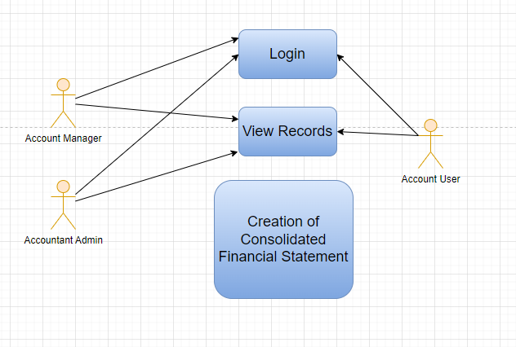

### Design of Workflow

* Design workflow is not applicable to this screen as records in it are created by only one role and are not sent to users with other roles for approval or modification.

### Validations

The data entered on this page will undergo a 2 step validation (I.e. client side and server side validation).

The following validation is done on client side:

1. Fields creation for Filters

The following validation is done on server side before save:

1. Get data
2. Get Column

After successful validation check from both client-side and server-side the result in the reports will be shown to user based on the filter that they have set.

**Client Side Validation**

Client-side validation refers to the process of validating user input directly on the client's web browser before saving it to the server for further processing. Following are some client side validations done for vendor selection report.

* **Field creation for From Company, Start Date, End Date etc :**

Under filters assign fieldname, label, fieldtype, width, reqd and values for each of the filter values you want

**Server Side Validation**

Server-side validation refers to the process of validating user input on the server to ensure data integrity, security, and adherence to business rules before accepting or processing the information. Following are some server side validations done for vendor selection report.

* **Get_data**

1. Get value passed in filter for From date, To date
2. Write a query to get all necessary fields from Asset table
3. Return the data fetched through execution of query

* **Get_columns**

1. Pass values for label, fieldname, fieldtype, options and width of the column to be created
2. Return the columns value to create all columns

**Notification:**

* This section is not applicable since there is no notifications to be triggered

### Field List:

**Filter Fields**

|  |  |  |  |  |  |  |
| --- | --- | --- | --- | --- | --- | --- |
| **ID** | **Field Label** | **Field Type** | **Validation/Action** | **Mandatory** | **Remarks** | **R/N/D** |
|  | Company | Link Field | Fetched from Company master screen |  |  |  |
|  | Filter Based On | Drop Down | Fiscal Year/Date Range |  |  |  |
|  | Start Year | Link Field | Fetched from Fiscal Year master screen |  | Display depends on If Filter based on Fiscal Year |  |
|  | End Year | Link Field | Fetched from Fiscal Year master screen |  | Display depends on If Filter based on Fiscal Year |  |
|  | Start Date | Date | Start Date should be less than End Date |  | Display depends on If Filter based on Date Range |  |
|  | End Date | Date | End Date should be greater than Start Date |  | Display depends on If Filter based on Date Range |  |
|  | Finance Book | Link Field | Fetched from Finance Book master screen |  |  |  |
|  | Report | Dropdown | Profit and Loss Statement/Balance Sheet/Cash Flow |  |  |  |
|  | Currency | Link Field | Fetched from Currency master screen |  |  |  |
|  | Accumulated Values in Group Company | Checkbox |  |  |  |  |
|  | Include Default Book Entries | Checkbox |  |  | It includes predefined transactions used for opening balances of ledger accounts, such as banks, cash, and accounts payable/receivable. |  |
|  | Show zero values | Checkbox |  |  | "Show Zero Values" option allows you to display parties that have a zero balance in the report. |  |

**Columns**

|  |  |  |
| --- | --- | --- |
| **ID** | **Column Fields** | **Description** |
|  | Account | Name of the Account |
|  | Amount | Amount based on the Account |

### Processes After Form Submission

* This section is not applicable since the form is not submittable.

### Process Flow:



### Pre-requisites and Dependency

* Not Applicable

## Fixed Deposit

A fixed deposit (FD) is a [financial instrument](https://en.wikipedia.org/wiki/Financial_instrument" \o "Financial instrument) provided by banks or [non-bank financial institutions](https://en.wikipedia.org/wiki/Non-bank_financial_institution" \o "Non-bank financial institution) which provides investors a higher rate of [interest](https://en.wikipedia.org/wiki/Interest" \o "Interest) than a regular [savings account](https://en.wikipedia.org/wiki/Savings_account" \o "Savings account), until the given maturity date. It may or may not require the creation of a separate account. This screen will help in tracking Fixed Deposits.

### Use Case Diagram

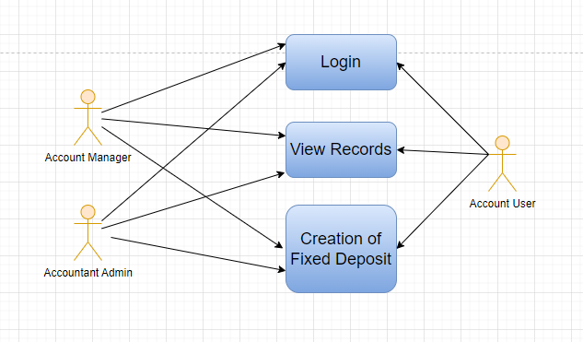

### Design of Workflow

* Design workflow is not applicable to this screen as records in it are created by only one role and are not sent to users with other roles for approval or modification.

### Validations

**Client Side Validation:**

Client-side validation refers to the process of validating user input directly on the client's web browser before saving it to the server for further processing.

The following validations are done on client side for Fixed Deposit Screen:

* Mandatory checks for fields : None
* Linked fields : The FD Account field is linked to the Account Screen. The Company field is linked to the Company Screen. The Bank Account field is linked to the Bank Account Screen. The Interest Account field is linked to the Account Screen.

**Server Side Validation:**

Server-side validation refers to the process of validating user input on the server to ensure data integrity, security, and adherence to business rules before accepting or processing the information.

There are no server side validations Fixed Deposit.

**Notification:**

* Not Applicable

### Field List:

|  |  |  |  |  |  |  |
| --- | --- | --- | --- | --- | --- | --- |
| **ID** | **Field Name** | **Field Type** | **Mandatory** | **Validation/Action** | **Remarks** | **R/N/D** |
| 1 | FD Number | Int |  |  |  |  |
| 2 | Posting Date | Date |  |  |  |  |
| 3 | FD Account | Link Field |  | Links to Account Screen |  |  |
| 4 | FD Start Date | Date |  | FD Start Date should be less than Maturity Date |  |  |
| 5 | Company | Link Field |  | Links to Company Screen |  |  |
| 6 | Bank Account | Link Field |  | Links to Account Screen |  |  |
| 7 | Interest Account | Link Field |  | Links to Account Screen |  |  |
| 8 | Maturity Date | Date |  | FD Maturity Date should be greater than FD Start Date |  |  |
| 9 | FD Amount | Currency |  |  |  |  |
| 10 | Maturity Amount | Currency |  |  |  |  |
| 11 | Interest Payable | Select |  | Options: On Maturity Quarterly Monthly |  |  |
| 12 | FD Tenure | Data |  |  |  |  |
| 13 | Interest Type | Select |  | Options: Simple Compound |  |  |
| 14 | Interest Percentage | Float |  |  |  |  |
| 15 | Interest Calculation | Table |  | Fixed Deposit Interest | For further details regarding table Please check below |  |

### Processes After Form Submission

* This section is not applicable since the form has no workflow on submission.

### Process Flow:

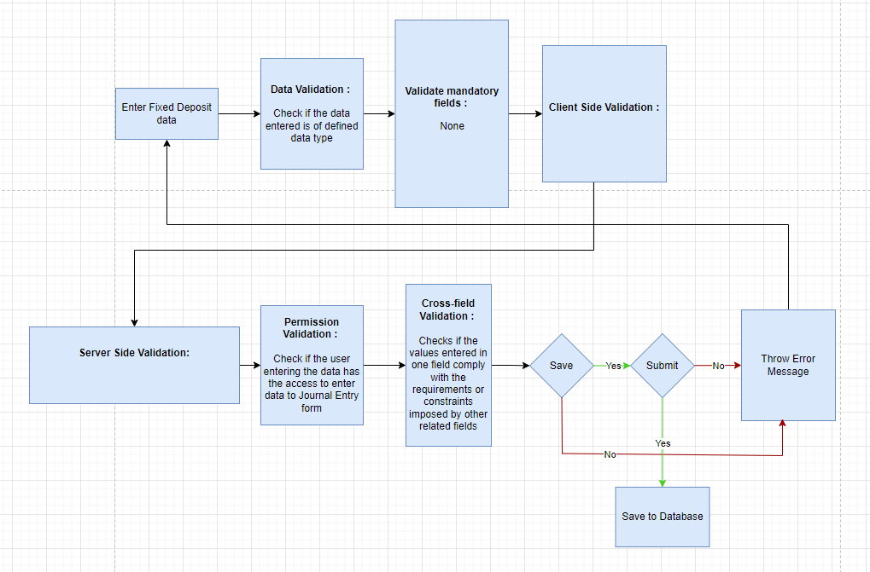

### Pre-requisites and Dependency

* Account
* Company

# Tools And Technologies

This section explains the tools that are used to build this design document

* Draw.io - it is an online tool used to develop the flowcharts used in this document.
* WPS office - it is a text editor that has been used to write and assemble this document

# Non-Functional Requirements

## Performance

Specify performance requirements, including response times, transaction throughput, and system scalability

## Reliability

Define the reliability requirements, such as availability, fault tolerance, and disaster recovery

## Usability

Describe usability requirements, including user-friendly interfaces, clear error messages, and intuitive workflows

## Compatibility

Specify compatibility requirements with different operating systems, web browsers, and devices

## Security

Security requirements, including authentication, access control, data encryption, and secure communication protocols

* Authentication: The system will provide robust and secure authentication mechanisms to ensure that only authorized users can access the system and its resources
* Authorization: The system will enforce access controls to restrict users' actions based on their roles and privileges, ensuring that users can only access the resources they are authorized to use
* Data Encryption: Sensitive data, both at rest and in transit, will be encrypted to protect it from unauthorized access or interception
* Secure Communication: Secure communication protocols (e.g., HTTPS, TLS) should be used to protect data exchanged between clients and servers

## Compliance

Specify any legal or regulatory compliance requirements, such as GDPR, PCI DSS, or other industry-specific standards

## Documentation

Describe the documentation requirements, including user manuals, developer guides, and API documentation

## Security: User access and authorization

The screens and the data in them is made secure by creating roles with different permissions and then assigning those roles the appropriate users. For this screen following are the roles and their corresponding permissions:

### 

**Company**

|  |  |  |  |  |  |  |  |  |
| --- | --- | --- | --- | --- | --- | --- | --- | --- |
| **ID** | **Role** | **Read** | **Write** | **Create** | **Delete** | **Submit** | **Cancel** | **Amend** |
| 1 | Account User | No | No | No | No | NA | NA | NA |
| 2 | Account Manager | Yes | Yes | Yes | No | NA | NA | NA |
| 3 | Accountant Admin | Yes | Yes | Yes | No | NA | NA | NA |

**Account**

|  |  |  |  |  |  |  |  |  |
| --- | --- | --- | --- | --- | --- | --- | --- | --- |
| **ID** | **Role** | **Read** | **Write** | **Create** | **Delete** | **Submit** | **Cancel** | **Amend** |
| 1 | Account User | No | No | No | No | NA | NA | NA |
| 2 | Account Manager | Yes | Yes | Yes | No | NA | NA | NA |
| 3 | Accountant Admin | Yes | Yes | Yes | No | NA | NA | NA |

**Fiscal Year**

|  |  |  |  |  |  |  |  |  |
| --- | --- | --- | --- | --- | --- | --- | --- | --- |
| **ID** | **Role** | **Read** | **Write** | **Create** | **Delete** | **Submit** | **Cancel** | **Amend** |
| 1 | Account User | No | No | No | No | NA | NA | NA |
| 2 | Account Manager | Yes | Yes | Yes | No | NA | NA | NA |
| 3 | Accountant Admin | Yes | Yes | Yes | No | NA | NA | NA |

**Accounting Period**

|  |  |  |  |  |  |  |  |  |
| --- | --- | --- | --- | --- | --- | --- | --- | --- |
| **ID** | **Role** | **Read** | **Write** | **Create** | **Delete** | **Submit** | **Cancel** | **Amend** |
| 1 | Account User | No | No | No | No | NA | NA | NA |
| 2 | Account Manager | Yes | Yes | Yes | No | NA | NA | NA |
| 3 | Accountant Admin | Yes | Yes | Yes | No | NA | NA | NA |

**Finance Book**

|  |  |  |  |  |  |  |  |  |
| --- | --- | --- | --- | --- | --- | --- | --- | --- |
| **ID** | **Role** | **Read** | **Write** | **Create** | **Delete** | **Submit** | **Cancel** | **Amend** |
| 1 | Account User | No | No | No | No | NA | NA | NA |
| 2 | Account Manager | Yes | Yes | Yes | No | NA | NA | NA |
| 3 | Accountant Admin | Yes | Yes | Yes | No | NA | NA | NA |

**Bank**

|  |  |  |  |  |  |  |  |  |
| --- | --- | --- | --- | --- | --- | --- | --- | --- |
| **ID** | **Role** | **Read** | **Write** | **Create** | **Delete** | **Submit** | **Cancel** | **Amend** |
| 1 | Account User | No | No | No | No | NA | NA | NA |
| 2 | Account Manager | Yes | Yes | Yes | No | NA | NA | NA |
| 3 | Accountant Admin | Yes | Yes | Yes | No | NA | NA | NA |

**Bank Account**

|  |  |  |  |  |  |  |  |  |
| --- | --- | --- | --- | --- | --- | --- | --- | --- |
| **ID** | **Role** | **Read** | **Write** | **Create** | **Delete** | **Submit** | **Cancel** | **Amend** |
| 1 | Account User | No | No | No | No | NA | NA | NA |
| 2 | Account Manager | Yes | Yes | Yes | No | NA | NA | NA |
| 3 | Accountant Admin | Yes | Yes | Yes | No | NA | NA | NA |

**Mode of payment**

|  |  |  |  |  |  |  |  |  |
| --- | --- | --- | --- | --- | --- | --- | --- | --- |
| **ID** | **Role** | **Read** | **Write** | **Create** | **Delete** | **Submit** | **Cancel** | **Amend** |
| 1 | Account User | No | No | No | No | NA | NA | NA |
| 2 | Account Manager | Yes | Yes | Yes | No | NA | NA | NA |
| 3 | Accountant Admin | Yes | Yes | Yes | No | NA | NA | NA |

**Currency**

|  |  |  |  |  |  |  |  |  |
| --- | --- | --- | --- | --- | --- | --- | --- | --- |
| **ID** | **Role** | **Read** | **Write** | **Create** | **Delete** | **Submit** | **Cancel** | **Amend** |
| 1 | Account User | No | No | No | No | NA | NA | NA |
| 2 | Account Manager | No | No | No | No | NA | NA | NA |
| 3 | Accountant Admin | No | No | No | No | NA | NA | NA |

**Party Type**

|  |  |  |  |  |  |  |  |  |
| --- | --- | --- | --- | --- | --- | --- | --- | --- |
| **ID** | **Role** | **Read** | **Write** | **Create** | **Delete** | **Submit** | **Cancel** | **Amend** |
| 1 | Account User | No | No | No | No | NA | NA | NA |
| 2 | Account Manager | No | No | No | No | NA | NA | NA |
| 3 | Accountant Admin | No | No | No | No | NA | NA | NA |

**Cost Center**

|  |  |  |  |  |  |  |  |  |
| --- | --- | --- | --- | --- | --- | --- | --- | --- |
| **ID** | **Role** | **Read** | **Write** | **Create** | **Delete** | **Submit** | **Cancel** | **Amend** |
| 1 | Account User | No | No | No | No | NA | NA | NA |
| 2 | Account Manager | Yes | Yes | Yes | No | NA | NA | NA |
| 3 | Accountant Admin | Yes | Yes | Yes | No | NA | NA | NA |

**Accounting Dimension**

|  |  |  |  |  |  |  |  |  |
| --- | --- | --- | --- | --- | --- | --- | --- | --- |
| **ID** | **Role** | **Read** | **Write** | **Create** | **Delete** | **Submit** | **Cancel** | **Amend** |
| 1 | Account User | No | No | No | No | NA | NA | NA |
| 2 | Account Manager | Yes | Yes | Yes | No | NA | NA | NA |
| 3 | Accountant Admin | Yes | Yes | Yes | No | NA | NA | NA |

**Journal Entry**

|  |  |  |  |  |  |  |  |  |
| --- | --- | --- | --- | --- | --- | --- | --- | --- |
| **ID** | **Role** | **Read** | **Write** | **Create** | **Delete** | **Submit** | **Cancel** | **Amend** |
| 1 | Accountant Admin | Yes | Yes | Yes | No | Yes | Yes | Yes |
| 2 | Account Manager | Yes | Yes | Yes | No | Yes | Yes | Yes |
| 3 | Account User | Yes | Yes | Yes | No | Yes | Yes | Yes |

**GL Entry**

|  |  |  |  |  |  |  |  |  |
| --- | --- | --- | --- | --- | --- | --- | --- | --- |
| **ID** | **Role** | **Read** | **Write** | **Create** | **Delete** | **Submit** | **Cancel** | **Amend** |
| 1 | Account User | No | No | No | No | NA | NA | NA |
| 2 | Account Manager | No | No | No | No | NA | NA | NA |
| 3 | Accountant Admin | No | No | No | No | NA | NA | NA |

**General Ledger**

|  |  |  |  |  |  |  |  |  |
| --- | --- | --- | --- | --- | --- | --- | --- | --- |
| **ID** | **Role** | **Read** | **Write** | **Create** | **Delete** | **Submit** | **Cancel** | **Amend** |
| 1 | Accountant Admin | Yes | Yes | NA | NA | NA | NA | NA |
| 2 | Account Manager | Yes | Yes | NA | NA | NA | NA | NA |
| 3 | Account User | Yes | Yes | NA | NA | NA | NA | NA |

**Payment Entry**

|  |  |  |  |  |  |  |  |  |
| --- | --- | --- | --- | --- | --- | --- | --- | --- |
| **ID** | **Role** | **Read** | **Write** | **Create** | **Delete** | **Submit** | **Cancel** | **Amend** |
| 1 | Accountant Admin | Yes | Yes | Yes | No | Yes | Yes | Yes |
| 2 | Account Manager | Yes | Yes | Yes | No | Yes | No | Yes |
| 3 | Account User | Yes | Yes | Yes | No | Yes | No | Yes |

**Bank Reconciliation Tool**

|  |  |  |  |  |  |  |  |  |
| --- | --- | --- | --- | --- | --- | --- | --- | --- |
| **ID** | **Role** | **Read** | **Write** | **Create** | **Delete** | **Submit** | **Cancel** | **Amend** |
| 1 | Account User | No | No | No | No | NA | NA | NA |
| 2 | Account Manager | Yes | Yes | Yes | No | NA | NA | NA |
| 3 | Accountant Admin | Yes | Yes | Yes | No | NA | NA | NA |

**Bank Clearance**

|  |  |  |  |  |  |  |  |  |
| --- | --- | --- | --- | --- | --- | --- | --- | --- |
| **ID** | **Role** | **Read** | **Write** | **Create** | **Delete** | **Submit** | **Cancel** | **Amend** |
| 1 | Account User | No | No | No | No | NA | NA | NA |
| 2 | Account Manager | Yes | Yes | Yes | No | NA | NA | NA |
| 3 | Accountant Admin | Yes | Yes | Yes | No | NA | NA | NA |

**Bank Reconciliation Statement**

|  |  |  |  |  |  |  |  |  |
| --- | --- | --- | --- | --- | --- | --- | --- | --- |
| **ID** | **Role** | **Read** | **Write** | **Create** | **Delete** | **Submit** | **Cancel** | **Amend** |
| 1 | Accountant Admin | Yes | Yes | NA | NA | NA | NA | NA |
| 2 | Account Manager | Yes | Yes | NA | NA | NA | NA | NA |
| 3 | Account User | Yes | Yes | NA | NA | NA | NA | NA |

**Accounts Receivable Report**

|  |  |  |  |  |  |  |  |  |
| --- | --- | --- | --- | --- | --- | --- | --- | --- |
| **ID** | **Role** | **Read** | **Write** | **Create** | **Delete** | **Submit** | **Cancel** | **Amend** |
| 1 | Accountant Admin | Yes | Yes | NA | NA | NA | NA | NA |
| 2 | Account Manager | Yes | Yes | NA | NA | NA | NA | NA |
| 3 | Account User | Yes | Yes | NA | NA | NA | NA | NA |

**Accounts Receivable Summary Report**

|  |  |  |  |  |  |  |  |  |
| --- | --- | --- | --- | --- | --- | --- | --- | --- |
| **ID** | **Role** | **Read** | **Write** | **Create** | **Delete** | **Submit** | **Cancel** | **Amend** |
| 1 | Accountant Admin | Yes | Yes | NA | NA | NA | NA | NA |
| 2 | Account Manager | Yes | Yes | NA | NA | NA | NA | NA |
| 3 | Account User | Yes | Yes | NA | NA | NA | NA | NA |

**Accounts Payable Report**

|  |  |  |  |  |  |  |  |  |
| --- | --- | --- | --- | --- | --- | --- | --- | --- |
| **ID** | **Role** | **Read** | **Write** | **Create** | **Delete** | **Submit** | **Cancel** | **Amend** |
| 1 | Accountant Admin | Yes | Yes | NA | NA | NA | NA | NA |
| 2 | Account Manager | Yes | Yes | NA | NA | NA | NA | NA |
| 3 | Account User | Yes | Yes | NA | NA | NA | NA | NA |

**Accounts Payable Summary Report**

|  |  |  |  |  |  |  |  |  |
| --- | --- | --- | --- | --- | --- | --- | --- | --- |
| **ID** | **Role** | **Read** | **Write** | **Create** | **Delete** | **Submit** | **Cancel** | **Amend** |
| 1 | Accountant Admin | Yes | Yes | NA | NA | NA | NA | NA |
| 2 | Account Manager | Yes | Yes | NA | NA | NA | NA | NA |
| 3 | Account User | Yes | Yes | NA | NA | NA | NA | NA |

**Purchase Register Report**

|  |  |  |  |  |  |  |  |  |
| --- | --- | --- | --- | --- | --- | --- | --- | --- |
| **ID** | **Role** | **Read** | **Write** | **Create** | **Delete** | **Submit** | **Cancel** | **Amend** |
| 1 | Accountant Admin | Yes | Yes | NA | NA | NA | NA | NA |
| 2 | Account Manager | Yes | Yes | NA | NA | NA | NA | NA |
| 3 | Account User | Yes | Yes | NA | NA | NA | NA | NA |

**Item Wise Purchase Register Report**

|  |  |  |  |  |  |  |  |  |
| --- | --- | --- | --- | --- | --- | --- | --- | --- |
| **ID** | **Role** | **Read** | **Write** | **Create** | **Delete** | **Submit** | **Cancel** | **Amend** |
| 1 | Accountant Admin | Yes | Yes | NA | NA | NA | NA | NA |
| 2 | Account Manager | Yes | Yes | NA | NA | NA | NA | NA |
| 3 | Account User | Yes | Yes | NA | NA | NA | NA | NA |

**Trial Balance for Party Report**

|  |  |  |  |  |  |  |  |  |
| --- | --- | --- | --- | --- | --- | --- | --- | --- |
| **ID** | **Role** | **Read** | **Write** | **Create** | **Delete** | **Submit** | **Cancel** | **Amend** |
|  | Account User | Yes | No | NA | NA | NA | NA | NA |
|  | Account Manager | Yes | No | NA | NA | NA | NA | NA |
|  | Account Admin | Yes | Yes | NA | NA | NA | NA | NA |

**Tax Detail Report**

|  |  |  |  |  |  |  |  |  |
| --- | --- | --- | --- | --- | --- | --- | --- | --- |
| **ID** | **Role** | **Read** | **Write** | **Create** | **Delete** | **Submit** | **Cancel** | **Amend** |
|  | Account User | Yes | No | NA | NA | NA | NA | NA |
|  | Account Manager | Yes | No | NA | NA | NA | NA | NA |
|  | Account Admin | Yes | Yes | NA | NA | NA | NA | NA |

**Supplier Ledger Summary Report**

|  |  |  |  |  |  |  |  |  |
| --- | --- | --- | --- | --- | --- | --- | --- | --- |
| **ID** | **Role** | **Read** | **Write** | **Create** | **Delete** | **Submit** | **Cancel** | **Amend** |
| 1 | Accountant Admin | Yes | Yes | NA | NA | NA | NA | NA |
| 2 | Account Manager | Yes | Yes | NA | NA | NA | NA | NA |
| 3 | Account User | Yes | Yes | NA | NA | NA | NA | NA |

**Trial Balance**

|  |  |  |  |  |  |  |  |  |
| --- | --- | --- | --- | --- | --- | --- | --- | --- |
| **ID** | **Role** | **Read** | **Write** | **Create** | **Delete** | **Submit** | **Cancel** | **Amend** |
|  | Account User | Yes | No | NA | NA | NA | NA | NA |
|  | Account Manager | Yes | No | NA | NA | NA | NA | NA |
|  | Account Admin | Yes | Yes | NA | NA | NA | NA | NA |

**Balance Sheet**

|  |  |  |  |  |  |  |  |  |
| --- | --- | --- | --- | --- | --- | --- | --- | --- |
| **ID** | **Role** | **Read** | **Write** | **Create** | **Delete** | **Submit** | **Cancel** | **Amend** |
|  | Account User | No | No | NA | NA | NA | NA | NA |
|  | Account Manager | No | No | NA | NA | NA | NA | NA |
|  | Account Admin | Yes | Yes | NA | NA | NA | NA | NA |

**Profit and Loss Statement**

|  |  |  |  |  |  |  |  |  |
| --- | --- | --- | --- | --- | --- | --- | --- | --- |
| **ID** | **Role** | **Read** | **Write** | **Create** | **Delete** | **Submit** | **Cancel** | **Amend** |
|  | Account User | No | No | NA | NA | NA | NA | NA |
|  | Account Manager | No | No | NA | NA | NA | NA | NA |
|  | Account Admin | Yes | Yes | NA | NA | NA | NA | NA |

**Cash Flow**

|  |  |  |  |  |  |  |  |  |
| --- | --- | --- | --- | --- | --- | --- | --- | --- |
| **ID** | **Role** | **Read** | **Write** | **Create** | **Delete** | **Submit** | **Cancel** | **Amend** |
|  | Account User | Yes | No | NA | NA | NA | NA | NA |
|  | Account Manager | Yes | No | NA | NA | NA | NA | NA |
|  | Account Admin | Yes | Yes | NA | NA | NA | NA | NA |

**Consolidated Financial Statement**

|  |  |  |  |  |  |  |  |  |
| --- | --- | --- | --- | --- | --- | --- | --- | --- |
| **ID** | **Role** | **Read** | **Write** | **Create** | **Delete** | **Submit** | **Cancel** | **Amend** |
|  | Account User | No | No | NA | NA | NA | NA | NA |
|  | Account Manager | No | No | NA | NA | NA | NA | NA |
|  | Account Admin | Yes | Yes | NA | NA | NA | NA | NA |

**Fixed Deposit**

|  |  |  |  |  |  |  |  |  |
| --- | --- | --- | --- | --- | --- | --- | --- | --- |
| **ID** | **Role** | **Read** | **Write** | **Create** | **Delete** | **Submit** | **Cancel** | **Amend** |
| 1 | Account User | Yes | Yes | Yes | No | NA | NA | NA |
| 2 | Account Manager | Yes | Yes | Yes | No | NA | NA | NA |
| 3 | Accountant Admin | Yes | Yes | Yes | No | NA | NA | NA |

# Database Design

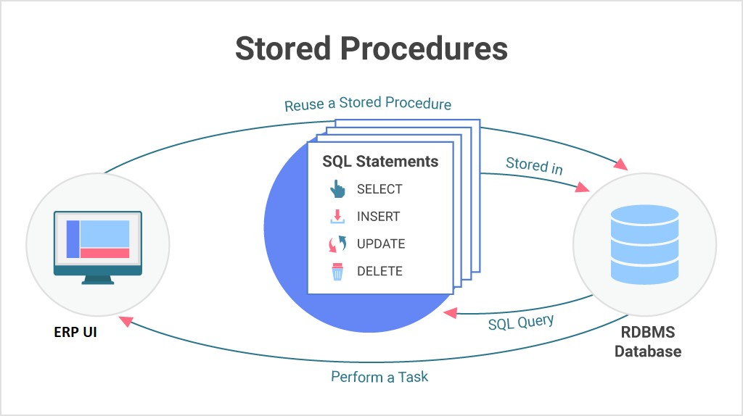

**Prototype**

# Prototype

The screen samples that have been derived based on the requirements gathered from the users / SME’s of the **Accounting** module

## Company

Description: A company is a legal entity made up of an association of people carrying on a commercial or industrial enterprise.

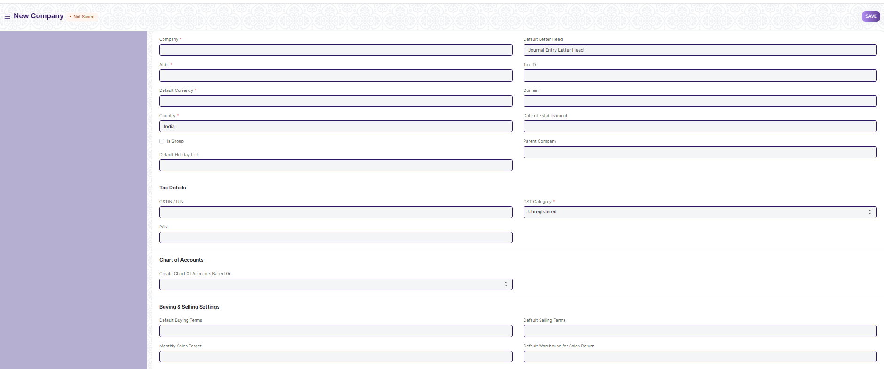

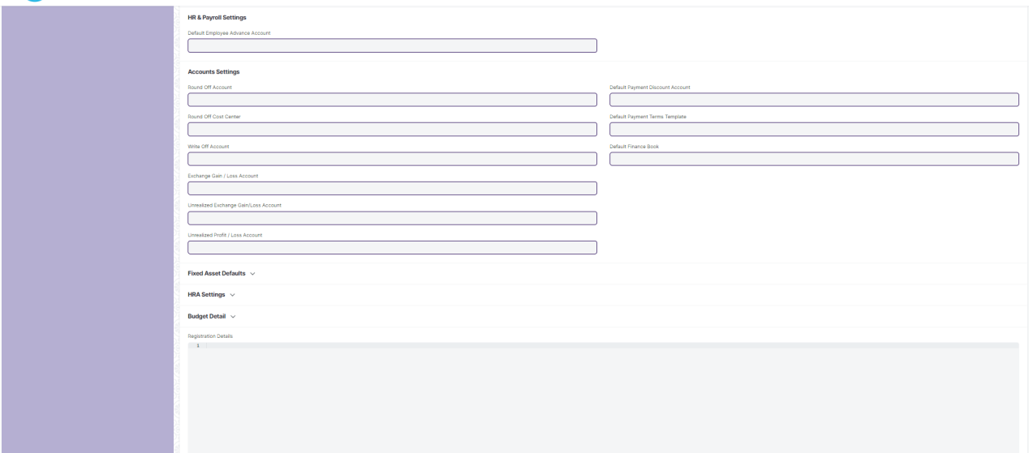

Figure Company

## Account

Description: The Chart of Accounts is the blueprint of the accounts in your organization.Chart of Accounts is a tree view of the names of the Accounts (Ledgers and Groups) that a Company requires to manage its books of accounts.Each of the Accounts of chart of Accounts is Link Fielded to General Ledger.

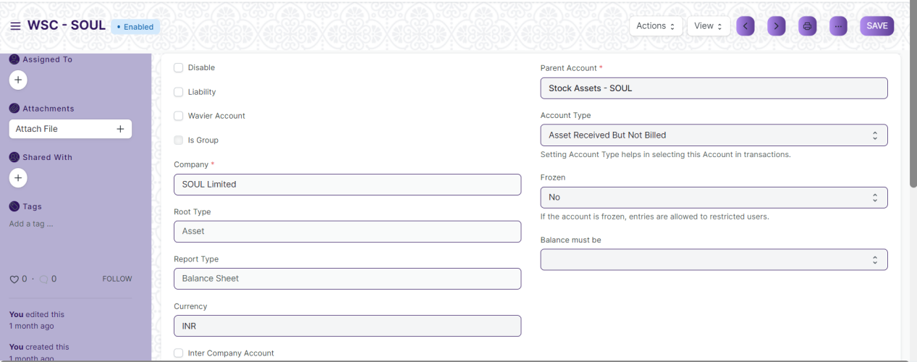

Figure Account

## Fiscal Year

## 

Figure Fiscal Year

## Accounting Period

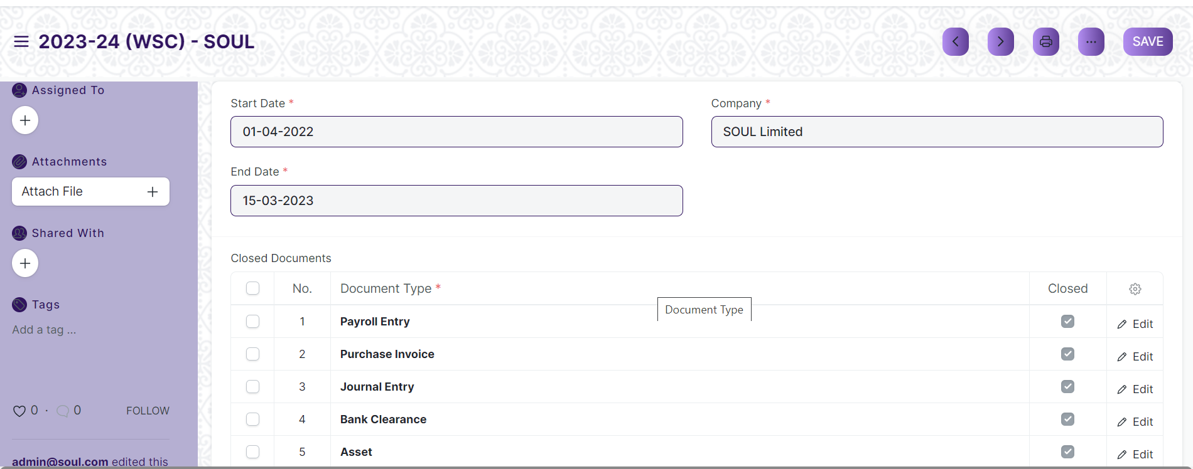

Figure Accounting Period

## Finance Book

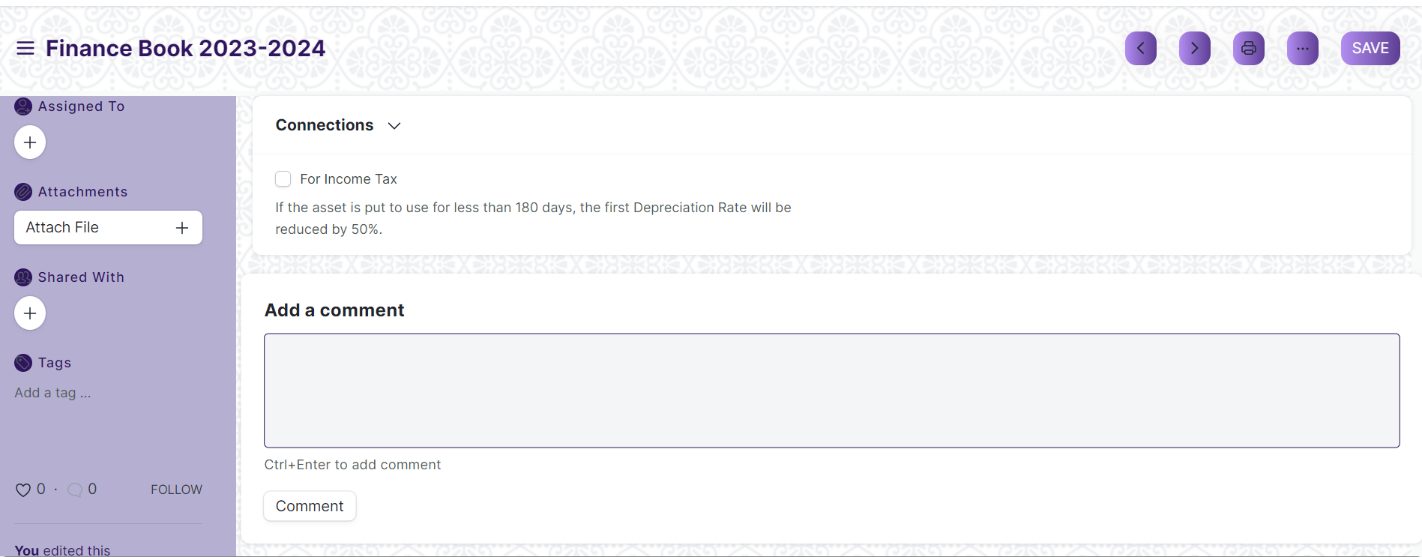

Figure Finance Book

## Bank

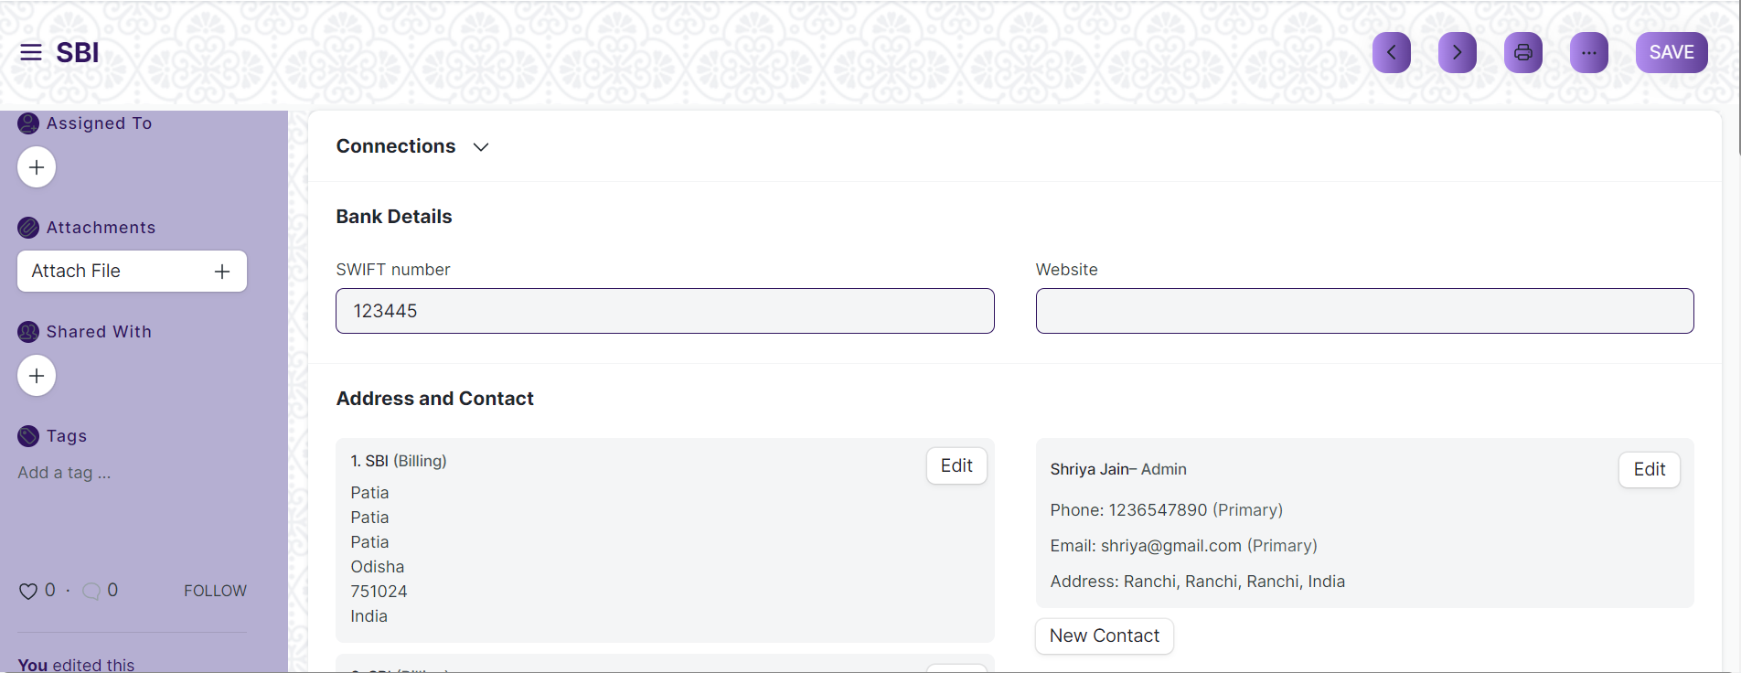

Figure Bank

## Bank Account

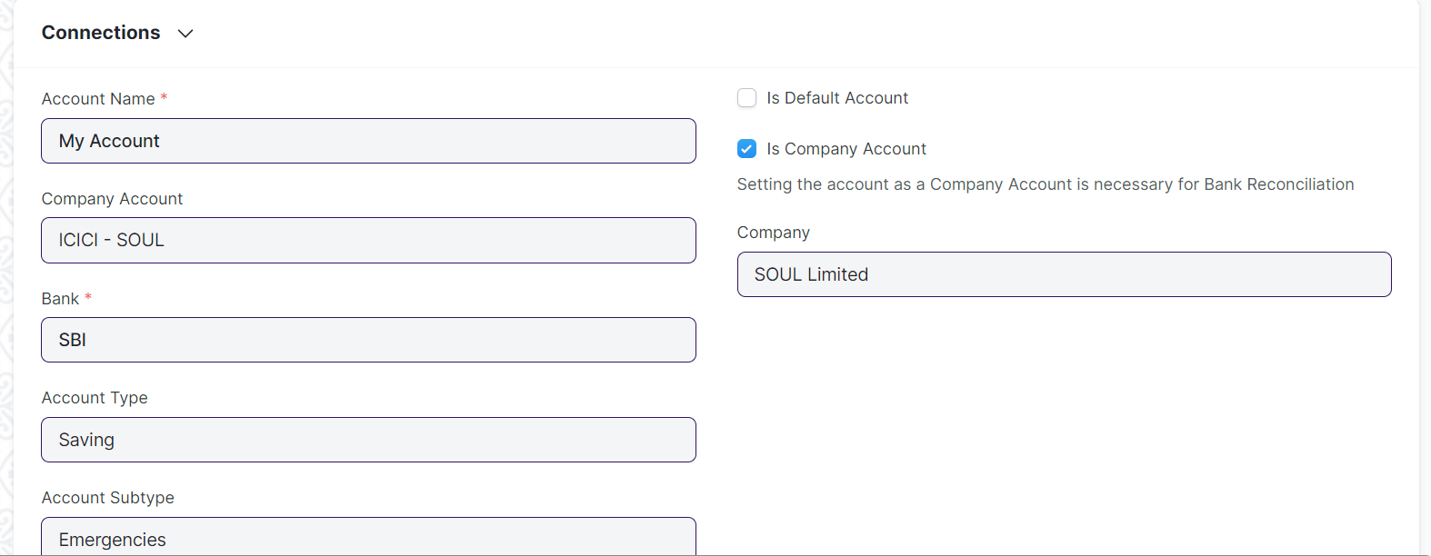

Figure Bank Account

## Mode of Payment

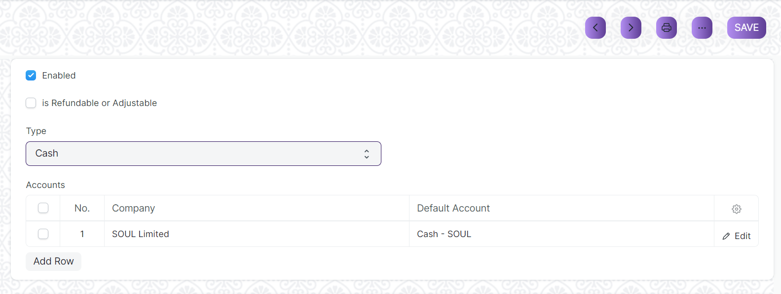

Figure Mode of Payment

## Currency

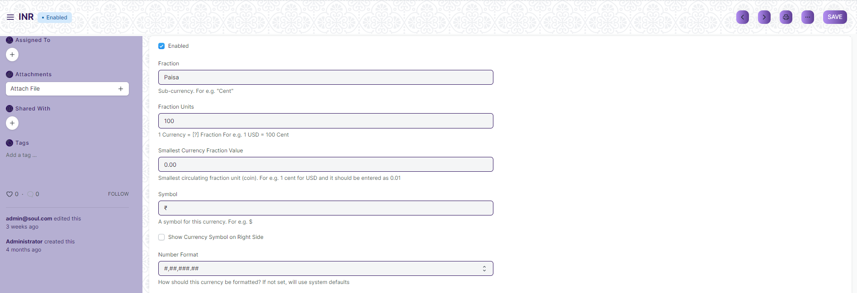

Figure Currency

## Party Type



Figure Party Type

## Cost Center

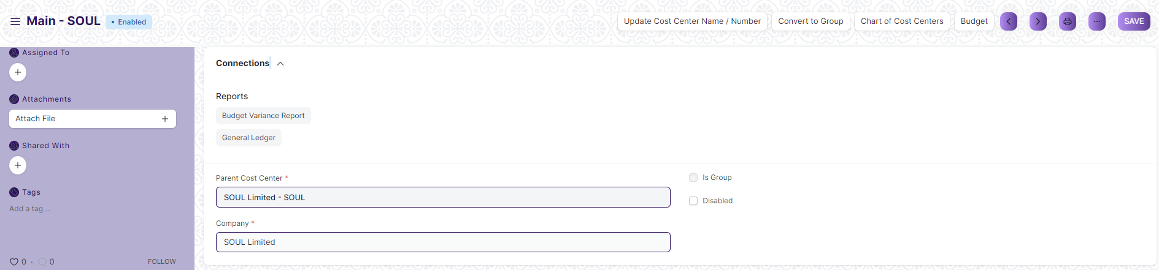

Figure Cost Center

## Accounting Dimension

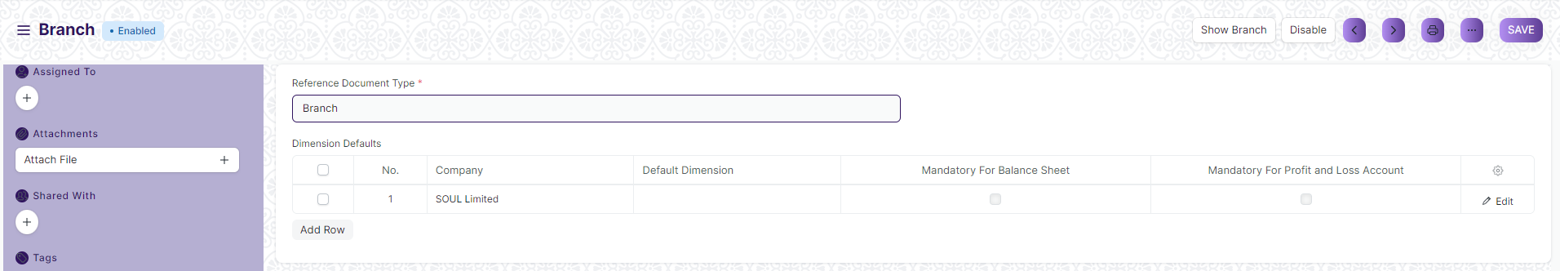

Figure Accounting Dimesion

## Journal Entry

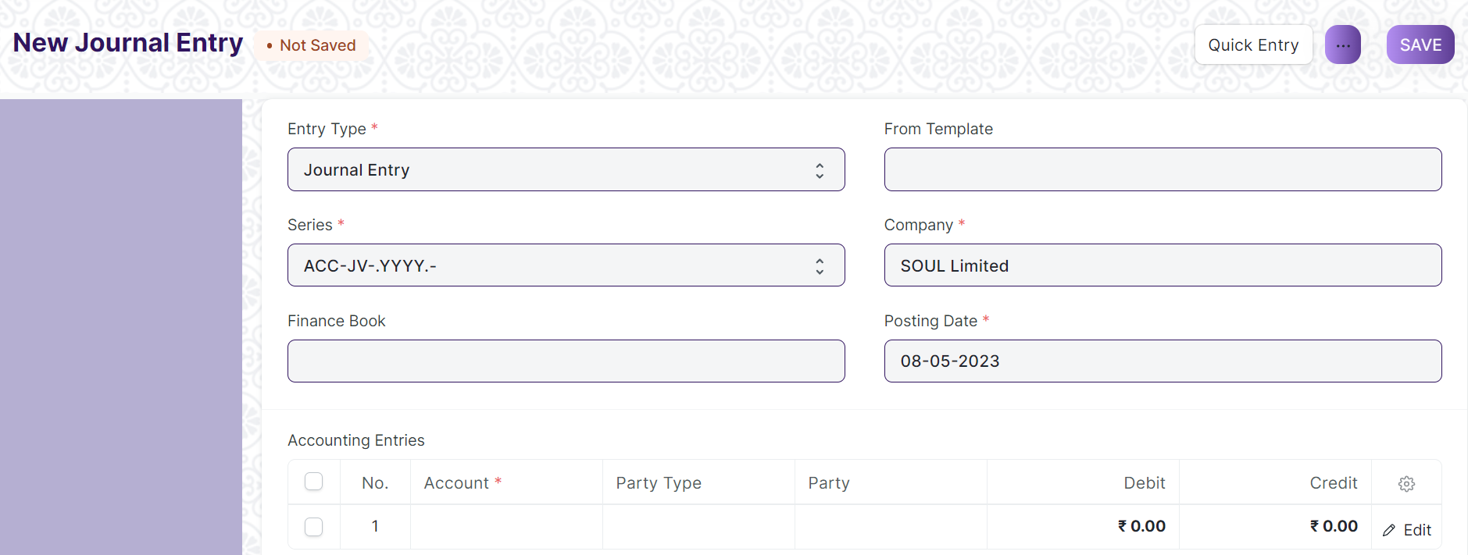

Figure Journal Entry

## GL Entry

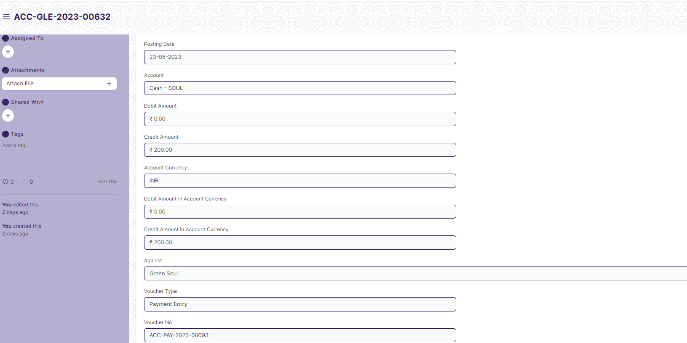

Figure GL Entry

## General Ledger

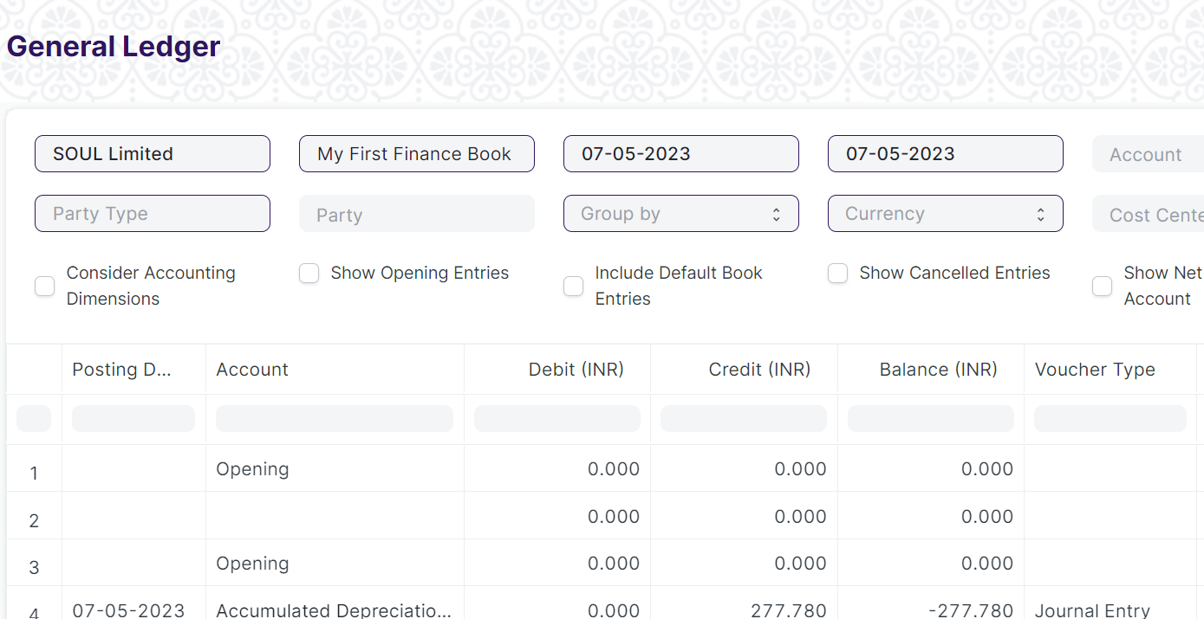

Figure General Ledger

## **payment entry**Payment Entry

Figure Payment Entry

## Bank Reconciliation Tool

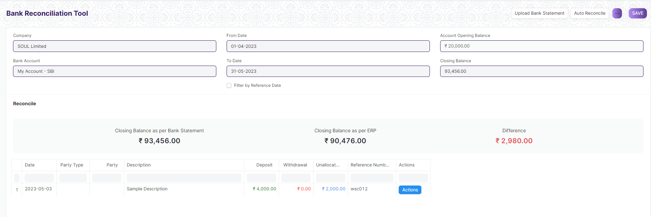

Figure Bank Reconciliation Tool

## Bank Clearance

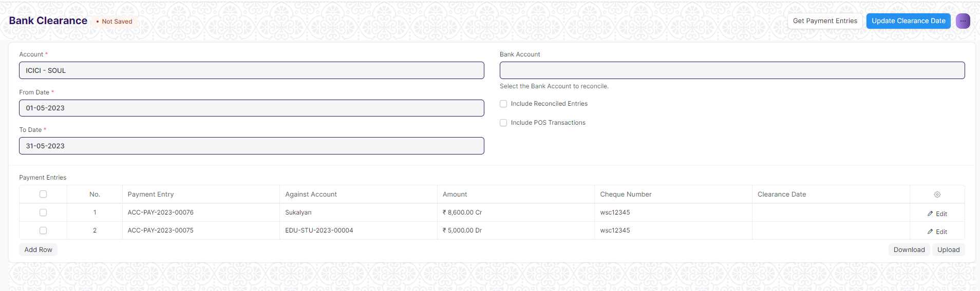

Figure Bank Clearance

## Bank Reconciliation Statement

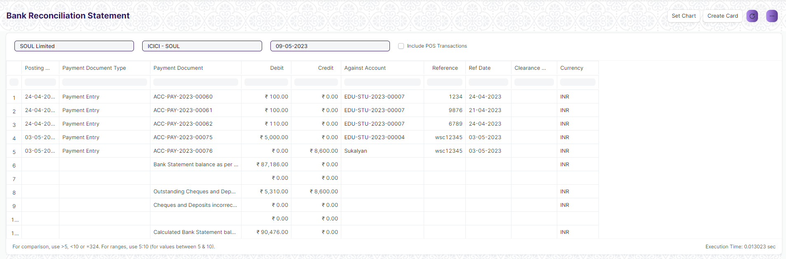

Figure Bank Reconciliation Statement

## Accounts Receivable Report

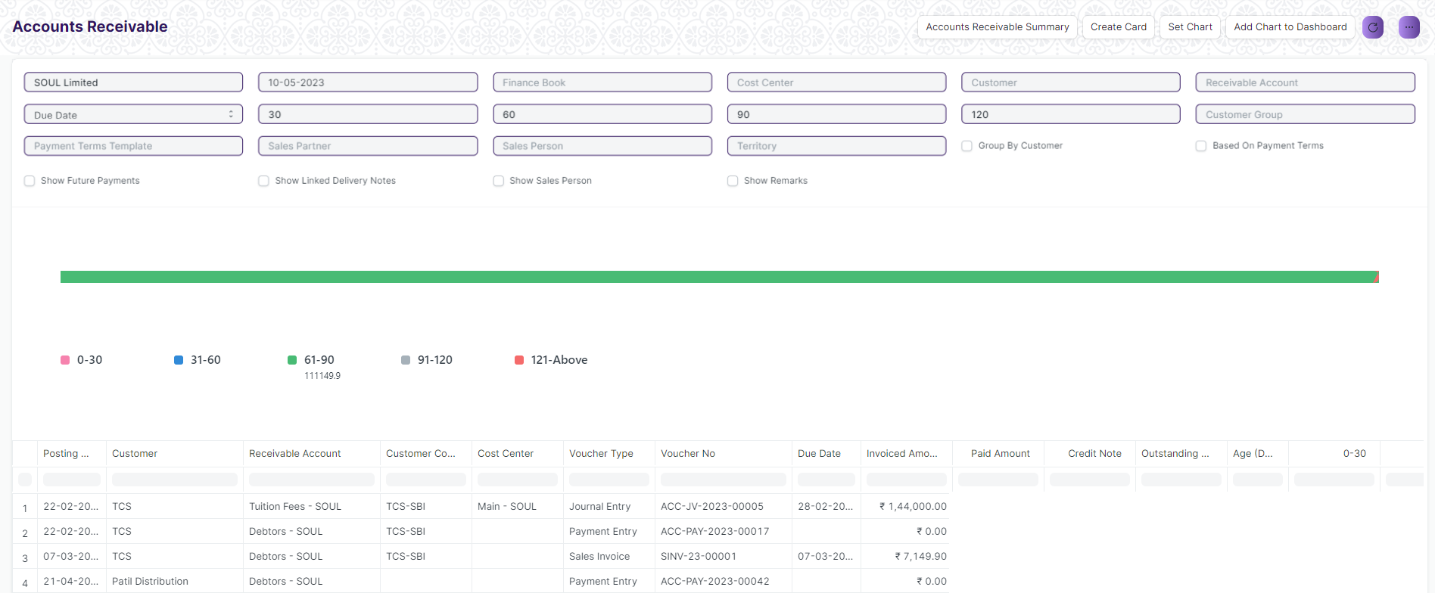

Figure Accounts Receivable

## Accounts Receivable Summary Report

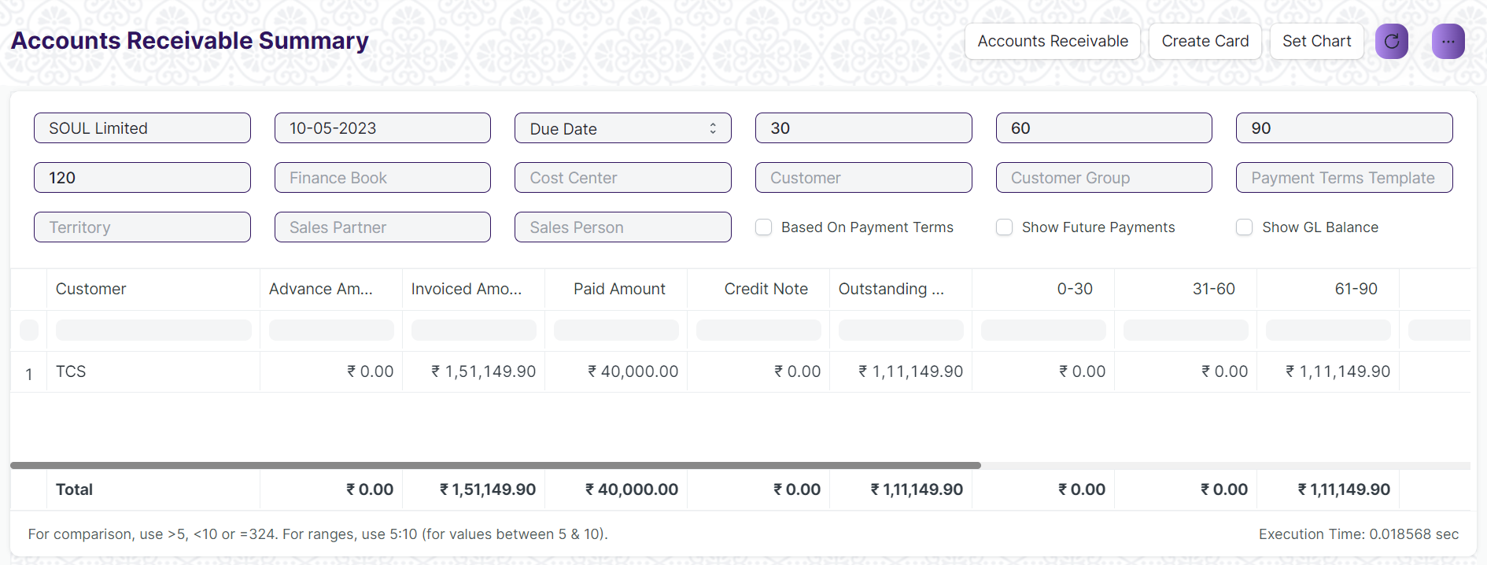

Figure Accounts Receivable Summary

## Accounts Payable Report

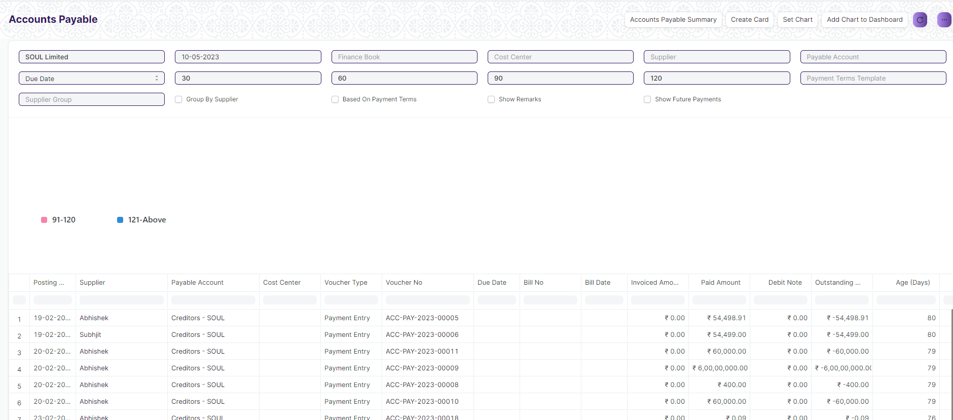

Figure Accounts Payable

## Accounts Payable Summary Report

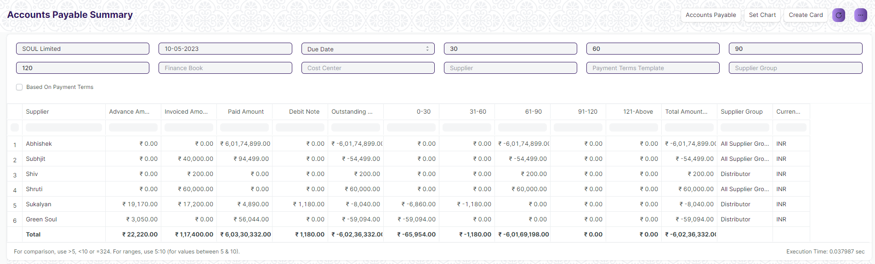

Figure Accounts Payable Summary

## Purchase Register Report

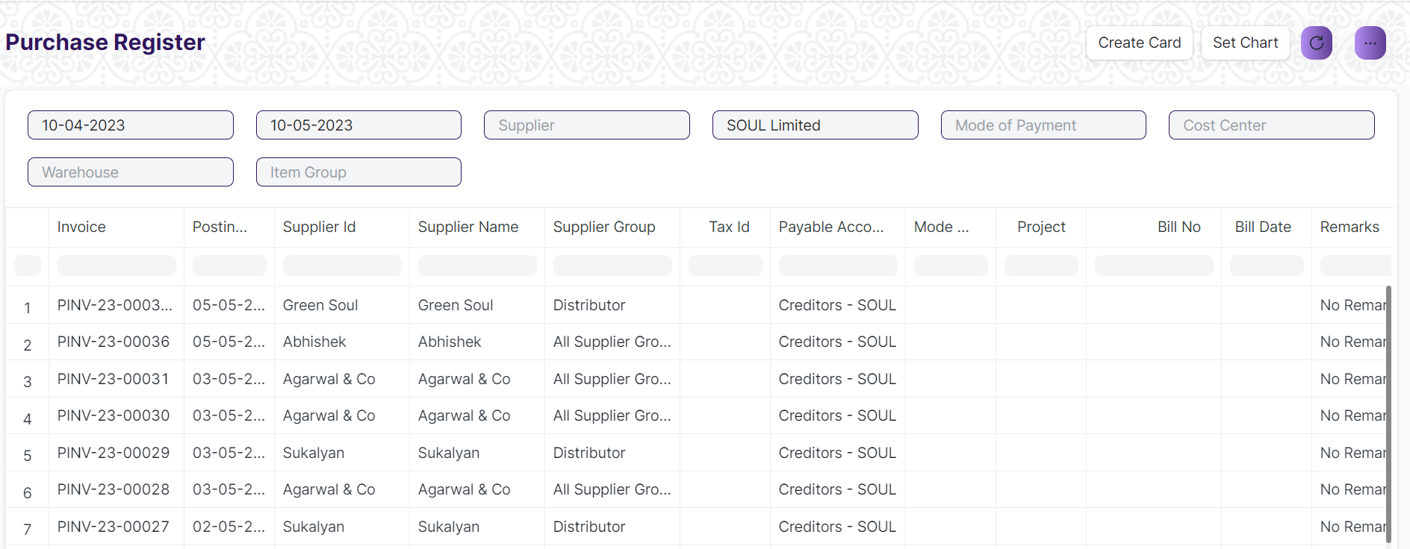

Figure Purchase Register Report

## Item Wise Purchase Register Report

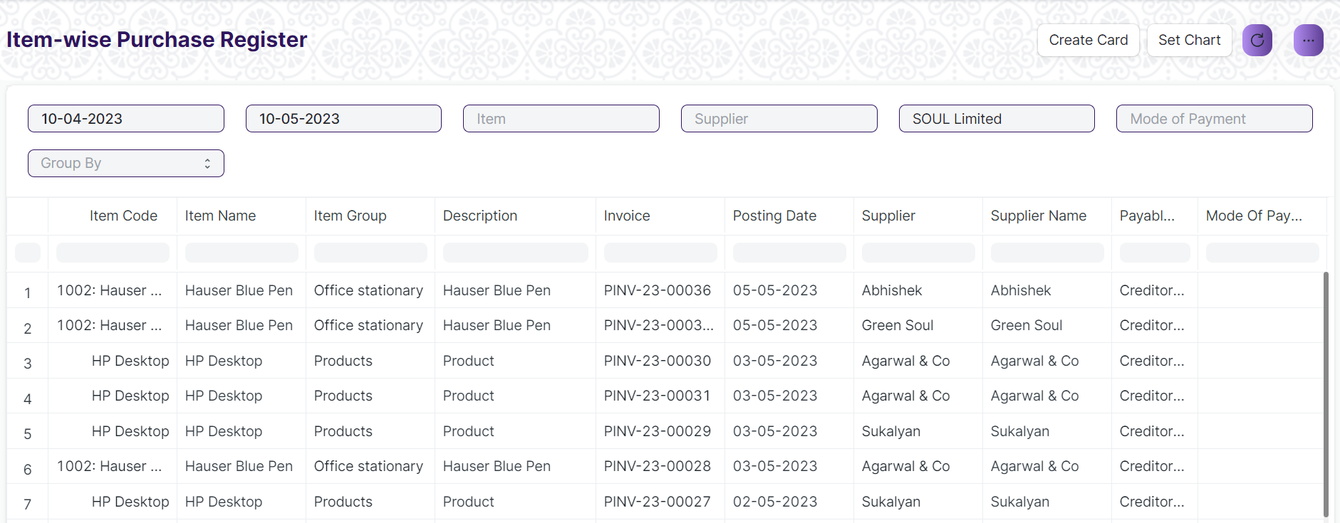

Figure: Item Wise Purchase Register

## Trail Balance for Party Report

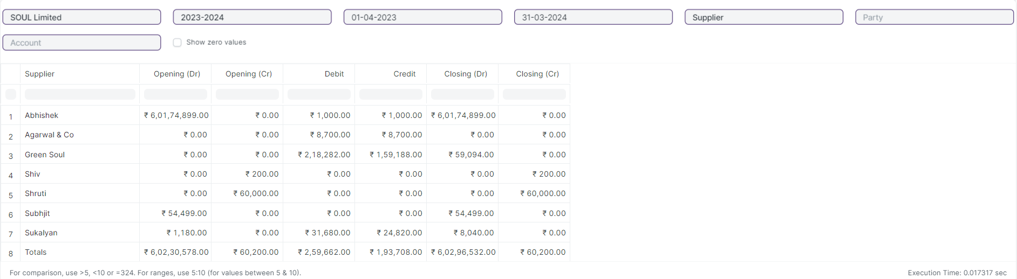

Figure: Trail Balance for Party Report

## Tax Detail Report

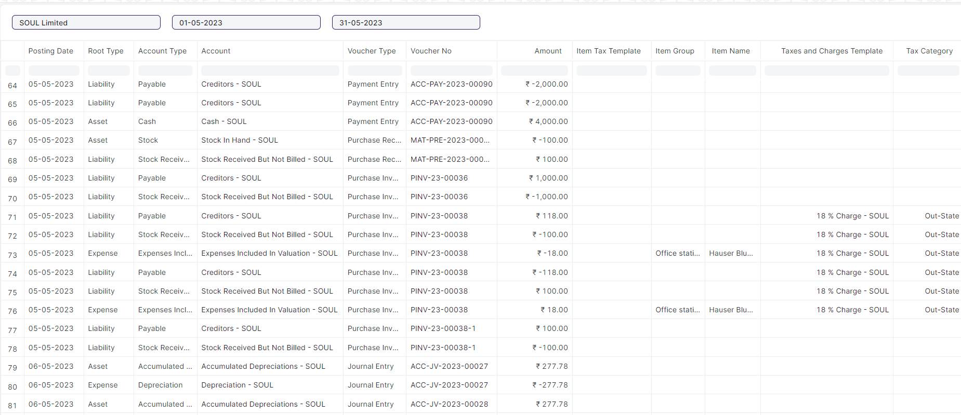

Figure: Tax Detail Report

## Supplier Ledger Summary Report

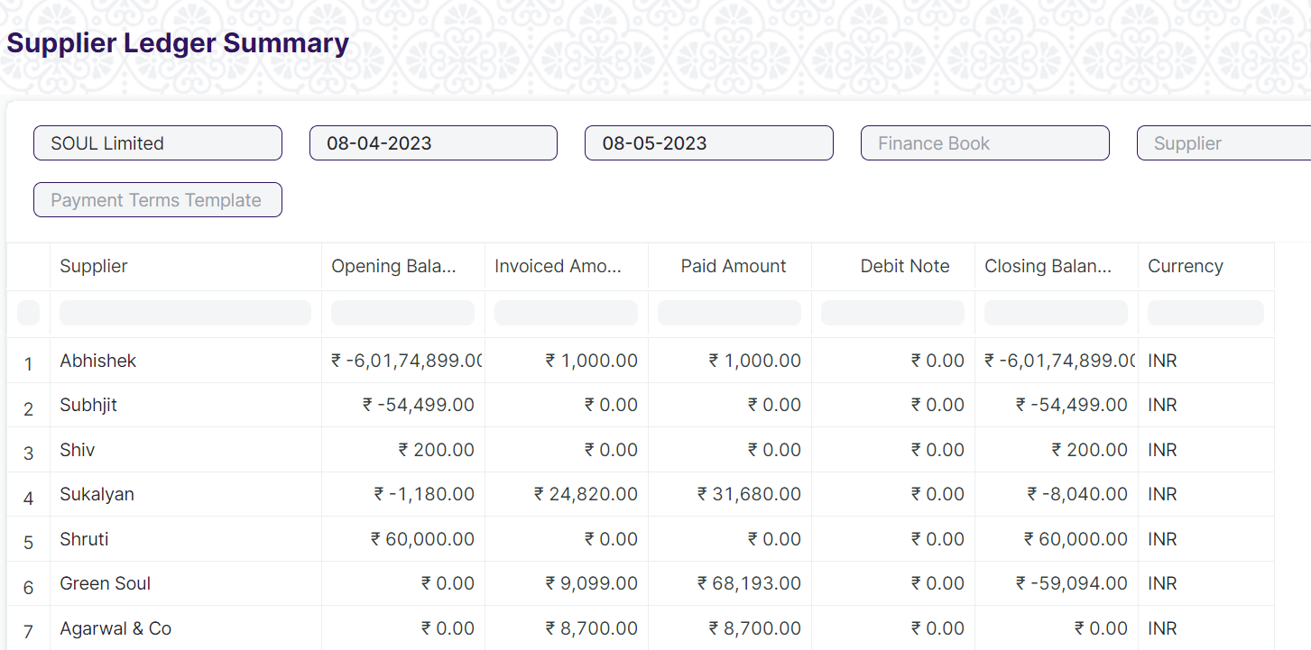

Figure:Supplier Ledger Summary Report

## Trial Balance

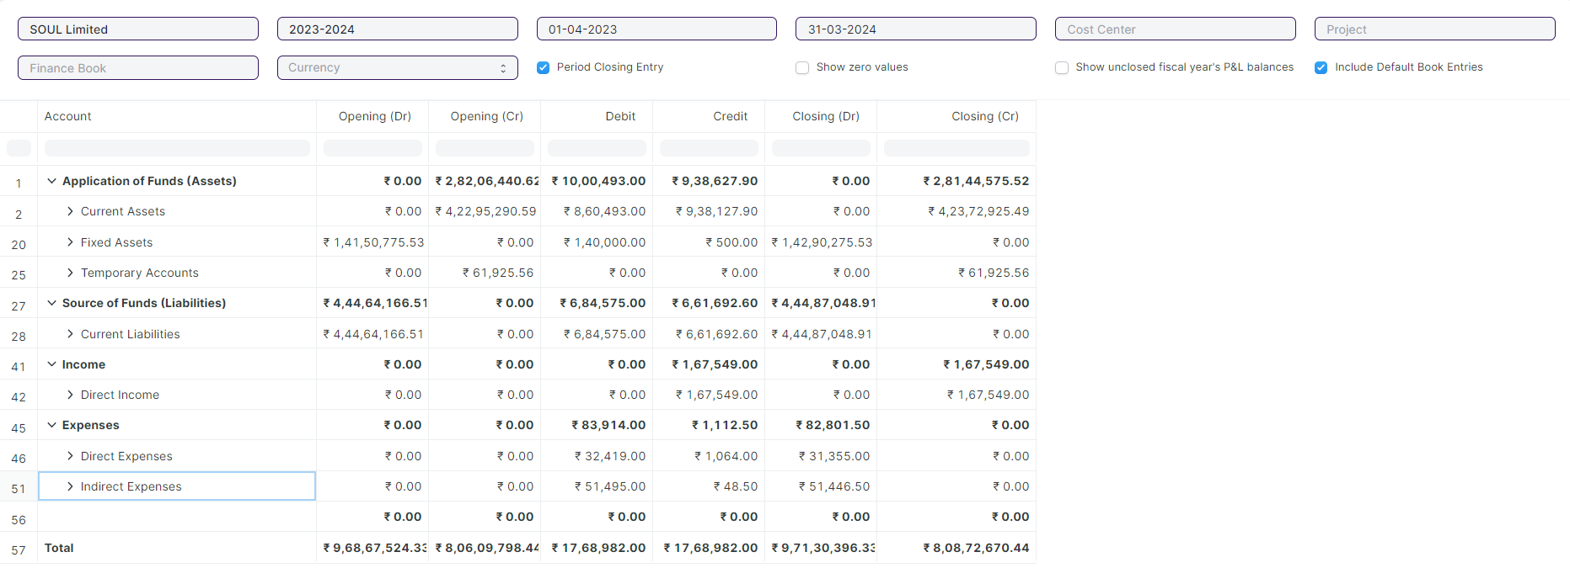

Figure:Trail Balance

## Balance Sheet

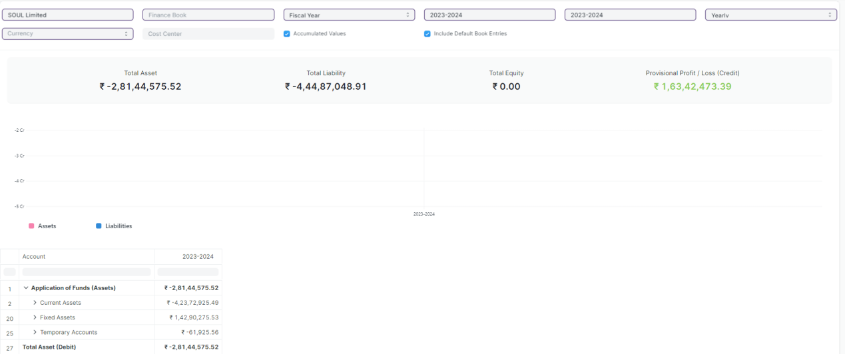

Figure:Balance Sheet

## Profit and Loss Statement

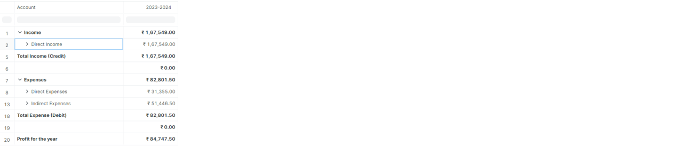

Figure:Profit and Loss Statement

## Cash Flow

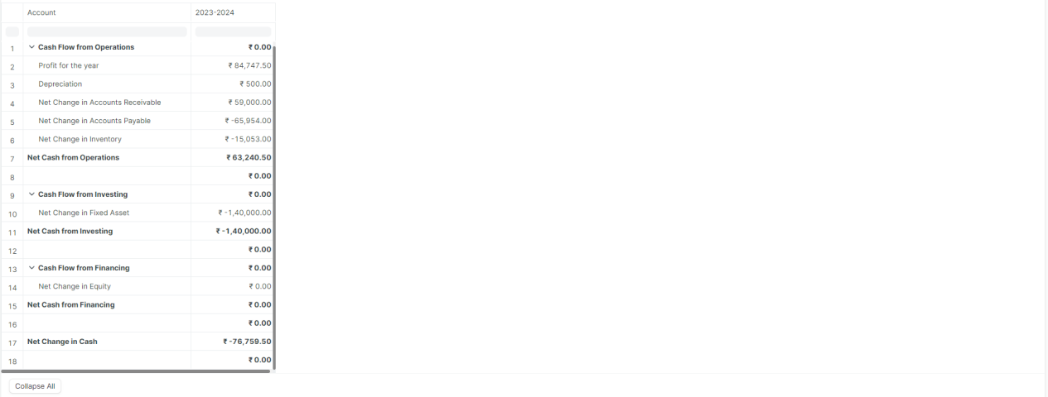

Figure:Cash Flow Report

## Consolidated Financial Statement

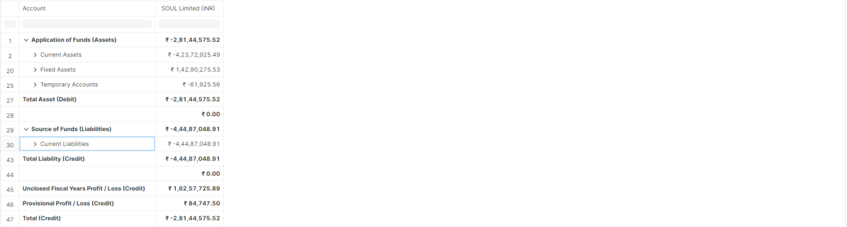

Figure:Consolidated Financial Statement

## Fixed Deposit

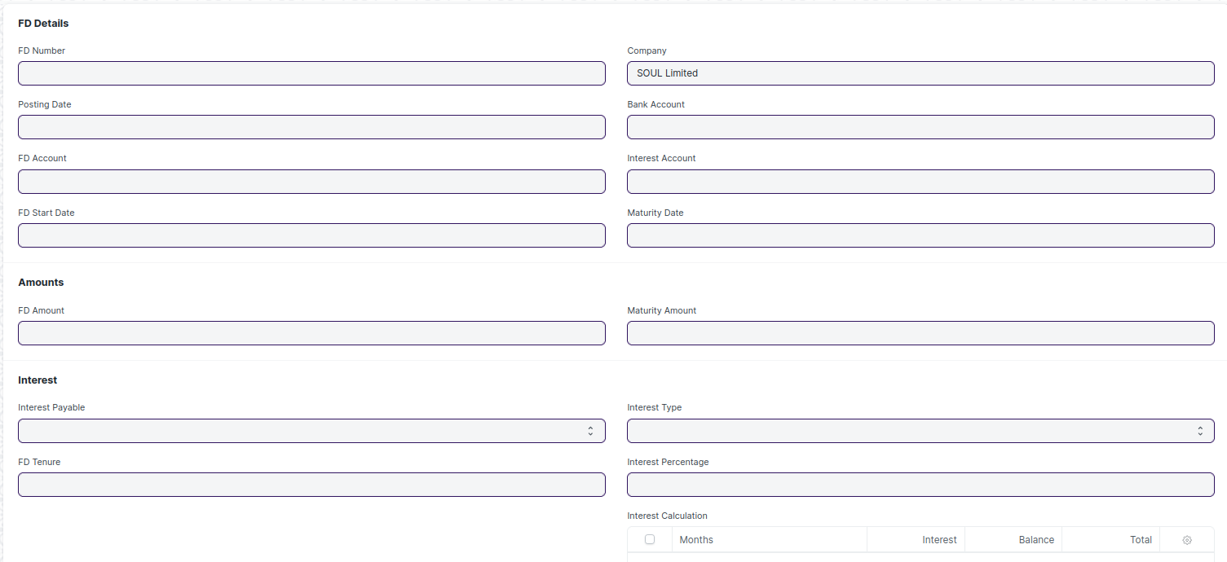

Figure:Fixed Deposit

# Definitions and Acronyms

The following table explains the terms and abbreviations used in the document:

|  |  |
| --- | --- |
| **Abbreviation** | **Description** |
| HLD | High Level Design |
| LLD | Low Level Design |
| API | Application Programming interface |
| NA | Not Applicable |
| ERP | Enterprise Resource Planning |
| HRMS | Human Resource Management System |
| GDPR | General Data Protection Regulation |
| PCI DSS | Payment Card Industry Data Security Standard |

# Deployment Description

* Application Name: Campus Management Application At World Skill Center (WSC)
* Deployment Environment: Production
* Server Information: IP address:117.250.67.19, domain name:erp.worldskillcenter.org, hosting provider: OCAC
* Deployment Date: 13-06-2023

Database Information: MariaDB 10.6.*, Installed on the same server as the Application